Business Solution Requirements and Design
CE IEE MDM- PHase III
Consumer's Energy
Author: BJ Hardesty
Date: 10/25/2013
Version: 3.0
Table of Contents
A. Document Controls 6
A.1. Change Record 6
A.2. Reviewers 6
A.3. Document Storage 6
A.4. Document Owner 6
B. About This Document 7
B.1. Document Purpose 7
B.2. Audience 8
C. Solution Requirements Workshop Summary 9
C.1. Workshop Overview 9
C.2. Workshops Conducted & Participants 9
C.3. Workshops Objectives 10
C.4. Requirements Not in This Document 11
D. Project Objective & Scope Summary 12
D.1. Project Objective Summary 12
D.2. Project Scope Summary 12
D.3. IEE Interaction 14
D.4. Project Background 14
D.5. Constraints 15
D.6. Dependencies 17
D.7. Assumptions 19
E. Solution Overview 21
E.1. Business Solution Overview Diagram 21
E.2. Business Solution Overview Narrative 21
E.3. CE Departments Affected 21
E.4. Systems Affected 21
F. Device Acquisition 22
F.1. Summary 22
F.2. Business Process Flow 23
F.3. Business Process 49
F.4. Device Acquisition Requirements List for December 49
F.5. Outstanding Issues for IEE 50
F.6. Gaps Identified for IEE 50
G. Meter Registration 51
G.1. Summary 51
G.2. Business Process Flow 51
G.3. Business Process 52
G.4. Meter Registration Requirements List for December 57
G.5. Outstanding Issues for IEE 60
G.6. Gaps Identified for IEE 61
H. Data Capture 62
H.1. Summary 62
H.2. Business Process Flow 63
H.3. Business Process 64
H.4. Data Capture Requirements List for December 64
H.5. Outstanding Issues for IEE 67
H.6. Gaps Identified for IEE 67
I. Smart Meter Billing 68
I.1. Summary 68
I.2. Business Process Flow 69
I.3. Business Process 69
I.4. Smart Meter Billing Requirements List for December 70
I.5. Example of report requested 78
I.6. Outstanding Issues for IEE 79
I.7. Gaps Identified for IEE 79
J. Manage Billing Exceptions 80
J.1. Summary 80
J.2. Business Process Flow 81
J.3. Business Process 97
J.4. Manage Billing Exceptions Requirements List for December 101
J.5. Outstanding Issues for IEE 104
J.6. Gaps Identified for IEE 105
K. Smart Meter Opt Out Inquiry 106
K.1. Summary 106
K.2. Business Process Flow 107
K.3. Business Process 113
K.4. Smart Meter Opt Out Requirements Listing for December 113
K.5. Outstanding Issues for IEE 113
K.6. Gaps Identified for IEE 113
L. Supply Chain Inventory Management 114
L.1. Summary 114
L.2. Business Process Flow 114
L.3. Business Process 115
L.4. Requirements Listing for December 115
L.5. Outstanding Issues for IEE 115
L.6. Gaps Identified for IEE 115
M. RMA – Reverse Logistics 116
M.1. Summary 116
M.2. Business Process Flow 116
M.3. Business Process 117
M.4. RMA-Reverse Logistics Requirements Listing for December 117
M.5. Outstanding Issues for IEE 117
M.6. Gaps Identified for IEE 117
N. VEE Requirements 118
N.1. Summary 118
N.2. Business Process Flow 119
N.3. Business Process 119
N.4. VEE Requirements List for April 120
N.1. Outstanding Issues for IEE 124
N.2. Gaps Identified for IEE 124
O. Events 125
O.1. Summary 125
O.2. Business Process Flow 126
O.3. Business Process 127
O.4. Non-Functional Requirements List for December 127
O.5. Outstanding Issues for IEE 127
O.6. Gaps Identified for IEE 127
P. Cutover to Automated Reads Requirements 128
P.1. Summary 128
P.2. Business Process Flow 129
P.3. Business Process 130
P.4. Cutover to Automated Reads Requirements List for April 130
P.1. Outstanding Issues for IEE 130
P.2. Gaps Identified for IEE 130
Q. Non-Functional Requirements 131
Q.1. Summary 131
Q.2. Business Process Flow 131
Q.3. Business Process 132
Q.4. Non-Functional Requirements List for December 132
Q.5. Outstanding Issues for IEE 135
Q.6. Gaps Identified for IEE 135
R. Reports – Interactive Map 136
R.1. Summary 136
R.2. Business Process Flow 138
R.3. Business Process 139
R.4. Reports – Interactive Map Requirements for December 139
R.5. Outstanding Issues for IEE 139
R.6. Gaps Identified for IEE 140
S. Reports – Device List 141
S.1. Summary 141
S.2. Business Process Flow 142
S.3. Business Process 143
S.4. Reports – Device List Requirements for December 143
S.5. Outstanding Issues for IEE 143
S.6. Gaps Identified for IEE 143
T. Reports – Device List Continued 144
T.1. Summary 144
T.2. Business Process Flow 145
T.3. Business Process 146
T.4. Reports – Interactive Map Requirements for December 146
T.5. Outstanding Issues for IEE 146
T.6. Gaps Identified for IEE 146
U. Reports – Reconciliation 147
U.1. Summary 147
U.2. Business Process Flow 148
U.3. Business Process 149
U.4. Reports – Interactive Map Requirements for December 149
U.5. Outstanding Issues for IEE 150
U.6. Gaps Identified for IEE 150
V. Reports – Read Rate 151
V.1. Summary 151
V.2. Business Process Flow 152
V.3. Business Process 153
V.4. Reports – Read Rate Requirements for December 153
V.5. Outstanding Issues for IEE 153
V.6. Gaps Identified for IEE 153
W. Reports – Event Display 154
W.1. Summary 154
W.2. Business Process Flow 155
W.3. Business Process 156
W.4. Reports – Events Display Requirements for December 156
W.5. Outstanding Issues for IEE 156
W.6. Gaps Identified for IEE 156
X. Reports – Data Integrity 157
X.1. Summary 157
X.2. Business Process Flow 158
X.3. Business Process 159
X.4. Reports – Data Integrity Requirements for April 159
X.5. Outstanding Issues for IEE 159
X.6. Gaps Identified for IEE 159
Y. Opower Web Presentment 160
Y.1. Summary 160
Y.2. Business Process Flow 161
Y.3. Business Process 161
Y.4. Reports – Opower Web Presentment Requirements for April 162
Y.5. Outstanding Issues for IEE 162
Y.6. Gaps Identified for IEE 162
Z. Requirements Not Applicable to IEE 163
Z.1. Summary 163
AA. Requirements Not Included In This Document 211
AA.1. Interface 211
AA.2. Data Migration 211
AA.3. Network Design 211
AA.4. Installation Planning 211
AA.5. Solution Technical Architecture & System Security 211
BB. Gaps/Concerns Listing 212
CC. Open Issues & Questions 213
DD. Solution Requirements Sign-Off 214
EE. Appendices 215
EE.1. Glossary 215
EE.2. Reference Documents 222
EE.3. Event Codes to be Processed 225

Document Controls

Change Record
Date | Author(s) | Version | Change Reference
10/25/2012 | BJ Hardesty | 2.0 | Original Document for Phase II. Note document number 2.0 indicates first document for Phase II.
11/5/2012 | BJ Hardesty | 2.1 | Incorporated input from Itron team.
11/15/2012 | BJ Hardesty | 2.2 | Incorporated input from Consumer’s team. Removed Equipment Calibration.
10/25/2013 | Harikrishnan Bhanu | 3.0 | Updated with mention of OpenWay

Reviewers
Name | Sign-off? | Position
Hayden Shepherd | Yes | Itron Project Manager
Hari Bhanu | Yes | Itron Technical Consultant
BJ Hardesty | Yes | Itron Business Consultant
Chad Conrad | Yes | CE Project Manager
Jack Hobbick | Yes | CE Business Process Owner
Mark McCollum | Yes | CE Business Process Owner
Ivan Principe | Yes | CE Smart Grid Requirements Manager
Jeff Tolonen | Yes | CE Solution Architect

Document Storage
This document was created using MS Word and is stored in the Itron Sharepoint site at https://extranet.itron.com/access/prj/13765/default.aspx and within Consumer’s Document Library.

Document Owner
This document contains information that is confidential and proprietary to Itron, who is the owner and responsible for developing and maintaining this document. It is understood that this document is for the purposes of the CE IEE MDM project. This document, or portions thereof, should not be referred to, distributed or utilized in any other way outside of the project’s needs without prior approval of Itron.

About This Document

Document Purpose
This document defines the solution requirements for the CE IEE MDM Phase II project. This relates to the Release 3 for December 2012.
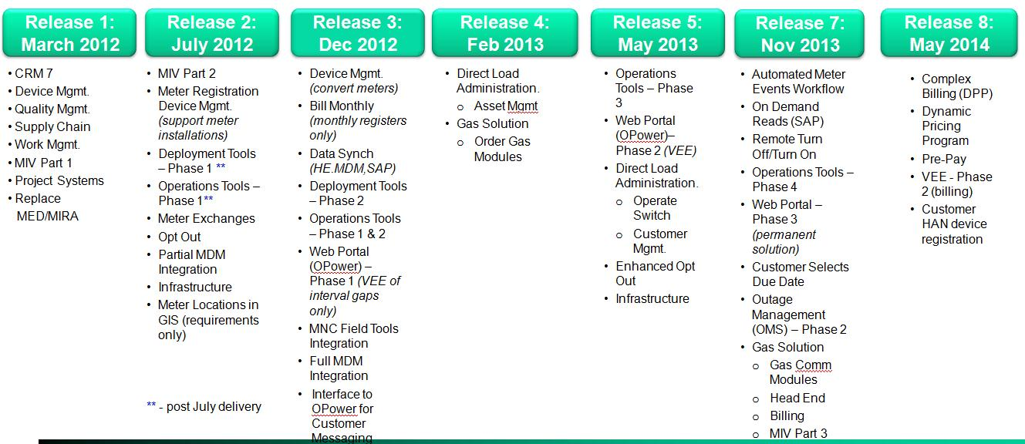
Note that the above scope has been updated. The new scope is below.
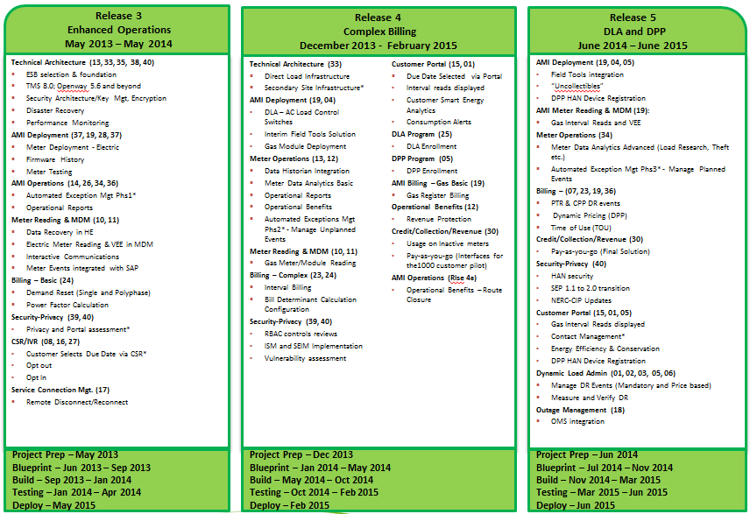
Prior to developing this document, a series of Solution Requirements & Design Workshops are conducted. Upon completion of the workshop the Business Solution Requirements (this document) is produced. This document provides direct input into:
- Business Solution Design
- Technical Architecture Design
NOTE: Terms and phrases used in this document are defined in the glossary in the appendices.

Audience
This document is meant to be reviewed by the CE stakeholders. This will include the CE Project Manager, CE Technical Lead, and CE Business Process Owners.

Solution Requirements Workshop Summary
This section summarizes the workshops conducted.

Workshop Overview
The Solution Requirements & Design Workshops are a series of facilitated sessions organized by major business area/process. The objective is to collect the key requirements and designs needed to enter the Design Phase of the project.

Workshops Conducted & Participants
These workshops were conducted for CE and the following individuals lead the workshops.
# | Workshop | CE Assignees | Requirements Document Title
1 | Device Acquisition | Ken Krejcik/  Jeff Tolonen/  Debbie Sleight | PP4_W1_SC-050-050 Device Acquisition
2 | Meter Registration | Jeff Tolonen/  Jack Moore/Srikanth/  Tom O'Reilly/Debbie Sleight | PP4_W3_WM-080-150 Meter Registration
3 | Data Capture | Jack Moore | PP4_W8 2-WM-050-150 Data Capture
4 | Smart Meter Opt Out | David McWethy | PP4_W20_CM-080-150 Smart Meter Opt Out
5 | Supply Chain Inv Mgt | Laura Voncina | PP4_SC-050-090 Supply Chain Inv Mgt
6 | Smart Energy Billing | Joel Evangelista | W13a_Smart Energy Billing
7 | Manage Billing Exceptions | Sean Whittier | W13b_Manage Billing Exceptions
8 | SEOC Reports/ Reconciliation | David Koerkel | W6.3_TS-030-010 SGOC Reports - 01 02 Reconciliation
9 | SGOC Reports / Interactive Map | David Koerkel | W6.3_TS-030-010 SGOC Reports - 03 Interactive Map
10 | SGOC Reports SDP/Device List | David Koerkel | W6.3_TS-030-010 SGOC Reports - 10 11 12 13 14 Device List
11 | Additional Event Handling | David Koerkel  Ivan Principe | TMSEventHandling-Approved 19-Oct-12
12 | VEE | Joel Evangelista  Richard Hall | W27_RM-010-160_Validation Editing and Estimation
13 | RMA – Reverse Logistics | Stacy Craddock | SG4_SC-050-090_RMA- Reverse Logistics
14 | Non Functional Requirements | Mike McClintock | SG Non-Functional Reqs_W17
15 | Opower Web Presentment | David McWethy | W16.1_CM-080-160_ Opower Web Portal Operations
16 | Cutover to Automated Reads | Kristine Pascarello | W11 _RM-030-040_Cutover to Automated Reads
17 | SGOC Reports SDP/Device List Continued | Dave Koerkel | W6.1_TS-030-090_SEOC Device List Continued
18 | SGOC Reports SDP/Read Rate | Dave Koerkel | W6.1_TS-030-060_SEOC Read Rate
19 | SGOC Reports SDP/Event Display | Dave Koerkel | W6.1_TS-030-070_SEOC Event Display
20 | SGOC Reports SDP/Data Integrity | Dave Koerkel | W6.1_TS-030-080_SEOC Data Integrity Check

Workshops Objectives
Each workshop was organized to meet specific objectives. This section lists those objectives and whether or not the objectives were met.
# | Workshop | Workshop Objective | Topics Covered
1 | Device Acquisition | Define meter acquisition | - No additional requirements for IEE
2 | Meter Registration | Define process of meter registration | - No additional requirements for IEE
3 | Data Capture | Define requirements for collecting readings and events from the meter to TMS. | - Collection of data in pulses versus engineering units  - Interfaces between SAP, OpenWay, TMS, ESM, and IEE
4 | Smart Meter Opt Out | Define process required to set up an account or change an account to a legacy meter reading from AMI meter reading. | - Setting AMI meter to inactive.  - Reassign meter to Field Read
5 | Supply Chain Inv Mgt | Define processes for Supply change | - No additional requirements for IEE
6 | Smart Energy Billing | Process of sending bulk meter read requests through ISAIM to IEE and back to SAP | - ABE Requests  - ABE Responses
7 | Manage Billing Exceptions | Walk through various exceptions, who will work, and what portions of IEE are used to work. | - ABE Exception Queue
8 | SEOC Reports/ Reconciliation | Define data requirements for reconciliation of meters between IEE, SAP, OpenWay, and TMS. | - IEE data feed to Bitstew
9 | SGOC Reports / Interactive Map | Define requirements for file extracts for reconciliation between applications | - Define what files will be provided, data requirements in PP6
10 | SGOC Reports SDP/Device List | Define requirements for file extracts for device lists between applications | Define what files will be provided, data requirements in PP6
11 | Additional Event Handling | PP4 was updated, but no actual workshop to be held. | - Additional events to be captured during December 2012 implementation.
12 | VEE | To define the correct estimation routines to be used and in which order. | - Estimation of missing intervals  - Validation Queue
13 | RMA – Reverse Logistics | Define the requirements for returning equipment to Itron. | - No additional requirements for IEE
14 | Non Functional Requirements | Identify and define the requirements for technical aspects of the project | - Define metrics for performance  - Define DR and RP constraints  - Define required disk space
15 | Opower Web Presentment | Define the data that must be passed from the IEE and SAP applications to Opower. | - Data extract from IEE to Opower
16 | Cutover to Automated Reads | Define the process of route acceptance | - Utilize ABE response file for extract to compare reads against manual process
17 | SGOC Reports SDP/Device List Continued | N/A | - No workshop held
18 | SGOC Reports SDP/Read Rate | N/A | - No workshop held
19 | SGOC Reports SDP/Event Display | N/A | - No workshop held
20 | SGOC Reports SDP/Data Integrity | N/A | - No workshop held

Requirements Not in This Document
- Data Integration – No requirements captured in this document. Please see Technical Architecture Design.
- Data Migration – No requirements captured in this document. Please see Technical Architecture Design.
- Installation Planning – No requirements captured in this document. The contract (a.k.a. Statement of Work) between Itron and CE is the key reference point for installation deployment requirements. The workshops are intended to gather the additional details required move to the design phase of the project for this portion of the effort.
- Network Design – No requirements captured in this document. Please see Network Design & Technical Architecture Design.
- Solution Technical Architecture & System Security – No requirements captured in this document. Please see Technical Architecture Design.

Project Objective & Scope Summary

Project Objective Summary
Consumer’s Energy (CE) is seeking to implement Itron’s Advanced Metering Infrastructure (AMI) solution which includes IEE MDM as a meter data management application for 1.8 million electric meters and 1.5 million gas meters within their service territory.

Project Scope Summary
Phase I - Items included in this phase of the project for July 20th include - Completed July 19, 2012.
Synchronization of meters and service delivery points between IEE and SAP (Interface required) to support meter creation and meter installation (registration).
Development of meter and service point programs.
Establishment of end user security.
Configuration of application upon initial installation for use in 5 environments (Sandbox, Development, Prime Development, QA and Prime QA).
Configuration of application upon initial installation for use in Production / Disaster Recovery Environments.
Phase II – Collection of meter register reads and intervals reads to provide electric registers to SAP for billing by April, 2013.
Capturing and storing of meter events (alerts and exceptions) between OpenWay, TMS and IEE (Interface required*).
Capturing and storing of register reads between OpenWay, TMS and IEE (Interface required.*)
Capturing and storing of interval reads between OpenWay, TMS and IEE (Interface required.*)
Initial MNC Field Tools Integration (Interface required.*)
Ability to provide data (Device ID & validated* Interval Data) to OPower for warehousing and web presentment to ensure bill ready interval data in the Web Portal (OPower - Pilot),
Implementation of IBM Change Data Capture for above interface.
Validation of intervals to include only gap fill and estimation of gaps.
Request and response processing of register reads for billing between IEE and SAP (Interface required.*)
Ability to provide data to BitStew’s Grid Director for enhanced reporting required for managing the day-to-day operations of the Smart Meters in addition to deployment analysis.
Ability to capture and store contingency meter readings via HHF file for limited number of readings per day.
Reporting as needed for billing register reads.

Phase III – Integration with web portal with validated data by May, 2013.
Support the integration with BitStew’s Grid Director for enhanced reporting required for managing the day-to-day operations of the Smart Meters, Head End and the MDUS in addition to deployment analysis.
Support integration with OPower providing VEE (Validation, Estimation & Editing) functionality to ensure bill ready interval data to the Web Portal.
Potential integration with Direct Load Administration (DLA) processing.
Capturing and storing of additional meter events (alerts and exceptions) between OpenWay, TMS and IEE.
Phase IV – Integration with CONSUMERS ENERGY Outage Management System (OMS) and gas solution by November, 2013.
OMS Integration to manage electric smart meter outage events (Interface required.*)
Request and response (including On-Demand) processing of interval reads for billing between IEE and SAP (Interface required.*)
Interfaces for any additional 3rd party applications.*
Capturing, storing and distribution of meter events (alerts and exceptions) between OpenWay, TMS and IEE to SAP.
Support the integration with BitStew’s Grid Director for enhanced reporting required for managing the day-to-day operations of the Smart Meters, Head End and the MDUS in addition to deployment analysis.
Any additional reporting required.
Support integration with final web portal solution.
Integration with a Gas solution.
Support customer select due date from a performance perspective.
Deploy interface services between the Head Ends OpenWay and TMS, and MDUS IEE using Service Oriented Architecture (SOA) and Common Information Modeling (CIM) following international standards (IEC 61968-9 -- Interfaces for Meter Reading & Control).
Support remote meter connect / disconnect processes (Turn On – TN/Turn Off’s – TF).
Ability to process On-Demand Reads from SAP through IEE to TMS and OpenWay.
Phase V – Implementation of Interval Billing including passing billing determinants to SAP for billing by May, 2014.
Validation of interval reads to include all validations required by CONSUMERS ENERGY (Full VEE capabilities).
Implementation of Interval Billing including passing billing determinants to SAP for billing.
Support Complex Billing including any published tariff is fully functional using interval data from every meter.
Additional capturing, storing and distribution of meter events (alerts and exceptions) between OpenWay and TMS and IEE to SAP.
Support the integration with BitStew’s Grid Director for enhanced reporting required for managing the day-to-day operations of the Smart Meters, Head End and the MDUS in addition to deployment analysis.
Ability to support HAN integration for Dynamic Pricing programs.
Ability to support pay as you go (pre-pay) program.

IEE Interaction
The IEE MDM application will reside in the center of the architecture with interaction to various other applications to communicate and translate register and interval readings, meter events, and processing of commands between SAP and both TMS and OpenWay for disconnects/reconnects, meter programming changes, and various other commands.

Project Background
CE began the AMI project using GridNet for the head end application and OSISoft for the meter data management application. Itron purchased SmartSynch in May, 2012, and renamed the product to just Itron TMS. This is managed by the Itron Cellular Solutions division. In June, 2012, the contract for IEE MDM was signed to replace OSISoft MDM with IEE.

Constraints
Constraints are identified as boundaries/decisions that are set and which the project team must work within.
Project Constraints
# | Description | Date Identified
1 | CE will be implementing a SQL Server database solution. | 5/22/2012
2 | The level of services estimated assumes that the project time line will be consistent with the schedule specified in the statement of work plan provided by Itron. Changes to the duration of the schedule, including changes in the project start date and/or changes in project duration, may require changes in the estimated effort and cost. | 5/22/2012
3 | Our estimate is based on Itron’s Standard Implementation Methodology. Should a SI be used by CE on this project, any SI-imposed deviation from Itron’s Standard Implementation Methodology will have an impact on the estimate period. | 5/22/2012
4 | Any scope not specifically identified in the SOW is expressly excluded. | 5/22/2012
5 | Servers will be deployed in a VM environment. | 5/22/2012
6 | IEE must be installed, configured, and able to accept events from the TMS head end by 12/13/2012. | 5/22/2012
7 | IEE must be able to accept readings from the TMS head end by 12/13/2012 | 5/25/2012
8 | The Manufacturer Test file process will not be automated | 5/25/2012
9 | Test meters will have a GE serial number and GE catalog number, and no CE material number (purchased as a text item). | 5/25/2012
10 | The MED/MIRA database will be retired in 2012. After the DLM project completes (March 2012), all former MED/ MIRA processes will be captured in SAP QM. The switch from "Legacy Device" MED/MIRA to SAP for input and reporting will require training for at least part of the MTC and SGFID employees, with some individuals needing to be trained extensively to fulfill new or expanded roles. | 5/25/2012
11 | The ship file provided by the meter manufacturer and received by the system will be loaded by the SGOC team. The import/load process into the Head End will not be automated during the Jul/Sept 2012 releases.  This process also covers the following scenarios/variants:  • Mass meter creation  • Individual meter creation  • Changing the meter record (changing of the device category, meter status, etc.) | 5/25/2012
12 | Device location ID (SDP-service delivery point) shall be used to uniquely identify a systematic location. | 5/25/2012
13 | The utility serial number shall be used to uniquely identify a meter. (UIID) | 5/25/2012
14 | Communication Board Firmware Upgrade Over the Air through the Head End is part of July release. Metrology Firmware upgrades will only be performed at MTC on an exception basis. Cell and HAN modem f/w upgrades will not be supported by GEN1 meters that will be deployed in December. | 5/25/2012
15 | This PP4s were written with the expectation that it is only for the December 2012 release and will be revisited for future releases. | 5/25/2012
16 | These PP4s do not cover meter program upgrades, as that is out of scope for December 2012. For the December 2012 release, if a premise needs a new program, it is expected a meter exchange will be performed. | 5/25/2012
17 | These PP4 do not cover kV2c meters, as they are out of scope for December 2012. However, it should be noted that careful consideration of firmware upgrades on kV2c should be taken. On 1/12/2012 in response to AI055, the vendor stated the following regarding Metrology Firmware upgrades: "The normal patching process leaves a kV2c in an unprogrammed state, with all LP data lost. The kV2c block release that is under development will fix this so that LP data is not lost when patching." (LP is Load Profile) | 5/25/2012
18 | The current process for reading meters uses Fieldnet to collect meter data on a monthly basis. Hard to access or non-communicating meters will continue to use this process. | 5/25/2012
19 | OMS will not be part of the December 2012. | 5/25/2012
20 | The new process will collect event data via the communications network. This data will only be used as a verification of a working Smart Grid System. | 5/25/2012
21 | TMS does not provide a process to retrieve events on a predefined read schedule. A predefined list of events will be transmitted from the meter upon occurrence. | 5/25/2012
22 | Upon receipt of the meter data at the Head End, the Head End publishes the meter data to the MDM. | 5/25/2012
23 | Only INT_016 Publish Server Event is scheduled for December 2012. | 5/25/2012
24 | Meters will be set up in SAP and SG Systems at time of meter creation in SAP [*PP4 Addendum: This decision was later changed to the following: "Meters will first be created in the SAP system which will trigger an automatic update to the MDM system, however, device creation in the Head End system will be delayed until after the Manufacturer Test File results have been uploaded successfully into SAP."] | 5/25/2012
25 | Moving a meter across environments within the Verizon “Dev.” private network will not happen | 5/25/2012
26 | Files from meter MNFC will not be loaded into SAP until the meters have been accepted [*PP4 Addendum: This decision was later changed to the following: "The Manufacturer Test file will be loaded in SAP after the devices have been created in SAP. The Head End Ship File will only be loaded after the Manufacturer Test File has been successfully loaded into SAP."] | 5/25/2012
27 | The Manufacturer Test file process will not be automated | 5/25/2012
28 | Loading of ship file into the Head End will occur at the same time as the meters are loaded into SAP through IQ04 to mitigate an out of sync condition [*PP4 Addendum: This decision was later changed to the following: "Loading of the ship file into the Head End system will occur only after the Manufacturer Test File has been uploaded successfully into SAP (it will differ from the MDM system which is based on the SAP IQ04 Device Creation step)."]The Manufacturer Test file process will not be automated | 5/25/2012
29 | The ship file provided by the meter manufacturer and received by the system will be loaded by the SGOC team. The import/load process into the Head End will not be automated during the Jul 2012 releases.  This process also covers the following scenarios/variants:  • Mass meter creation  • Individual meter creation  • Changing the meter record (changing of the device category, meter status, etc.)  [Changing of meter records are carried out using transactions IQ02, IE02 and EG42.]  Test meters will have a GE serial number and GE catalog number, and no CE material number (purchased as a text item) | 5/25/2012
30 | Loading of ship file into the Head End will occur at the same time as the meters are loaded into SAP through IQ04 to mitigate an out of sync condition [*PP4 Addendum: This decision was later changed to the following: "Loading of the ship file into the Head End system will occur only after the Manufacturer Test File has been uploaded successfully into SAP (it will differ from the MDM system which is based on the SAP IQ04 Device Creation step)."] | 5/25/2012
31 | Smart Meter Deployment:  • Deployment schedules could be impacted by a potential return to the deployment areas.  • Potential to return to deployment areas for meter exchange when customer first opt outs and subsequently requests a smart meter to be installed  • Potential for not all meters to be exchanged prior to MRU close-out. Therefore, the Legacy meters will be returned to the Meter Reading Department for manual meter reading which does not stop the MRU closure process. | 9/6/2012
32 | Customer Choice:  • Customer who opt out are not eligible for smart grid enabled programs | 9/6/2012
33 | Dual-Head-End Configuration:  • IEE must be configured to transmit and receive messages from both TMS and OpenWay | 10/24/2013

Dependencies
The following items have been identified as possible issues that could prevent the delivery of the system/components as specified in the statement of work. The dependencies will each be assigned a risk and mitigated to prevent or reduce the risk associated with subsequent deliverables.
Project Dependencies
# | Description | Date Identified
1 | Development of the IEE/TMS Interface is required to pass events and readings from the head end to the meter data management. | 5/22/2012
2 | Development of the IEE/SAP Interface is required to pass meter readings from the meter data management to the billing engine. | 5/22/2012
3 | Delivery of UOM scripts for deployment of meter programs for Phase II. | 5/24/2012
4 | First Article meters are to validate the production run before proceeding with purchase | 5/25/2012
5 | Meters will first be created in the SAP system which will trigger an automatic update to the MDM system; however, device creation in the Head End system will be delayed until after the Manufacturer Test File results have been uploaded successfully into SAP. | 5/25/2012
6 | SAP standard process is to let meters register in the MDM at meter creation | 5/25/2012
7 | The Manufacturer Test file will be loaded in SAP after the devices have been created in SAP. The Head End Ship File will only be loaded after the Manufacturer Test File has been successfully loaded into SAP | 5/25/2012
8 | Loading of the ship file into the Head End system will occur only after the Manufacturer Test File has been uploaded successfully into SAP (it will differ from the MDM system which is based on the SAP IQ04 Device Creation step | 5/25/2012
9 | The Smart Grid Operations Center(SGOC) will need to support the production Smart Grid systems and associated processes to ensure proper operation of smart meters - this involves smart meter lifecycle and data integrity analysis | 5/25/2012
10 | Corporate BTS Cyber Security will need to monitor the security for the Smart Grid infrastructure. Most work involves using standard current processes but the smart grid systems are large and complicated | 5/25/2012
11 | SGOC will now have steps to carry out and validate after new SG devices are installed in the field as well as associated systems, e.g. SAP | 5/25/2012
12 | The infrastructure and application administration team will need to support the Smart Grid environment | 5/25/2012
13 | BTS application support teams also need to support the Smart Grid applications | 5/25/2012
14 | The AMI ESM meters are a part of numerous new SG technology components that need to be integrated with the Electric Grid network, the IT infrastructure network and the Carriers communication network infrastructure | 5/25/2012
15 | Meters that do not successfully complete firmware upgrades (over the air) will be exchanged after many unsuccessful attempts to correct/complete the issue. | 5/25/2012
16 | The current firmware version is not needed on the work order. | 5/25/2012
17 | New meter can attempt firmware upgrade at time of exchange even when there was a communication failure with the old meters firmware upgrade. | 5/25/2012
18 | In the event of an Electric Smart Meter - "Requirements for Smart Meter Upgradeability" Failure, CE will send the meter to the vendor per existing RMA/RMR procedure as a Warranty Failure Smart Meter. | 5/25/2012
19 | As documented in IS005, firmware upgrades cannot be scheduled to avoid crossing multiple intervals. The only control is the start time of the download (SGR00015). It is assumed this will be addressed procedurally in the Firmware Upgrade Plan. | 5/25/2012
20 | Dependent processes are in place for July 2012 in order to provide the operational reports with the information required. These processes include:  + Supply Chain/Procurement  + Deployment  + Meter Create  + Meter Install/Registration  + Meter Data Capture | 5/25/2012
21 | Every meter needs to report its meter data every day for the downstream systems (Head End, MDM, SAP, etc...) to work. Resolving meter issues in a timely fashion will be critical in accomplishing this goal. | 5/25/2012
22 | The legacy meters will be replaced with new electric smart meters that use a communication module to communicate to a centralized system (Head End and the MDM).  To perform in depth analytics, information collected from the meters via the communication network will be accessible to the operational reports with additional information such as the premise, meter, and customer. This information will help to determine trends and root cause analysis | 5/25/2012
23 | The ESM needs to send events to the Head End. | 5/25/2012
24 | The Head End will forward the events to the MDM. | 5/25/2012
25 | The Operational Reports using all data pertaining to the meter/location/service type will be used to identify and assess the issue generating the event. | 5/25/2012
26 | The Supply Chain and Procurement Procedures have completed and the meter was delivered as required from the vendors. | 5/25/2012
27 | The meter registered through the Meter Create Process with the Head End, MDUSMDM and SAP without exception. | 5/25/2012
28 | Dual-Head-End Configuration:  • IEE must be configured to transmit and receive messages from both TMS and OpenWay | 10/24/2013

Assumptions
Scope is based on assumptions that have not been confirmed through detailed requirements gathering. Scope, effort, price and timeline may be altered due to requirements changes or the results of detailed requirements gathering. Final scope, effort, price and timeline will be documented and managed via the Scope of Work and Change Order Process.
Any scope changes to the SOW will only be accomplished by a change order agreed to and signed by both parties. The appropriate hourly consulting services rate will apply to all such additional work. For more information about the Change Order process, please see the Change Order section of this document.
Assumptions
# | Description | Date Identified
1 | HAN device implementation is out of scope for the December 2012 deliverable. | 5/22/2012
2 | Implementation of interval readings for billing is out of scope for the December 2012 Deliverable. | 5/22/2012
3 | Test meters (DEV/QA) will not become Production meters. | 5/25/2012
4 | Moving a meter across environments within the Verizon “Dev.” private network will not happen | 5/25/2012
5 | If meters are returned (RMA), the repaired meters will be returned to Consumers Energy with the same serial numbers (if meter is a replacement, it will have a different serial number) | 5/25/2012
6 | The replacement of MED/MIRA with SAP as well as other DLM deliverables will have a major change impact on MTC and SG Program users. Users will not have a great deal of time to adjust to the change prior to more major changes of introducing MDM and the AMI Head End systems into the overall integrated design. For many employees this will be a large amount of change in a very short period of time (both for business users as well as BTS). | 5/25/2012
7 | CE assumes in the scenario where a legacy meter is replaced with an AMI meter, the Register Create service will trigger instead of the register change service - transaction EG30. | 5/25/2012
8 | The SDP ID will not need to be sent prior to Installation of the meter. | 5/25/2012
9 | The Firmware Upgrade process starts as the firmware in question exits the Technology Assessment and Quality Assurance processes. | 5/25/2012
10 | Firmware upgrades will be performed when the meter is on premises. Firmware upgrades will only be performed at MTC on an exception basis. | 5/25/2012
11 | Data model will be built to support the tools | 5/25/2012
12 | Data is secure | 5/25/2012
13 | Asset information, premise information, historic information, read information, and event information is critical in diagnosing and prioritizing the corrective response. | 5/25/2012
14 | Events may need to be forwarded to other areas within the company for further investigation. | 5/25/2012
15 | Recording the event and response in a repository will provide consistent and quick response. | 5/25/2012
16 | A RACI Matrix has been developed to provide input for which groups may need to know which type of events. For July 2012, these groups will not be receiving events. Event Handling process will stop just before "contact scheduler". | 5/25/2012
17 | The Meter Data Capture process WM-050-150 is vital for obtaining the event information. | 5/25/2012
18 | For July 2012, the event process TS-010-010 will end just prior to the "contact scheduler". | 5/25/2012
19 | Metrology event priority from the meter is dependent on the communication module prioritization of events. | 5/25/2012
20 | SAP standard process is to let meters register in the MDM at meter creation. The SDP ID will not need to be sent prior to Installation of the meter. We assume in the scenario where a legacy meter is replaced with an AMI meter, the Register Create service will trigger instead of the register change service - transaction EG30 (SGR02780) | 5/25/2012
21 | Additional Workshops to finalize requirements for the May 2014 release related to interval billing will be defined at a later date. | 5/25/2012
22 | New device attributes associated with kV2c meters are for informational purposes and can be added as a device characteristic. | 8/27/2012
23 | KV2c Testing attributes fall within Master Inspection Characteristics (MICs). | 8/27/2012
24 | Meter configuration required for kV2c meters to be carried through the acquisition, installation and registration process within SAP will be covered in the "Meter Config for single and polyphase" documentation (Deliverable name: Proposed Billing and Usage Measurements for the AMI Poly Phase (ESM) Electric Smart Service Meters). | 8/27/2012
25 | In regard to SGR02755, CE assumes Itron IEE and Itron ICS will develop and deliver a solution that uses the 8 digit Consumers Energy provided Utility Serial Number as a Key to link all data between TMS and IEE | 8/27/2012
26 | Dual-Head-End Configuration:  • This configuration has only been tested in a point-to-point scenario and cannot be guaranteed with any middleware in place. | 10/24/2013
.

Solution Overview

Business Solution Overview Diagram
This process provides a high level look at the overall solution design. Each proceeding section will document in greater detail.
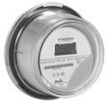
OpenWay and TMS
IEE
MDUS
SAP

Business Solution Overview Narrative
The Business Solution is to install AMI Meters for electric accounts and recording endpoints for Gas meters. The data is collected via TMS (Electric) and OpenWay (Electric) and passed to the meter data management system (IEE). IEE handles validation of the data, data stream for web presentment and distribution to downstream systems. SAP handles the billing of customer accounts.

CE Departments Affected
The following departments will be affected by the implementation of the new IEE MDM applications.
- Metering Technology Center (MTC) - Receiving Personnel
- Mass Deployment Cross Docks - Receiving Personnel
- Purchasing & Supply Chain Management
- Smart Grid Operations Center (SGOC)
- Business Technology Solutions (BTS)
- Smart Grid Field Implementation & Deployment (SGFID) employees
- Customer Billing

Systems Affected
System ID | System Name | System Description
Itron | TMS | Transaction Management System
Itron | OpenWay | Open Way Collection Engine
Itron | IEE MDM | Meter Data Management
Itron | IEE MDM | Meter Data Unification & Synchronization System - ITRON Enterprise Edition
SAP | ES | SAP Enterprise Services
SAP | QM | SAP Quality Management
SAP | ERP-MM | SAP Enterprise Resource Planning-Materials Management
SAP | DM | SAP Device Management
SAP | RM | SAP Revenue Management
SAP | TS | SAP Technical Services
SAP | WM | SAP Work Management
VEE-Ops Reports | Operational Reports Set | Bit Stew Grid Director
GE | ESM | The electric smart meter
Bitstew | Grid Director | Bitstew's application to manage analytical tools and dashboards
WECO | WECO

Device Acquisition

Summary
Device Acquisition encompasses the Supply Chain (SC) & Quality Management (QM) activities which will jointly be used by the Smart Grid Program and the Metering Technology Center (MTC) for new device purchases. This process starts after the creation of a Purchase Order has been completed and communicated to the vendor. These were existing MTC processes that are currently being modified by DLM to support the SAP-QM replacement of MED/MIRA as well as the known Smart Grid Field Implementation & Deployment and Meter Installation Vendor (MIV) [i.e., Corix] requirements resulting from the DLM Blueprinting workshops. As an outcome of the SG July Release workshop for Meter Receipt & Device Creation, the Device Acquisition process is being updated to reflect the SAP interaction with the Smart Grid Systems, such as Meter Data Management (MDM) System and Advanced Metering Infrastructure (AMI) Head End System.

Business Process Flow
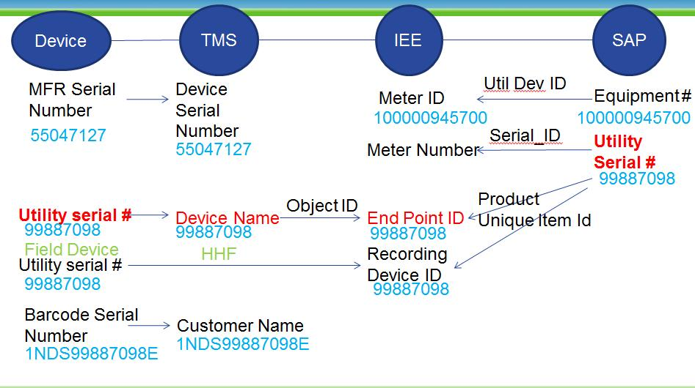

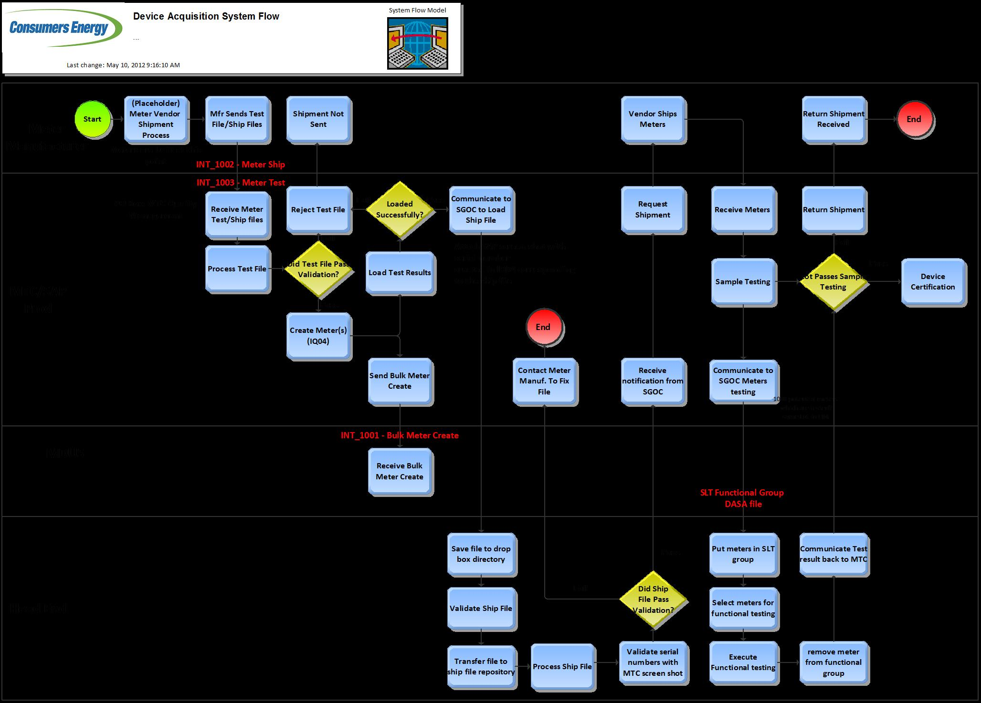

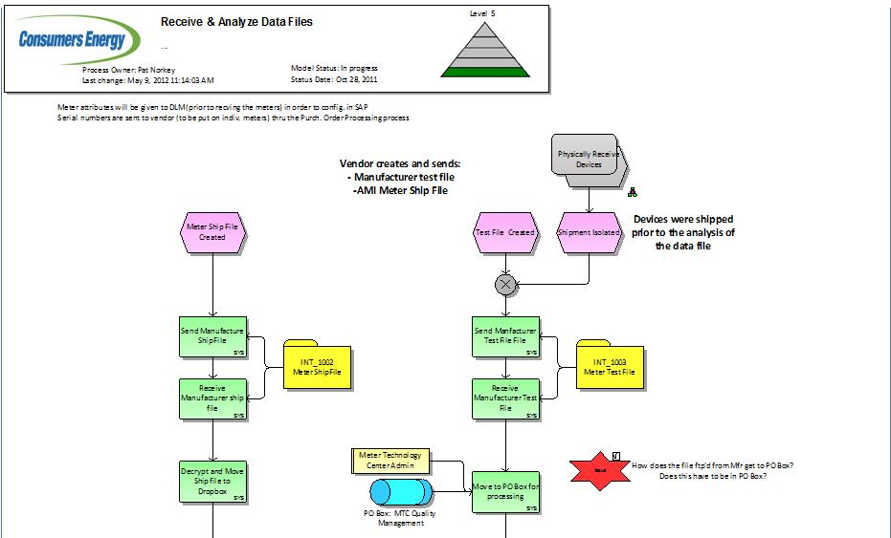

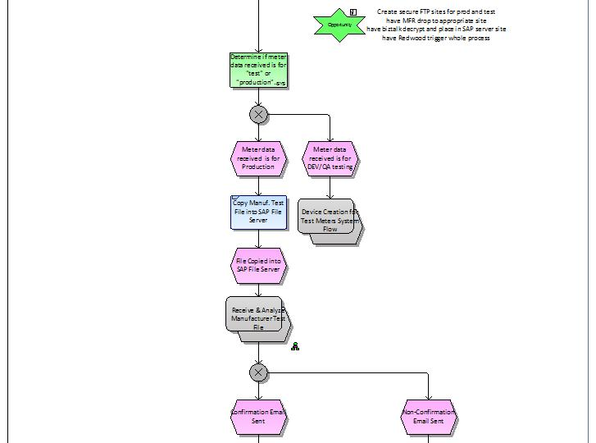

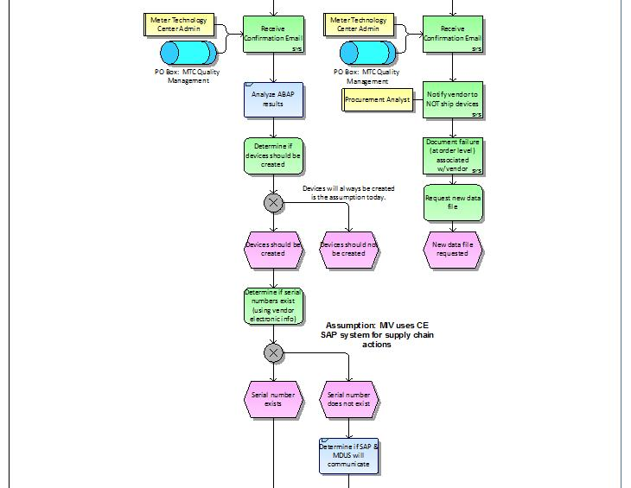

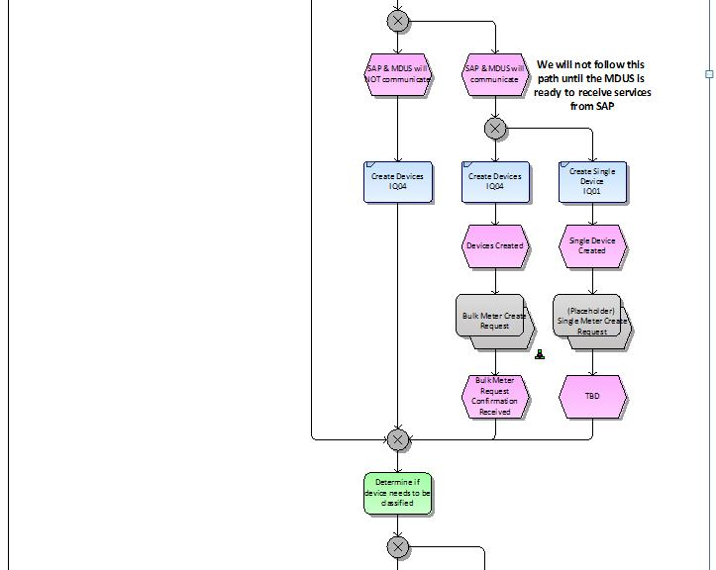

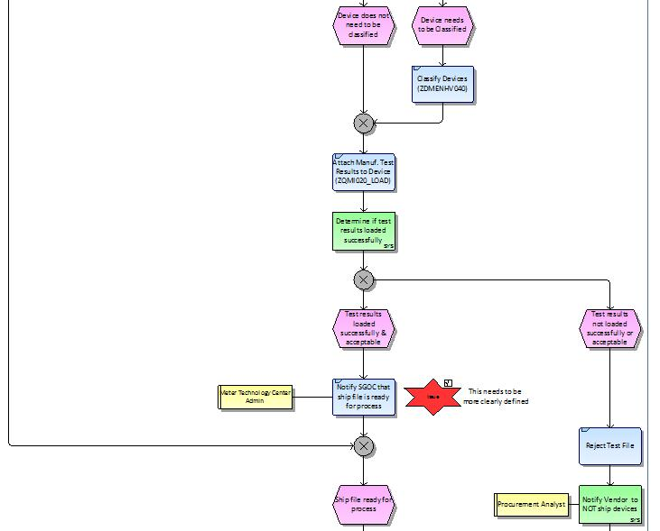

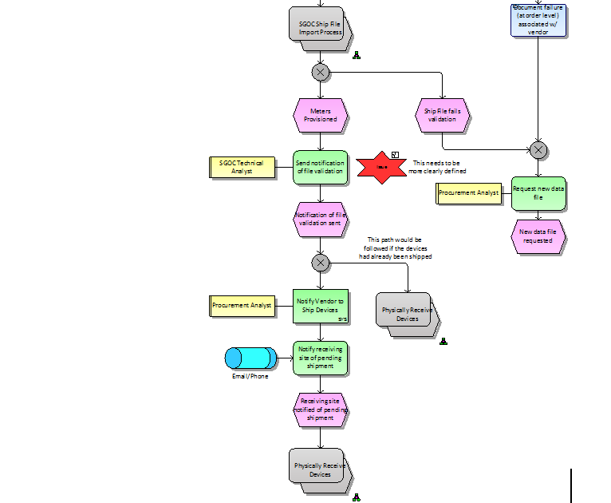
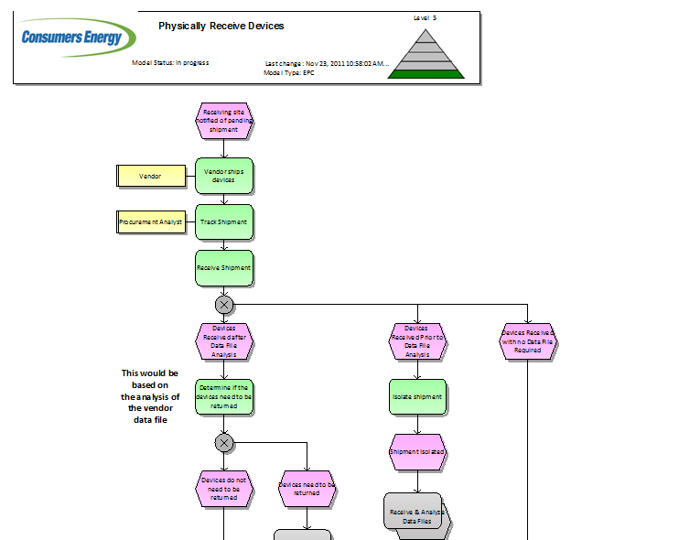

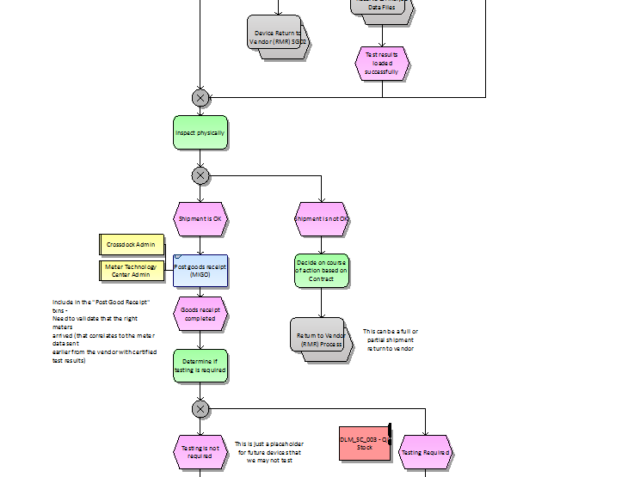

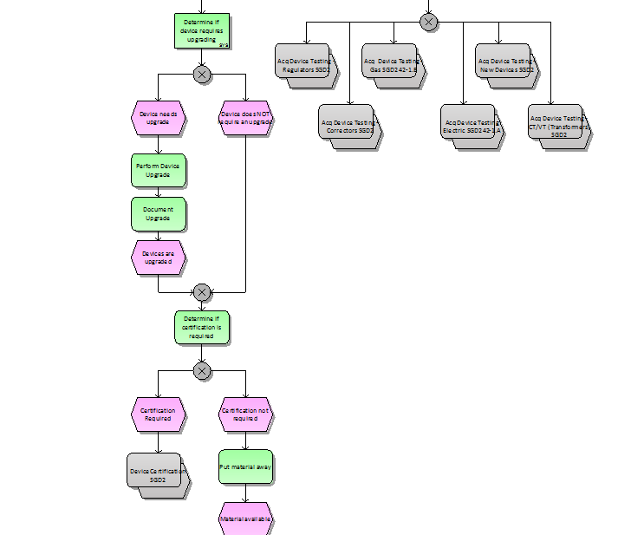
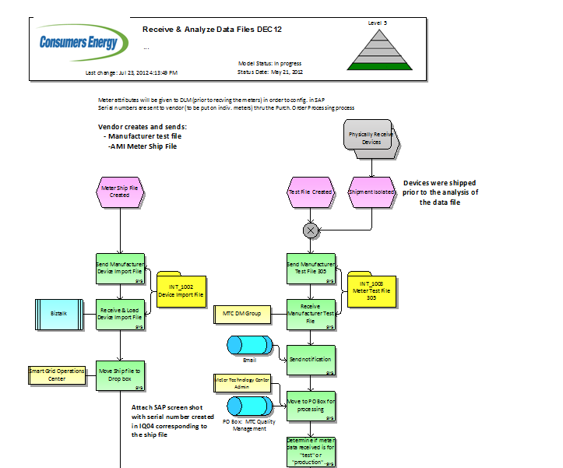
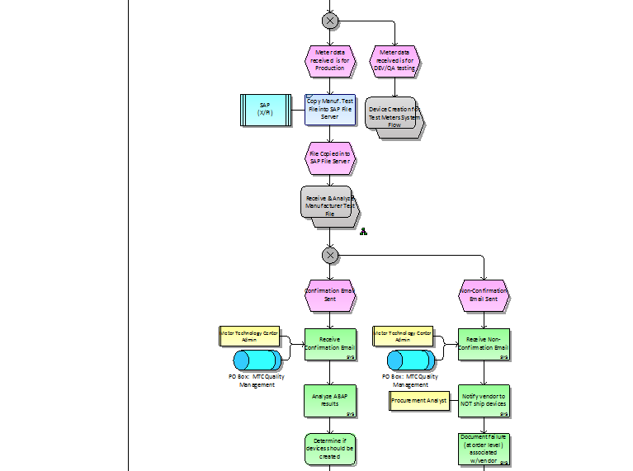

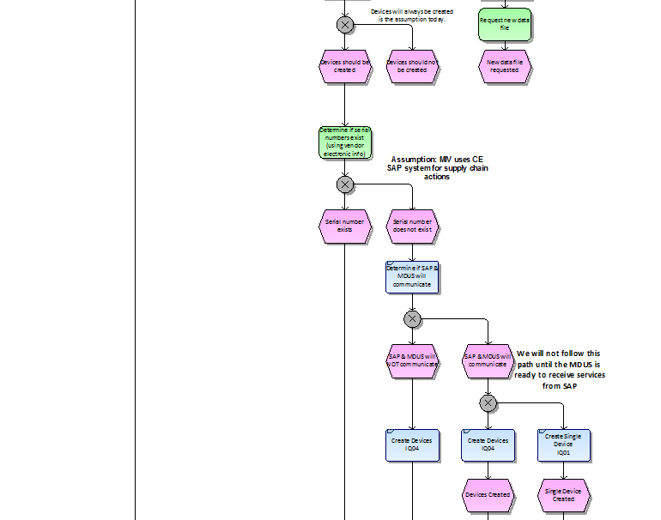
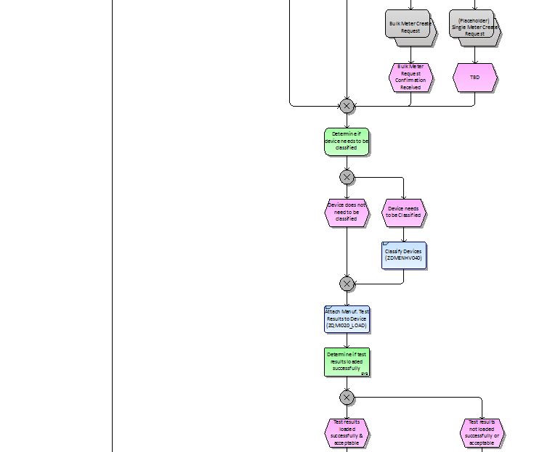
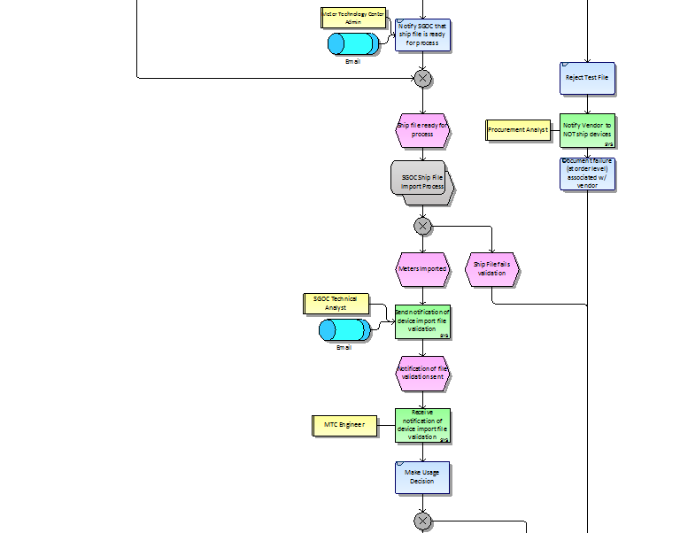
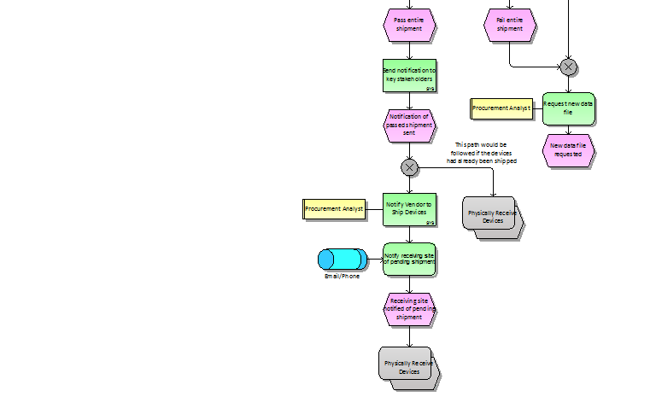

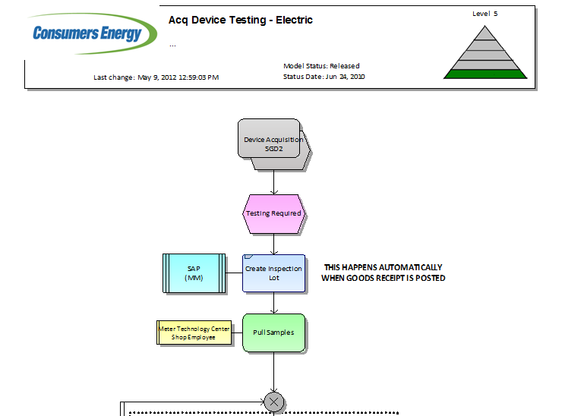

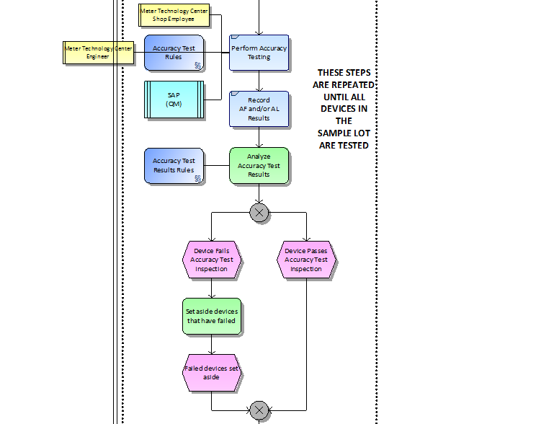

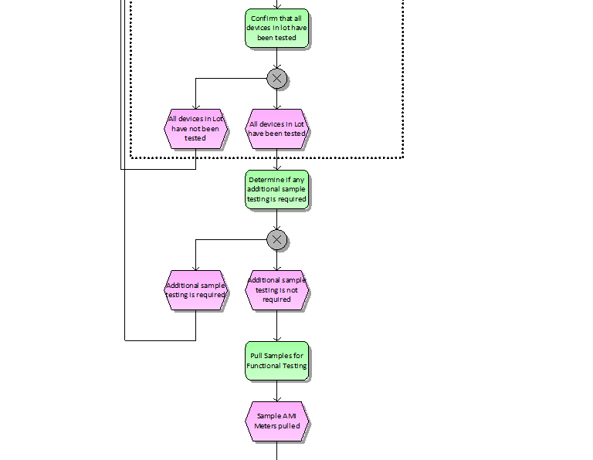
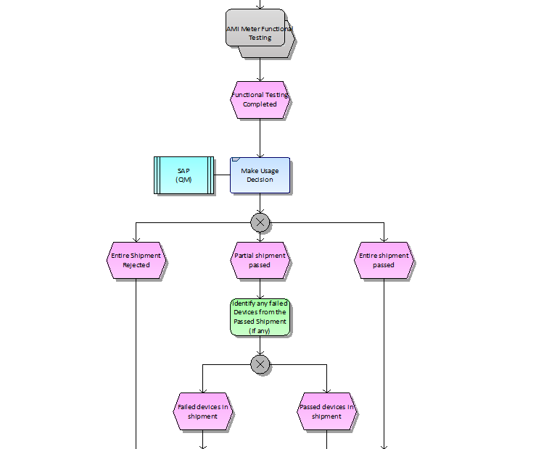
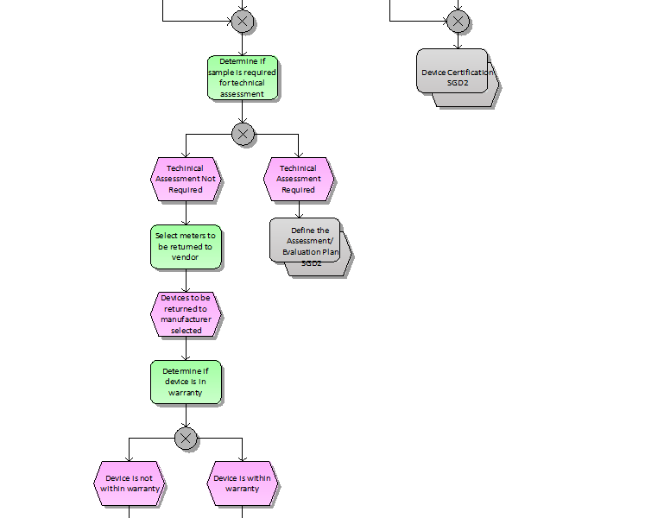
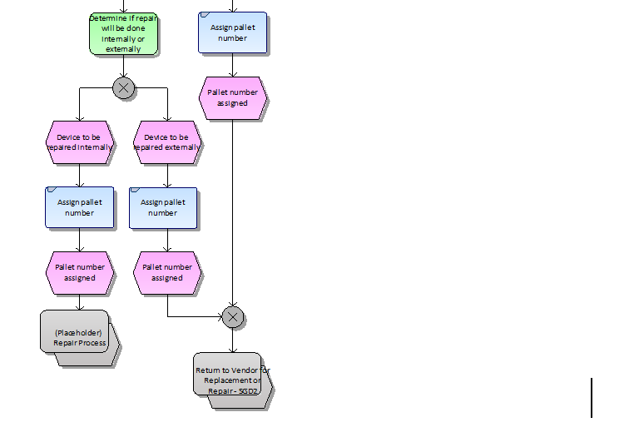

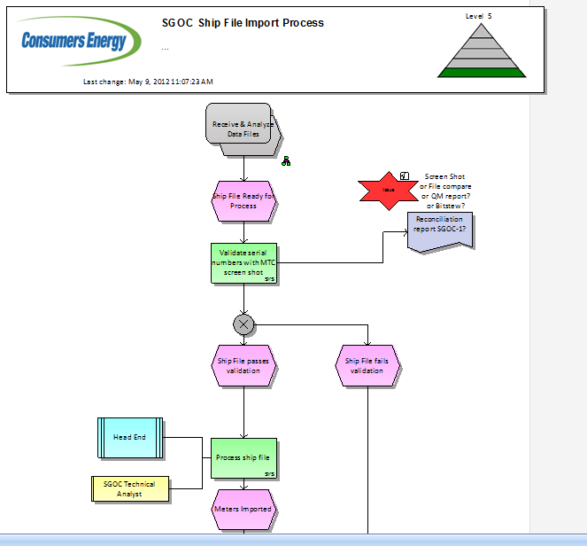
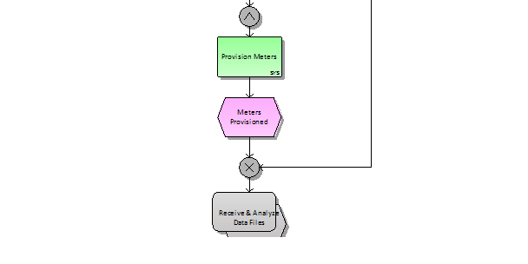

Business Process
The Device Acquisition process for Smart Grid devices begins with the Meter Manufacturer providing to Consumers Energy a Ship File (for the Head End) along with a Manufacturer Test File (for SAP). The Manufacturer Test File is first validated and analyzed by the SAP system to determine if the results are in alignment with the business user defined SAP file format and master data. The SAP system then generates an output of the file format validation as well as a statistical comparison. MTC business users will then manually review the SAP output and decide whether to proceed with the creation of the devices in SAP. If file format validation is acceptable, device master records are created in SAP to support the upload of the test results. MTC business users will then manually review the SAP output of the QM results recording and manually determine whether the results will be passed or failed. The MTC business user then manually performs a usage decision in SAP to record the accept/reject decision for the test file results. This portion of the process includes existing system functionality from March 2012.

The Device Acquisition process was enhanced in the July 2012 release to provide device master record information to the Head End and MDUS systems. After new device master data records are created in SAP, the information will be provided to the MDUS system. After the manufacturer test results are loaded successfully into SAP, a Head End operator will then manually import the Ship File information into the Head End system.

The following are key elements of the Device Acquisition process:
-Receipt of the Manufacturer Test File & Meter Ship File.
-Validation of the Manufacturer Test File and Analysis of Statistical Comparison
-Creation and Classification of Devices in SAP
-Creation of the Device Master Data in the MDUS System
-Manufacturer Test File Results Recording via QM_INT_020
-QM Usage Decision Based on Analysis of Upload Results
-Transmission of the Meter Ship File to the Head End
-Creation of the Device Master Data in the AMI Head End System
-Communication to Vendor (i.e. Approval to Ship, Request for new file, etc.)
-Physical Shipment and Receipt of the Material
-Goods Receipt and Sample Testing Inspection Lot Creation in SAP

Device Acquisition Requirements List for December
Req # | Requirement Description | Doc Xref | Solution
SGR02720-G | The Meter ship file sent to SAP shall be verified against the Meter test file. | W1_SC-050-050 Device Acquisition (2) | Itron will develop a query to produce a .csv file that contains MeterID, MeterNumber, EndpointID, StatusID, MeterProgramID, EffectiveStartDate, EffectiveEndDate, DeviceID, EffectiveStartDate, EffectiveEndDate, ServicePointID
SGR02755-G | The Utility Serial Number shall be used to uniquely identify a meter. | W1_SC-050-050 Device Acquisition (2) | IEE will utilize the Utility Serial Number to uniquely identify each meter ID, endpoint ID, and recorder ID as received from SAP.  CE assumes Itron IEE and Itron ICS will develop and deliver a solution that uses the 8 digit Consumers Energy provided Utility Serial Number as a Key to link all data between TMS and IEE.
SGOC-1 | BitStew report comparing Meter Ship file to Meter Test file, also comparing Meter ID (Utility Serial Number) between SAP and MDM. See TS-030-101 SGOC Reports PP4 for full detail. | W1_SC-050-050 Device Acquisition (2) | Itron will develop a query to produce a .csv file that contains MeterID, MeterNumber, EndpointID, StatusID, MeterProgramID, EffectiveStartDate, EffectiveEndDate, DeviceID, EffectiveStartDate, EffectiveEndDate, ServicePointID
ENH_SN01 | Modify SAP to map Utility Serial Number to UIID to pass to IEE for endpoint ID and recorder ID. | W1_SC-050-050 Device Acquisition (2) | ISAIM will map the UIID to pass to IEE for the meter ID, Endpoint ID, and Recorder ID for electric services.
ENH_SN02 | Modify IEE to match TMS Device Name to EndPoint ID and Recorder ID in IEE | W1_SC-050-050 Device Acquisition (2) | TMS will map the UIID to pass to IEE for the meter ID, Endpoint ID, and Recorder ID for electric services.

Outstanding Issues for IEE
Req # | Requirement Description | Doc Xref | Solution
 | None identified.

Gaps Identified for IEE
Req # | Requirement Description | Doc Xref | Solution
 | None identified.

Meter Registration

Summary
Device installation and registration of smart meters involves a complex series of interactions between SAP, the MDM, the Head End (HE), the Carrier network, and the Electric Smart Meter. This process starts, on one end, as work orders are field completed by CE or as the MIV post install file is processed. This triggers the appropriate services from SAP to inform the MDM of the various measurements required as well as the device location information. SAP will also need to notify the Head End of the installed or removed AMI meters.

Meanwhile, an electric smart meter is installed which should begin communicating with AMI Network. Please refer to the Meter Data Capture process for more information. It is assumed that the newly installed meter will already be identified in the AMI Head End.

The following processes depict the install, remove, and replace scenarios:
WM-080-100 AMI Meter Registration - AMI to AMI Replace
WM-080-110 AMI Meter Registration - Meter Removal
WM-080-120 AMI Meter Registration - New Meter Set
WM-080-130 AMI Meter Registration - Replace AMI with Conventional
WM-080-140 AMI Meter Registration - Replace Conventional with AMI
These scenarios, while different, employ many of the same interfaces.

To support this process and any exceptions that arise, a number of reports are required to manage the reconciliation of the meters as they move through this process.

Business Process Flow
Data inserts and updates are based on synchronization transactions provided by SAP to the IEE MDM. SAP sends the meter and service point information through web-services to the IEE application. IEE processes that information and returns a confirmation. In some instances, such as mixed meters, once a meter has meter readings loaded against it, then manual intervention may be required to correct any mistakes made in the field. A reconciliation process is defined to submit a list of meters and service points to Bitstew for comparison against the SAP meter and service points installed to insure data consistency between applications. The process will also compare installations against the TMS and OpenWay Head End applications as well. No direct updates are required between OpenWay or TMS and IEE. It is CE’s responsibility to maintain data integrity between the applications.

Business Process

Meter Registration Requirements List for December
Req # | Requirement Description | Doc Xref | Solution
N/A | New device attributes associated with kV2c meters are for informational purposes and can be added as a device characteristic. | W3_WM-080-150 Meter Registration | Out of scope for December 2012
N/A | kV2c Testing attributes fall within Master Inspection Characteristics (MICs). | W3_WM-080-150 Meter Registration | Out of scope for December 2012
N/A | Meter configuration required for kV2c meters to be carried through the acquisition, installation and registration process within SAP will be covered in the "Meter Config for single and polyphase" documentation (Deliverable name: Proposed Billing and Usage Measurements for the AMI Poly Phase (ESM) Electric Smart Service Meters). | W3_WM-080-150 Meter Registration | Out of scope for December 2012
N/A | CE assumes Itron IEE and Itron ICS will develop and deliver a solution that uses the 8 digit Consumers Energy provided Utility Serial Number as a Key to link all data between TMS and IEE | W3_WM-080-150 Meter Registration | Utility Serial Number will be used as a common key between the IEE and TMS applications. Recorder ID and Endpoint ID will be populated from SAP and allow IEE to correctly accept events and readings from TMS.
SGR01240-G | Need to reconcile meter measurements between the MDM, SAP, and the Head End as part of meter installation | W3_WM-080-150 Meter Registration | Data comparison between Neptune manual reads and AMI reads will be manual for December. In future releases, this will be automated (SGOC-9, DM_INT_460).
SGR02755-G | The Utility Serial Number shall be used to uniquely identify a meter. | W3_WM-080-150 Meter Registration | Utility Serial Number will be used as a common key between the IEE and TMS applications. Recorder ID and Endpoint ID will be populated from SAP and allow IEE to correctly accept events and readings from TMS.
SGR02862-G | SGOC needs to know whether a meter is retired or not | W3_WM-080-150 Meter Registration | Meter retired in IEE will be set to ‘Decommissioned’ state. This information must be passed from SAP to IEE.
SGR03297-G | SGOC must be able to reconcile all meter installs and meter removals between SAP, MDM, and Head End. | W3_WM-080-150 Meter Registration | Itron will develop a query to produce a .csv file that contains MeterID, MeterNumber, EndpointID, StatusID, MeterProgramID, EffectiveStartDate, EffectiveEndDate, DeviceID, EffectiveStartDate, EffectiveEndDate, ServicePointID
SGR03753-G | MDM needs to convert pulse data received by meter data collection system to engineering units using the pulse multiplier corresponding to the meter class. | W3_WM-080-150 Meter Registration | Meter programs will be passed from SAP to IEE via the meter program ID. Values will consist of RegisterGroup_MaterialPartNumber (MPN). These same values will be configured in IEE with each channel defined with the proper multiplier information to allow Raw Pulses to convert to Engineering Units as the meter readings are loaded into IEE. Multipliers will consist of the meter pulse multiplier *channel weight. For example a pulse multiplier of .5 and a channel weight of 4 will equal a multiplier of 2 within IEE.
SGR03297-Control | The MDM, HE and SAP shall have the ability to extract the meter registration data so that it can be reconciled between each system. | W3_WM-080-150 Meter Registration | Itron will develop a query to produce a .csv file that contains MeterID, MeterNumber, EndpointID, StatusID, MeterProgramID, EffectiveStartDate, EffectiveEndDate, DeviceID, EffectiveStartDate, EffectiveEndDate, ServicePointID
SGOC-2 | Meter Install/Registration Reconciliation Report (see TS-030-101 SGOC Reports PP4 for full detail) | W3_WM-080-150 Meter Registration | Itron will develop a query to produce a .csv file that contains MeterID, MeterNumber, EndpointID, StatusID, MeterProgramID, EffectiveStartDate, EffectiveEndDate, DeviceID, EffectiveStartDate, EffectiveEndDate, ServicePointID
CON_3001 | Write a program to convert Mtr Mft Pulse Mult to existing AMI devices for “Devise Class”. | W3_WM-080-150 Meter Registration | Itron will configure the meter and service point programs to include the device class as a part of the meter program and service point program names to match what is being sent from SAP. Each program will have unique multipliers to convert from pulse to kilowatt hours or the appropriate values.
INT_SN01 | TMS to IEE cXML interface must be changed to support using Device Utility Serial Number (Device Name) and be implemented and tested with IEE.  NOTE: This is already under development. No additional change is being requested, as this is here for documentation purposes only. | W3_WM-080-150 Meter Registration | The recorder ID, endpoint ID and Meter Number will contain the Utility Serial Number. TMS will send information using the same number as the endpoint ID.
ENH_3001 | Register Create, Register Change, and Replication services need to be modified to include additional reference to which pulse multiplier to use (likely Material number- register group combination). DM_INT_450 is the AMI registration services PP6. (Change the Services to add the code to append the new characteristic - New Badi to append the Characteristic to the register group field.)  NOTE: This is already under development. No additional change is being requested, as this is here for documentation purposes only. | W3_WM-080-150 Meter Registration | Itron will accept the additional information from SAP and load the meter/service points accordingly. See details on CON_3001.
ENH_SN01 | Modify SAP to map Utility Serial Number to UIID to pass to IEE for endpoint ID and recorder ID.  NOTE: This is already under development. No additional change is being requested, as this is here for documentation purposes only. | W3_WM-080-150 Meter Registration | SAP will send the utility serial number to IEE to be stored in the recorder ID, endpoint ID and Meter Number.
ENH_SN02 | Modify IEE to map TMS Device Name to EndPointID and RecorderID in IEE.  NOTE: This is already under development. No additional change is being requested, as this is here for documentation purposes only. | W3_WM-080-150 Meter Registration | The recorder ID, endpoint ID and Meter Number will contain the Utility Serial Number. TMS will send information using the same number as the endpoint ID.
SGR02778 | MDM shall send a meter registered notification to SAP for each meter installed in SAP that is communicating with the Head End. | W3_WM-080-150 Meter Registration | IEE will return a confirmation of transaction received notice to SAP as well as any error messages that are generated as a result of processing a synchronization transaction. Installation of a meter record in IEE constitutes a registered meter.
SGR03576 | The Meter Create service call between SAP and MDM shall be monitored | W3_WM-080-150 Meter Registration | Errors for synchronization will be reported in the IEE Task Monitor as well as the SAP queue. Consumers Energy will need to assign someone to review this on a daily basis.
SGR03579 | Data shared between SAP and MDM for meter create service shall be reconciled and synchronized. | W3_WM-080-150 Meter Registration | IEE will produce a daily extract of meters to be sent to Bitstew Grid Director for the reconciliation.
SGR03577 | The Meter Install service call between SAP and MDM needs to be monitored | W3_WM-080-150 Meter Registration | Transactions sent through the Web Services will return error messages to the originating application. The web services log should be monitored for failures.
SGR03578 | The Register Create service call between SAP and MDM needs to be monitored | W3_WM-080-150 Meter Registration | Transactions sent through the Web Services will return error messages to the originating application. The web services log should be monitored for failures.
SGR03580 | Data shared between SAP and MDM for register create service needs to be reconciled and synchronized. | W3_WM-080-150 Meter Registration | Itron will develop a query to produce a .csv file that contains MeterID, MeterNumber, EndpointID, StatusID, MeterProgramID, EffectiveStartDate, EffectiveEndDate, DeviceID, EffectiveStartDate, EffectiveEndDate, ServicePointID
SGR03581 | Data shared between SAP and MDM for meter install service needs to be reconciled and synchronized. | W3_WM-080-150 Meter Registration | Itron will develop a query to produce a .csv file that contains MeterID, MeterNumber, EndpointID, StatusID, MeterProgramID, EffectiveStartDate, EffectiveEndDate, DeviceID, EffectiveStartDate, EffectiveEndDate, ServicePointID
SGR03777-G | Meter Programs shall be uniquely identified based on Meter Type, Meter Class, Multipliers, Time-of-Use Schedules, and Interval Length. | W3_WM-080-150 Meter Registration | Meter and service point programs will be set up accordingly in the IEE application. See CON_3001 for details.
SGR03778-G | The meter program ID passed between IEE and SAP shall include the register group and material part number (for example ESM_A_30122516). | W3_WM-080-150 Meter Registration | Meter and service point programs will be set up with the register group and material part number as program names. Details will be provided by SAP configuration group to ensure that programs match as they are passed from one application to another.
SGR03780 | MDM shall have time of use schedules defined to include a no holiday schedule and a holiday weekend schedule. | W3 Device Installation and Registration | Holiday schedules will be configured as follows:  New Year’s Day - January 1,  Memorial Day - Last Monday in May,  Independence Day - July 4,  Labor Day - First Monday in September,  Thanksgiving Day - Fourth Thursday in November  Christmas Day - December 25  Note: Whenever January 1, July 4, or December 25 falls on Sunday, extended holiday periods such as Monday, January 2, Monday, July 5 and Monday, December 26 shall not be considered as holidays for application of off-peak hours.

Outstanding Issues for IEE
Req # | Requirement Description | Doc Xref | Solution
N/A | Conversion of current meter programs to new meter programs as a result of changes based on SGR03753-G. |  | IEE will be required to develop an update process that changes all existing ESM_A meter programs to match the ESM_A_(MPN) programs.

Gaps Identified for IEE
Req # | Requirement Description | Doc Xref | Solution
 | None identified

Data Capture

Summary
Success is defined by having the interval data, midnight register data, and event data in the MDM.

Meter Data Capture is the process of collecting data in the Head Ends (OpenWay and TMS) from electric smart meters (ESM) installed at customer premises. The process begins once the meter is communicating with the Head Ends (OpenWay and TMS) and is in the installed group after importing the install DASA file from SAP. When the meter is in the installed group, a daily read schedule is passed down to the meter.

The deployed schedules will execute and send the meter data to the Head End on an optimized schedule. Upon receipt of the meter data in the Head End, the Head End will publish the data to the MDM. The Interface defined for December 2012 to send the meter event data from TMS (the Head End) to the MDM is INT_016 Publish Server Event. The interface defined for December 2012 to send the interval and register meter read data from TMS (the Head End) to the MDM is INT_021 Publish Meter Read Data.

Meter Data as defined is load profile data (interval data), register data including the self-read captured by the meter at midnight and the current registers, and all event data regardless of source (meter and Head End).

This process ends with the MDM collecting the meter data published from the Head Ends (OpenWay and TMS).

The key elements of the Meter Data Capture process are:
Standard Process
• The ship file/Device Import File (DIF) is imported into the Head Ends (OpenWay and TMS). Note that for OpenWay this is done through Web Services.
• The meter is installed in the field and communicates with the Head End.
• The install DASA file from SAP is loaded into the Head Ends (OpenWay and TMS). Note that for OpenWay this is done through Web Services.
• The schedules are deployed to the meter.
• The schedules are executed on the meter collecting the meter data
• The meter data is then sent on an optimized schedule to the Head End
• Upon receipt of the meter data at the Head End, the Head End publishes the meter data to the MDM.
• For December 2012, meter event data will be published. (INT_016 Publish Server Event)
• For December 2012, interval and register meter read data will be published. (INT_021 Publish Meter Read Data)
• This process applies to Every Meter, Every day.

Exception Handling
Meters that do not communicate as scheduled fall under the exception handling process. These meters will be assessed and triaged to determine cause of the exception. The exception process is TS-010-010 Event Handling

Business Process Flow

Business Process
Meters are created through SAP using the ship files from the vendor. Data is then synchronized with IEE to establish meters and service points. SAP also sends a file to the TMS for valid meters to be established. Web services will be used to accomplish the same in OpenWay. When readings and events are received from the meter, TMS and OpenWay will forward that data to IEE matching on the Utility Serial Number.

Data Capture Requirements List for December
Req # | Requirement Description | Doc Xref | Solution
SGR00635 | The MDM shall retain all interval meter data (raw, validated, estimated, and edited) for the required seven year retention period. (REQ0066) | W8.2-WM-050-150 Data Capture | Until the purge process is defined, all data will be kept indefinitely in IEE MDM. All data will be available to users. This is standard functionality.
SGR00638 | The MDM shall retain all meter register data (raw, validated, estimated, and edited) based on the required seven year retention period. (REQ0070) | W8.2-WM-050-150 Data Capture | Until the purge process is defined, all data will be kept indefinitely in IEE MDM. All data will be available to users. This is standard functionality.
SGR00672 | The MDM shall record the source (the how) of all meter data (e.g. default retrieval process, on-demand/exception process, manual upload, etc.). | W8.2-WM-050-150 Data Capture | As data is loaded, IEE tracks the file received as well as the external system ID of each reading and event loaded.
SGR00720 | The MDM shall track the read source ("from where") of collected data (AMI System devices, Field Tools, Personnel, etc.). | W8.2-WM-050-150 Data Capture | As data is loaded, IEE tracks the file received as well as the external system ID of each reading and event loaded.
SGR00787 | The MDM shall make all meter data received from the AMI Head End available to other utility systems upon receipt. (REQ0428) | W8.2-WM-050-150 Data Capture | Users will be configured for external applications to extract data via web-services or extracts will be provided to applications for use. Biztalk will be used to transport extracts after creation.  Extracts are defined where data requirements are provided.
SGR00873 SGR00873-G  INT_8021 | The AMI Head End shall be able to transmit all meter read data (registers, intervals) received from the meter to the MDM.(REQ0562) | W8.2-WM-050-150 Data Capture | MDM will convert the meter readings from CXML to PBC XML and load the data into the database. A conversion interface must be developed.
SGR01064 | Data shall be stored in the MDM in a manner that would allow all meter data to be supplied to connected systems for the entire seven year retention period. | W8.2-WM-050-150 Data Capture | Until the purge process is defined, all data will be kept indefinitely in IEE MDM. All data will be available to users. This is standard functionality.  Users will be configured for external applications to extract data via web-services or extracts will be provided to applications for use. Biztalk will be used to transport extracts after creation.  Extracts are defined where data requirements are provided.
SGR01309 | The MDM shall be able to consume the data sent by the Head End and report issues when this is not possible. | W8.2-WM-050-150 Data Capture | Errors on import will be contained in the IEE logs. Validation errors will be logged in the validation queue and logs.
SGR02755  SGR02755-G | The Utility Serial Number shall be used to uniquely identify a meter. | W8.2-WM-050-150 Data Capture | SAP is sending the Utility serial number to IEE as the meter ID.
SGR03335  SGR03335-G | The MDM shall capture both on schedule and off schedule meter reading data. | W8.2-WM-050-150 Data Capture | IEE will capture any and all data transmitted by the head-end and hand held devices. This is standard functionality.
SGR03359 | The MDM shall prevent any user from editing raw meter data. | W8.2-WM-050-150 Data Capture | IEE can be configured to prevent usage, but other requirements within the document require update for correcting mixed meters or delayed meter exchanges.
SGR03406-Control | The MDM shall have the ability to store all meter read data. | W8.2-WM-050-150 Data Capture | Until the purge process is defined, all data will be kept indefinitely in IEE MDM. All data will be available to users. This is standard functionality.
SGR03407-Control | The MDM shall have the ability to export/report all meter read data. | W8.2-WM-050-150 Data Capture | The IBM Change Data Capture tool will be installed and utilized to scrape the database log files.
SGR03408-Control | The MDM shall have the ability to limit who can modify/delete the meter read data. | W8.2-WM-050-150 Data Capture | IEE MDM roles will be configured based on the spreadsheet included in phase I. End users will be assigned roles granting privileges based on their supervisor’s instructions.
SGR03409-Control | The MDM shall have the ability to log the following attributes if meter data is modified: who, what, when. | W8.2-WM-050-150 Data Capture | IEE audits and keeps a log of all data changed, the user who changed, and the date/time of the change. This is baseline functionality.
SGR03410-Control | The MDM shall have the ability to lock the change log from being altered by any user. | W8.2-WM-050-150 Data Capture | IEE audit logs are read only. Only the application itself can write to those logs.
SGR03411-Control | The MDM shall have the ability to limit who can make configuration modifications within the application. | W8.2-WM-050-150 Data Capture | IEE MDM roles will be configured based on the spreadsheet included in phase I. End users will be assigned roles granting privileges based on their supervisor’s instructions.
SGR03471-G  INT_8016 | Head End shall send meter events to the MDM upon receiving them from a meter. | W8.2-WM-050-150 Data Capture | IEE will consume the events translated from TMS through Multispeak. The Multispeak interface will be modified for IEE PBC format.
ENH_SN02 | Modify IEE to map TMS Device Name to EndPointID in IEE | W8.2-WM-050-150 Data Capture | IEE Endpoint ID will be populated based on the data received from SAP. This is baseline functionality.
INT_8016 | TMS to IEE interface to deliver meter event data. | W8.2-WM-050-150 Data Capture | IEE will receive and process the data as the files are transmitted from TMS. An interface will be developed to convert the CXML file to IEE PBC XML format.
INT_8021 | TMS to IEE interface to deliver meter read data (register and interval) | W8.2-WM-050-150 Data Capture | IEE will receive and process the data as the files are transmitted from TMS. An interface will be developed to convert the CXML file to IEE PBC XML format.
INT_SN01 | TMS to IEE cXML interface must be changed to support using Device Utility Serial Number(Device Name) and be implemented and tested with IEE | W8.2-WM-050-150 Data Capture | IEE will receive and process the data as the files are transmitted from TMS. An interface will be developed to convert the CXML file to IEE PBC XML format.

Outstanding Issues for IEE
Req # | Requirement Description | Doc Xref | Solution
SGR03359 | The MDM shall prevent any user from editing raw meter data. | W8.2-WM-050-150 Data Capture | IEE can be configured to prevent usage, but other requirements within the document require update for correcting mixed meters or delayed meter exchanges.

Gaps Identified for IEE
Req # | Requirement Description | Doc Xref | Solution
 | None identified

Smart Meter Billing

Summary
The process for billing using remote readings from electric smart meters (ESM) will be facilitated through a meter read request originating in and sent from SAP to the MDM. Bulk meter read requests for on-cycle portion billing will be utilized. The bulk meter read requests will be sent from SAP to the MDM prior to scheduled billing based upon the predefined read and bill schedule established by Billing Services. MDM will acknowledge the receipt of the request and will process the requests on the meter read date contained in the read request. Once the requests are fulfilled, i.e., register reads and read dates populated, MDM will send back the completed meter read requests to SAP for billing. If ESM data was not available in the MDM, SAP will still estimate the meter readings for billing using existing SAP validation and estimation rules.

Off-cycle billing will follow the same process as on-cycle billing. However, off-cycle billing requests will not be in bulk (i.e., a single meter read request to MDM for the ESM billing determinants (register readings).

Register Self-Read - A snapshot of the defined indexes/registers at a particular time. Current ESM configuration is set or midnight each day (i.e., 00:00:00).

MDM - Meter Data Management system which serves as the central repository for meter event and usage (register reads and interval usage) data collected from all AMI (Advanced Metering Infrastructure) Head-Ends and can be accessed by authorized applications responsible for processing this data.

For December 2012, the capabilities of the Smart Grid system will be extended to bill customers with the register reads collected from the electric smart meters via a Verizon cellular communication network.

Business Process Flow

Business Process
SAP will generate bulk meter requests for meter reads based on the portions (cycles) defined within the SAP application and customer’s requesting final bills. Requests will be sent in batches of 1 to 200,000 per day based on on- and off-cycle processing. Files will pass through the ISAIM adapter to be converted to ABE Requests. The Wait-Until-Date and the Deadline-Date are set within the ISAIM conversion based on an offset that is configured within IEE. When the request can be fulfilled by IEE, it will return the ABE Response to the ISAIM adapter which will convert it back to the format required by SAP. The response conversion will strip out the errors and statistics. If a register reading could not be returned, then nothing is returned to SAP. For requests not fulfilled by IEE, SAP will estimate the register read.

Smart Meter Billing Requirements List for December
Req # | Requirement Description | Doc Xref | Solution
N/A | SAP will send the bulk meter read requests to the MDM using the SAP defined read and bill schedule for each portion (On-Cycle Billing). | W13a_RM-010-140 Smart Meter Billing V1.5 2012.08.21 | Bulk meter reading requests for register reads will be passed to the ISAIM adapter in IEE. These will be converted to ABE Requests and the wait-until-date and deadline dates will be set to the scheduled bill date passed in the file.  Times for wait-until-date and deadline dates are still TBD.
N/A | MDM will verify the SAP meter request and fulfill meter data request to SAP if data exists in MDM | W13a_RM-010-140 Smart Meter Billing V1.5 2012.08.21 | IEE will process the ABE requests by searching from the most current to the oldest reading for the first available within the last 3 days.  ABE Response data will be passed back through the ISAIM adapter. The adapter will strip the statistics and errors and pass valid register reads back to SAP.
N/A | SAP will validate received data from MDM prior to billing | W13a_RM-010-140 Smart Meter Billing V1.5 2012.08.21 | SAP will verify the data coming in from IEE using the same validation that is currently in place.
N/A | SAP will estimate missing register reads from MDM and will bill using existing approved SAP estimation rules | W13a_RM-010-140 Smart Meter Billing V1.5 2012.08.21 | If a meter reading is not received, then SAP will estimate the reading. Estimated reads are not passed back to IEE.
N/A | For December 2012 we will only require the kWh-Delivered Total consumption register read for SAP billing. Customers that will require Time of Use (TOU), Demand and Power Factor register reads will be excluded from billing using ESM | W13a_RM-010-140 Smart Meter Billing V1.5 2012.08.21 | SAP will request and IEE will return only register reads for KWH Delivered during this phase. IEE is collecting additional registers and will return those if requested. Demand reset processes have yet to be determined and will return an invalid value that should not be used for billing.
SGR01305-G | SAP shall be able to make a request to the MDM for the preferred MNRR (Midnight Register Read) batch from one specific date/time for each meter of a billing portion.  The MDM fulfills meter read request per individual register and not by SAP register group.  For the December 2012 release, only the total kWh delivered register read will be requested by SAP to the MDM for billing. | W13a_RM-010-140 Smart Meter Billing V1.5 2012.08.21 | Bulk meter reading requests for register reads will be passed to the ISAIM adapter in IEE. These will be converted to ABE Requests and the wait-until-date and deadline dates will be set to the scheduled bill date passed in the file.  Requests will be sent in batch mode. When all requests are fulfilled in a batch or the deadline date is reached, the file of responses will be generated and returned. IEE does not have the SAP register group, it returns the responses based on the requests by meter channel.  Times for wait-until-date and deadline dates are still TBD.
SGR01307-G | MDM will receive the request from SAP for meter usage data (Register Reads) | W13a_RM-010-140 Smart Meter Billing V1.5 2012.08.21 | Bulk meter reading requests for register reads will be passed to the ISAIM adapter in IEE. These will be converted to ABE Requests and the wait-until-date and deadline dates will be set to the scheduled bill date passed in the file.  Requests will be sent in batch mode. When all requests are fulfilled in a batch or the deadline date is reached, the file of responses will be generated and returned. IEE does not have the SAP register group, it returns the responses based on the requests by meter channel.  Times for wait-until-date and deadline dates are still TBD.
SGR01325-G | On the scheduled bill date for the service delivery point, MDM shall determine if it currently contains the MNRR that meets the specified criteria from SAP as contained in the meter read request.  The MDM fulfills meter read request per individual register and not by SAP register group.  For the December 2012 release, only the kWh delivered total register read will be requested by SAP from the MDM for billing. | W13a_RM-010-140 Smart Meter Billing V1.5 2012.08.21 | Upon receipt of a request and maturation of wait-until-date, the MDM will attempt to pull the midnight register read for the scheduled bill date. If the midnight register read is not available, it will search from newest to oldest through the past three days for a register reading. If one is found, it will be substituted for the midnight register read. If it is not found, an error message will be returned in the ABE response indicating no register read was available.  Times for wait-until-date and deadline dates are still TBD.
SGR01327-G | MDM will fulfill the Register Read request from SAP when the required register reads are available in the scheduled read window within MDM.  MDM will fulfill (provide register readings) a meter read request in the following order:  1. Select the midnight register reading/readings of the scheduled bill date (a/k/a Hot Portion read date). If this reading or readings are not available, then:  2. Select the midnight register reading/readings of the scheduled bill date minus one calendar day. If this reading or readings are not available, then:  3. Select the midnight register reading/readings of the scheduled bill date minus two calendar days. If this reading or readings are not available, then:  4. If no register reading/readings are available during the three day read window, the MDM shall mark meter read requests with an error code. | W13a_RM-010-140 Smart Meter Billing V1.5 2012.08.21 | If no register readings are available in MDM during the three day read window then no register readings will be passed to SAP and SAP continues to estimate the register reading using existing approved validation and estimation rules.  The MDM fulfills meter read request per individual register and not by SAP register group.  Upon receipt of a request and maturation of wait-until-date, the MDM will attempt to pull the midnight register read for the scheduled bill date. If the midnight register read is not available, it will search from newest to oldest through the past three days for a register reading. If one is found, it will be substituted for the midnight register read. If it is not found, an error message will be returned in the ABE response indicating no register read was available.
SGR01329-G | Once SAP receives the requested MNRR data from MDM (fulfilled meter read request for both on-cycle and off-cycle bill request), SAP via a BADI shall modify the MDM register read date by subtracting one calendar day from the register read date. This will be the register read date used for SAP Bill calculation and Bill print. Note: If the most current register read date that is returned from the MDM is not the MNRR but a previous on demand register read by the Head-End that did not occur at midnight then the BADI subtracts one calendar day from the on-demand register read date and this register read will be used for SAP Bill calculation. | W13a_RM-010-140 Smart Meter Billing V1.5 2012.08.21 | Upon receipt of a request and maturation of wait-until-date, the MDM will attempt to pull the midnight register read for the scheduled bill date. If the midnight register read is not available, it will search from newest to oldest through the past three days for a register reading. If one is found, it will be substituted for the midnight register read. If it is not found, an error message will be returned in the ABE response indicating no register read was available.
SGR01908-G | MDM shall be able to process & send single / bulk meter read information data to SAP to fulfill single / bulk meter read request. | W13a_RM-010-140 Smart Meter Billing V1.5 2012.08.21 | IEE will process batches as they are received. If a batch file contains one or 200,000 requests, all requests within a single file must be fulfilled or the deadline date reached before batches are returned to SAP.
SGR02967-G | MDM shall have the capability to fulfill various reverse or rebill meter read requests received from Customer Billing (SAP).  If the MDM cannot provide a register read for either a final bill or a revised bill (cancel/rebill), the assumption is that SAP continues to estimate the register reading using existing approved validation and estimation rules or not bill the account if a number of consecutive estimation or other parameters are exceeded | W13a_RM-010-140 Smart Meter Billing V1.5 2012.08.21 | IEE will return the requested register reads based on the scheduled bill date sent through the bulk meter read requests. On-cycle bills will wait until the wait-until-date matures. Final bills will wait until the wait-until-date matures and send only the midnight reading for the scheduled bill date. Cancel/re-bills are processed based on the scheduled bill date in the past. Failure to find a register reading for the channel requested will result in an error message being returned.
SGR03404-G | MDM shall be able to fulfill SAP Meter Read Request based on register batch.  The MDM fulfills a meter read request by individual register and not by SAP register group. | W13a_RM-010-140 Smart Meter Billing V1.5 2012.08.21 | IEE will process batches as they are received. If a batch file contains one or 200,000 requests, all requests within a single file must be fulfilled or the deadline date reached before batches are returned to SAP.
SGR03414-G | SGOC shall be able to produce a report of unfulfilled meter read requests (exceptions only) from the MDM. This shall be a daily report based on Bill Portion Cycle. It shall contain at a minimum: the Service Delivery Point, Portion, Scheduled Bill Date, Scheduled Read Date, and Actual Read Date provided in the fulfilled meter read request.  The standard MDM ABE Monitor will list the read requests from SAP and the standard MDM validation queue will list which meters that the MDM could not provide meter readings. | W13a_RM-010-140 Smart Meter Billing V1.5 2012.08.21 | IEE does not contain the Bill Portion Cycle. Based on the scheduled bill date (Request date or deadline date), the MDM is able to produce a report. See example in section J.5.  Itron will provide a report for the following based on the example provided by P. J. Hirth.  -- Overview 1: meters missing readings for all three days  -- Overview 2: total meters to be billed today, grouped by correlation ID, and total readings  -- Detailed view: all meters billing today
SGR03415-G | SGOC shall be able to produce a report upon MDM receipt of a SAP meter read request, which shall identify which requests can either be fulfilled or not fulfilled by the MDM. It shall be a daily report based on the meter read requests sent from SAP. | W13a_RM-010-140 Smart Meter Billing V1.5 2012.08.21 | See example in section J.5.  Itron will provide a report for the following based on the example provided by P. J. Hirth.  -- Overview 1: meters missing readings for all three days  -- Overview 2: total meters to be billed today, grouped by correlation ID, and total readings  -- Detailed view: all meters billing today
SGR03430-G | SGOC shall be able to produce a report upon SAP receipt of a MDM meter read request confirmation (positive or negative). This shall identify which requests can either be fulfilled or not fulfilled by the MDM. It shall be worked daily by SGOC using a defined procedure / process. | W13a_RM-010-140 Smart Meter Billing V1.5 2012.08.21 | See example in section J.5.  Itron will provide a report for the following based on the example provided by P. J. Hirth.  -- Overview 1: meters missing readings for all three days  -- Overview 2: total meters to be billed today, grouped by correlation ID, and total readings  -- Detailed view: all meters billing today
SGR03432-Control-G | SAP shall have the ability to request meter data from the MDM and the requested register read date for either on-cycle or off-cycle billing. | W13a_RM-010-140 Smart Meter Billing V1.5 2012.08.21 | IEE will return the requested register reads based on the scheduled bill date sent through the bulk meter read requests. On-cycle bills will wait until the wait-until-date matures. Final bills will wait until the wait-until-date matures and send only the midnight reading for the scheduled bill date. Cancel/re-bills are processed based on the scheduled bill date in the past. Failure to find a register reading for the channel requested will result in an error message being returned.
SGR03434-Control-G | The MDM shall have the ability to export/report confirmation that the meter read request was received by the MDM. This acknowledgement shall be sent to SAP. | W13a_RM-010-140 Smart Meter Billing V1.5 2012.08.21 | As requests are received from ISAIM/SAP a confirmation will be returned to indicate that the file was received.
SGR03435-Control-G | The MDM shall have the ability to export/report a confirmation of which meter registered reads can/cannot be sent to SAP.  The MDM produces error messages in the ABE XML but are not sent to SAP. Currently SAP has no way to consume the error messages. | W13a_RM-010-140 Smart Meter Billing V1.5 2012.08.21 | See example in section J.5.  Itron will provide a report for the following based on the example provided by P. J. Hirth.  -- Overview 1: meters missing readings for all three days  -- Overview 2: total meters to be billed today, grouped by correlation ID, and total readings  -- Detailed view: all meters billing today
SGR03436-Control-G | When the “date for billing” attribute equals the current date, the MDM shall have the ability to send the most current register read data to SAP via the meter read document. | W13a_RM-010-140 Smart Meter Billing V1.5 2012.08.21 | If the request indicates that the midnight read is required, then the scheduled bill date must be updated to tomorrow through the BADI. As soon as the midnight reading is posted, then the response will be sent.
SGR03437-Control-G | SAP shall have the ability to export/report if meter read data is missing for a requested meter read from the MDM.  The standard MDM ABE Monitor will list the read requests from SAP and the standard MDM validation queue will list which meters that the MDM could not provide meter readings.  Currently SAP has no transaction to load the billing cycle into the MDM and associate the bill cycle to a SDP/meter. SGOC will be working the daily exceptions for all meters not reading. | W13a_RM-010-140 Smart Meter Billing V1.5 2012.08.21 | Upon receipt of a request and maturation of wait-until-date, the MDM will attempt to pull the midnight register read for the scheduled bill date. If the midnight register read is not available, it will search from newest to oldest through the past three days for a register reading. If one is found, it will be substituted for the midnight register read. If it is not found, an error message will be returned in the ABE response indicating no register read was available.
SGR03438-G | MDM shall be able to send a meter read fulfillment result to SAP (register readings) based on original meter read request. | W13a_RM-010-140 Smart Meter Billing V1.5 2012.08.21 | Upon receipt of a request and maturation of wait-until-date, the MDM will attempt to pull the midnight register read for the scheduled bill date. If the midnight register read is not available, it will search from newest to oldest through the past three days for a register reading. If one is found, it will be substituted for the midnight register read. If it is not found, an error message will be returned in the ABE response indicating no register read was available.
SGR03485-G | SAP using a BADI, shall have the ability to add one calendar day to the Off-Cycle read date for the dispatched read request to the MDM. The On-Cycle SAP Bulk Read Request to the MDM will also require a BADI to add one calendar day for the dispatched read request to the MDM. | W13a_RM-010-140 Smart Meter Billing V1.5 2012.08.21 | If the request indicates that the midnight read is required, then the scheduled bill date must be updated to tomorrow through the BADI. As soon as the midnight reading is posted, then the response will be sent.
SGR03766-G | The MDM shall have the capability to report active meters for reconciliation purposes. | W13a_RM-010-140 Smart Meter Billing V1.5 2012.08.21 | Itron will develop a query to produce a .csv file that contains MeterID, MeterNumber, EndpointID, StatusID, MeterProgramID, EffectiveStartDate, EffectiveEndDate, DeviceID, EffectiveStartDate, EffectiveEndDate, ServicePointID
SGR03767-G | The MDM shall have the capability to report meters associated to a Service Delivery Point (SDP) for reconciliation purposes. | W13a_RM-010-140 Smart Meter Billing V1.5 2012.08.21 | Itron will develop a query to produce a .csv file that contains MeterID, MeterNumber, EndpointID, StatusID, MeterProgramID, EffectiveStartDate, EffectiveEndDate, DeviceID, EffectiveStartDate, EffectiveEndDate, ServicePointID
SGR03764-G | SAP shall have the capability to send the meter read request to the MDM for a given billing portion for meters that are cut over for remote read from the MDM. | W13a_RM-010-140 Smart Meter Billing V1.5 2012.08.21 | Upon receipt of a request and maturation of wait-until-date, the MDM will attempt to pull the midnight register read for the scheduled bill date. If the midnight register read is not available, it will search from newest to oldest through the past three days for a register reading. If one is found, it will be substituted for the midnight register read. If it is not found, an error message will be returned in the ABE response indicating no register read was available.
N/A | Single Phase Register - kWh Delivered – Total from Self Read Register at Midnight for Single Phase | W13a_RM-010-140 Smart Meter Billing V1.5 2012.08.21 | IEE Meter programs are defined to allow collection of readings for KWH Delivered, KWH Received, KW Demand, and Voltage. Requests from SAP must request only the KWH Delivered channel. If other channels are requested, they will be returned.
RPT_13a01 | A custom report in the MDM will be developed to provide a daily listing of the on-cycle SAP meter read requests not fulfilled. | W13a_RM-010-140 Smart Meter Billing V1.5 2012.08.21 | Itron will develop a query to produce a .csv file that contains MeterID, MeterNumber, EndpointID, StatusID, MeterProgramID, EffectiveStartDate, EffectiveEndDate, DeviceID, EffectiveStartDate, EffectiveEndDate, ServicePointID
RPT_13a02 | SGOC BitStew Report. Reference PP4 SC-030-010 SGOC Reconciliation Reports and SGR03009-G for solution | W13a_RM-010-140 Smart Meter Billing V1.5 2012.08.21 | Itron will develop a query to produce a .csv file that contains MeterID, MeterNumber, EndpointID, StatusID, MeterProgramID, EffectiveStartDate, EffectiveEndDate, DeviceID, EffectiveStartDate, EffectiveEndDate, ServicePointID
RPT_13a03 | A custom report in the MDM will be developed to provide a daily listing of active meters and meters associated to an SDP. | W13a_RM-010-140 Smart Meter Billing V1.5 2012.08.21 | Itron will develop a query to produce a .csv file that contains MeterID, MeterNumber, EndpointID, StatusID, MeterProgramID, EffectiveStartDate, EffectiveEndDate, DeviceID, EffectiveStartDate, EffectiveEndDate, ServicePointID
INT_13a01 | SAP Bulk Meter Read Request to MDM shall contain both request information and acknowledgement of MDM receiving the request from SAP | W13a_RM-010-140 Smart Meter Billing V1.5 2012.08.21 | Upon receipt of the ABE request, IEE will return a confirmation.
INT_13a02 | MDM Bulk Meter Read Reply to SAP shall contain both request information and acknowledgement of SAP receiving the reply from SAP | W13a_RM-010-140 Smart Meter Billing V1.5 2012.08.21 | Upon receipt of the ABE request, IEE will return a confirmation.  Acknowledgement from SAP will need to be generated by SAP.
INT_13a03 | SAP Single Meter Read Request to MDM shall contain both request information and acknowledgement of MDM receiving the request from SAP | W13a_RM-010-140 Smart Meter Billing V1.5 2012.08.21 | Initiated request shall come from SAP.  Upon receipt of the ABE request, IEE will return a confirmation.
INT_13a04 | MDM Single Meter Read Reply to SAP shall contain both request information and acknowledgement of SAP receiving the reply from SAP | W13a_RM-010-140 Smart Meter Billing V1.5 2012.08.21 | Upon receipt of the ABE request, IEE will return a confirmation.  Acknowledgement from SAP will need to be generated by SAP.
INT_13a05 | SAP Bulk Meter Read Cancellation Request to MDM shall contain both request information and acknowledgement of MDM receiving the request from SAP | W13a_RM-010-140 Smart Meter Billing V1.5 2012.08.21 | Upon receipt of the ABE request cancellation, IEE will return a confirmation.  Acknowledgement from SAP will need to be generated by SAP.
INT_13a06 | SAP Single Meter Read Cancellation Request to MDM shall contain both request information and acknowledgement of MDM receiving the reply from SAP | W13a_RM-010-140 Smart Meter Billing V1.5 2012.08.21 | Initiated cancellation shall come from SAP.  Upon receipt of the ABE request, IEE will return a confirmation.
ENH_13a01 | Enterprise Service Implementation and Interface that needs to be tested. | W13a_RM-010-140 Smart Meter Billing V1.5 2012.08.21 | ISAIM interface adapter will be installed between IEE MDM and the SAP billing applications to translate records passed between the two applications.
ENH_13a02 | An SAP BADI will be required to add 1 day to the SAP Meter Read Requests date sent to the MDM for both on-cycle and off-cycle read requests. | W13a_RM-010-140 Smart Meter Billing V1.5 2012.08.21 | SAP ends the day at 23:59. Meter readings in IEE are timestamped based on the end time of the interval with the last interval of the day being 24:00. In order to synchronize the times in the two systems, SAP will add 1 day and strip the timestamp of the request thereby increasing the time to
ENH_13a04 | MDM meter read response will send the most recent register reads to SAP for a billing register group request via batch. In case there are registers for a billing register group with different dates sent by MDM to SAP, SAP will give an error. Need SAP to generate EMMA case and a process to work on the EMMA case. | W13a_RM-010-140 Smart Meter Billing V1.5 2012.08.21 | Upon receipt of a request and maturation of wait-until-date, the MDM will attempt to pull the midnight register read for the scheduled bill date. If the midnight register read is not available, it will search from newest to oldest through the past three days for a register reading. If one is found, it will be substituted for the midnight register read. If it is not found, an error message will be returned in the ABE response indicating no register read was available.  For December 2012 only KWH Delivered will be exchanged. After more channels are added and Demand Reset is resolved, SAP will need to evaluate the values returned for a specific meter to make sure that all meter readings have the same date.
ENH_13a05 | MDM meter read response will send the most recent register reads to SAP for a billing register group request via batch. | W13a_RM-010-140 Smart Meter Billing V1.5 2012.08.21 | IEE will received the ABE requests from SAP and fulfill those requests based on the information received in the request. SAP will provide the meter number and the scheduled bill date as the register meter reading required for billing.
SGR02968 | MDM will be capable of handling meter exchanges in accordance with current SAP procedures. | W13a_RM-010-140 Smart Meter Billing V1.5 2012.08.21 | IEE will receive transactions from SAP to remove existing meters and to install new meters in specific service delivery points. Transactions will be applied and any errors returned to SAP as they are generated.
SGR02982 | MDM (SDP ID centric) shall be able to fulfill a meter read request sent from SAP (SDP ID centric) | W13a_RM-010-140 Smart Meter Billing V1.5 2012.08.21 | Upon receipt of a request and maturation of wait-until-date, the MDM will attempt to pull the midnight register read for the scheduled bill date. If the midnight register read is not available, it will search from newest to oldest through the past three days for a register reading. If one is found, it will be substituted for the midnight register read. If it is not found, an error message will be returned in the ABE response indicating no register read was available.  All requests from SAP must be by meter. They do not have the capability of delivering request by service delivery point.
SGR03364 | Need to have the ability to request all meter data such as register reads and events from the MDM since the Installation date of the meter, and then apply those reads to the service delivery point as necessary | W13a_RM-010-140 Smart Meter Billing V1.5 2012.08.21 | The UI of IEE MDM allows the user to view all data on-line. Exports of readings are available through the same UI. Events can be viewed through the UI and reports.
SGR03402 | MDM shall have the capacity to check the availability of the received meter read request from SAP based upon configurable parameters. | W13a_RM-010-140 Smart Meter Billing V1.5 2012.08.21 | The UI provides a window to view all requests through the ABE Monitor window.
SGR03403 | MDM shall have the capability to manage received SAP read requests. MDM shall be capable of tracking and fulfilling meter read requests per SAP read and bill schedule. | W13a_RM-010-140 Smart Meter Billing V1.5 2012.08.21 | The ABE (AMI Billing Export) process manages all requests based on the wait-until-date and deadline date. Status and progress is tracked through the ABE Monitor window.
SGR03413 | Upon receipt of a meter read request, MDM shall be able to send a meter read confirmation (positive or negative) to SAP regarding the ability to fulfill a meter read request | W13a_RM-010-140 Smart Meter Billing V1.5 2012.08.21 | Meter request confirmations do not provide a confirmation (positive or negative of the ability to fulfill, only receipt of the request).
SGR03416 | On the scheduled portion bill date, the SGOC shall have the ability to configure the release time of the meter read request fulfillment from MDM to SAP. | W13a_RM-010-140 Smart Meter Billing V1.5 2012.08.21 | IEE MDM allows for the configuration of the wait-until-date (request fulfillment) date of the readings from the MDM to SAP.

Example of report requested
The following is an example of the Deadline Date report showing the number of meters to be estimated, the list of requests that cannot be fulfilled due to missing meter reads, and the total number of missing reads for the days requested.
Report Date: 08/09/2012 |  | Deadline Date Audit Summary Report
 | Most Current Index Reads Received In The Past Three Days
Deadline Date | Total Reads Requested | 8/9/2012 | 8/8/2012 | 8/7/2012 |  | Missing Reads
8/9/2012 | 5 | 1 | 1 | 1 |  | 2
8/10/2012 | 2 | 0 | 1 | 0 |  | 1
8/11/2012 | 8 | 6 | 0 | 0 |  | 2
8/12/2012 | 3 | 1 | 1 | 1 |  | 0
8/13/2012 | 2 | 0 | 0 | 1 |  | 1
 |  | Deadline Date Audit Detail Report
 | Meters Missing Index Reads In The Past Three Days
 |  | Deadline Date |  | Meter Number
 |  | 8/9/2012 |  | 10000001
 |  | 8/9/2012 |  | 10000040
 |  | 8/10/2012 |  | 10000310
 |  | 8/11/2012 |  | 10000320
 |  | 8/11/2012 |  | 10000440
 |  | 8/13/2012 |  | 10000007

Outstanding Issues for IEE
Req # | Requirement Description | Doc Xref | Solution
N/A | Need exact times for the scheduling of processes.
SGR03413 | Upon receipt of a meter read request, MDM shall be able to send a meter read confirmation (positive or negative) to SAP regarding the ability to fulfill a meter read request | W13a_RM-010-140 Smart Meter Billing V1.5 2012.08.21 | Meter request confirmations do not provide a confirmation (positive or negative of the ability to fulfill, only receipt of the request).

Gaps Identified for IEE
Req # | Requirement Description | Doc Xref | Solution
 | None Identified

Manage Billing Exceptions

Summary
Smart Meter Billing Data Exception processes handle data exceptions created by systemic, mechanical, or human error which caused or could potentially cause an impact to one or more customer bill(s). All Smart Grid processes must be designed resolve these exceptions and prevent additional exceptions whenever and wherever possible. For the purpose of this document, the smart meter billing data exceptions have been segregated into three segments: mixed meters, lost meters, and general billing exceptions.

Mixed meters is a situation where two or more meter locations are swapped within SAP causing a customer to be charged for another customer's consumption and vice-versa. These scenarios can be found months or even years after the installation so corrections within SAP and the MDM will need to be back-dated to the appropriate effective date. The head-end and reporting tools will need to accommodate for these changes.

Lost meters are devices that have been installed in the field yet there is no record of its installation in SAP meaning that the customer‘s usage is not reported or billed. A customer record may also not be established in SAP. Tools and workflows will need to be in place to detect and resolve these scenarios.

General billing exceptions revolve primarily around SAP billing EMMA cases. This could include everything from unreasonable high or low meter readings to customer complaints of a high bill. The Smart Grid MDMS brings with it a greater resolution of usage data that can be made available to the Customer Billing group to help them make more informed decisions.

The scope of this document surrounds these exception handling processes, controls and security to manage them, operational tools and reports required to support them.

Business Process Flow
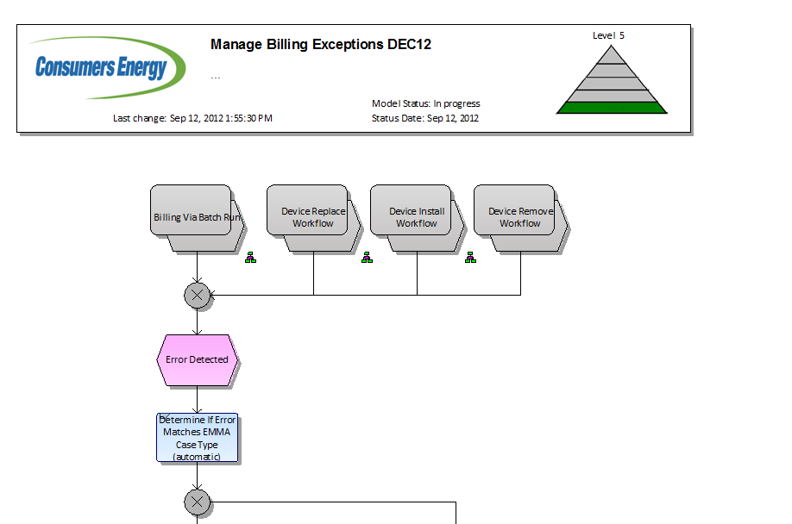
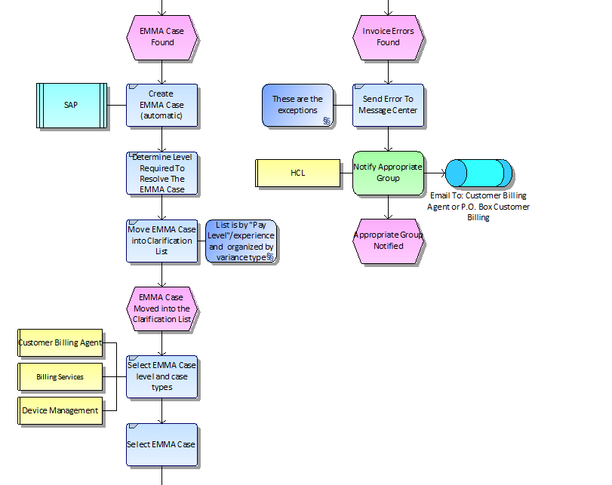
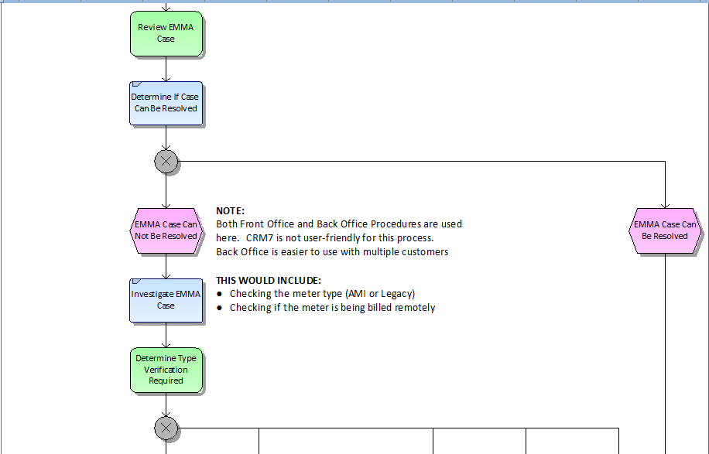

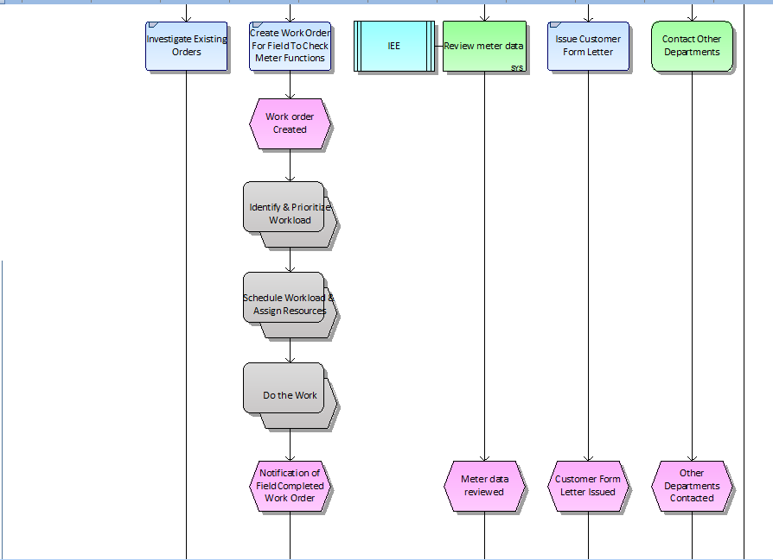

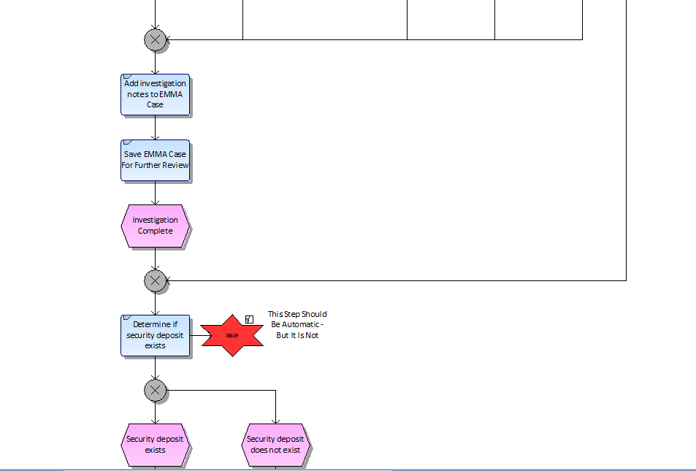
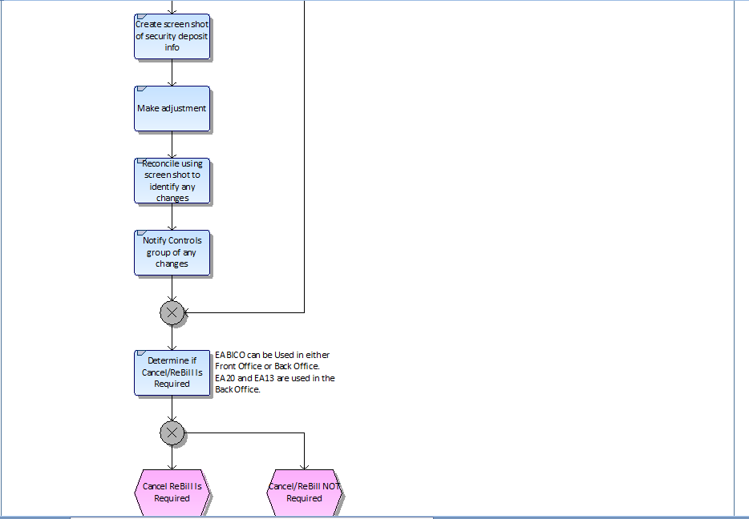

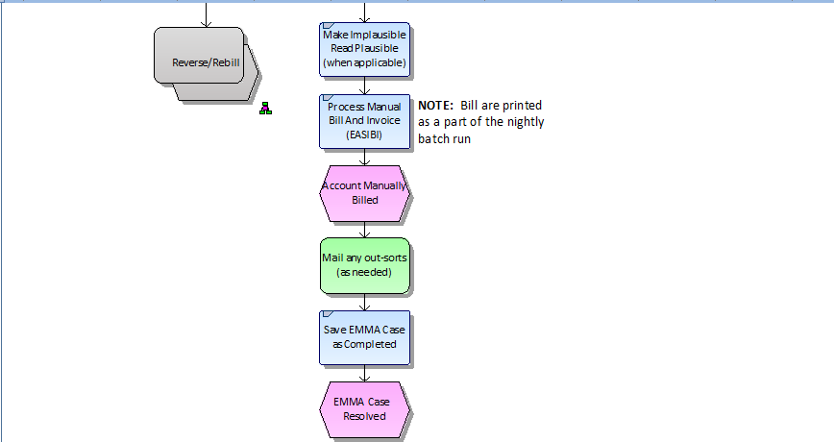

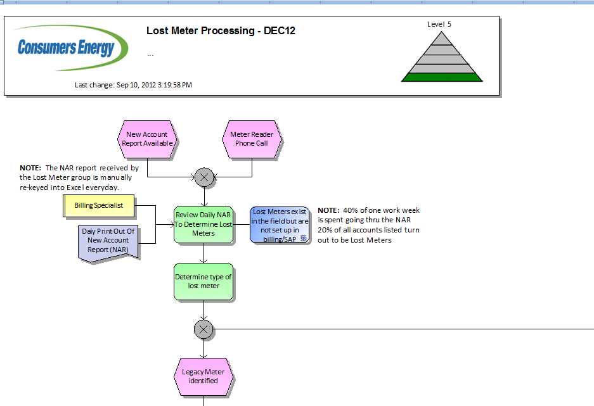
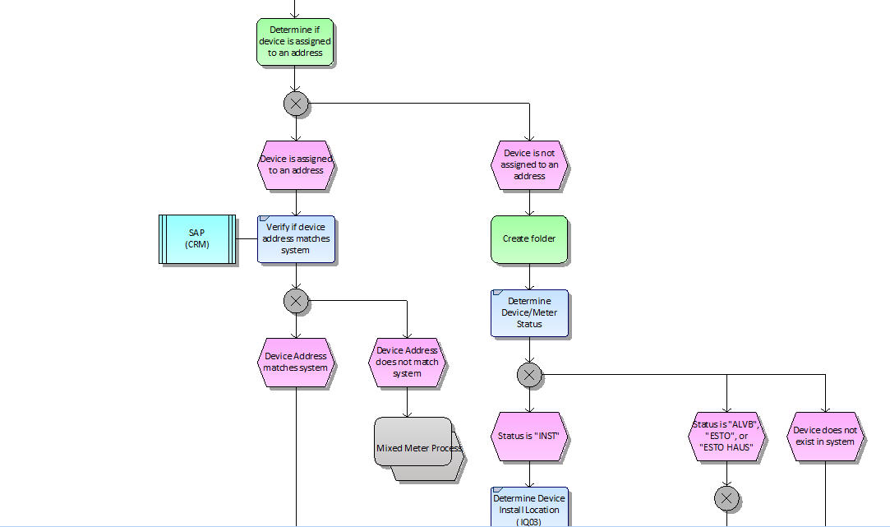

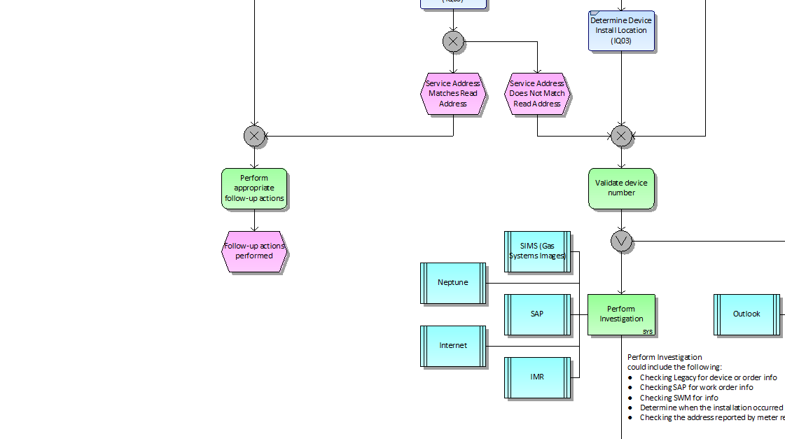

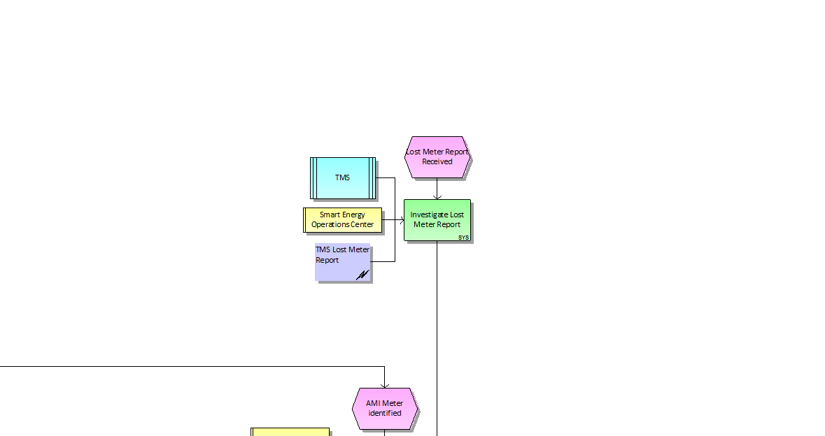

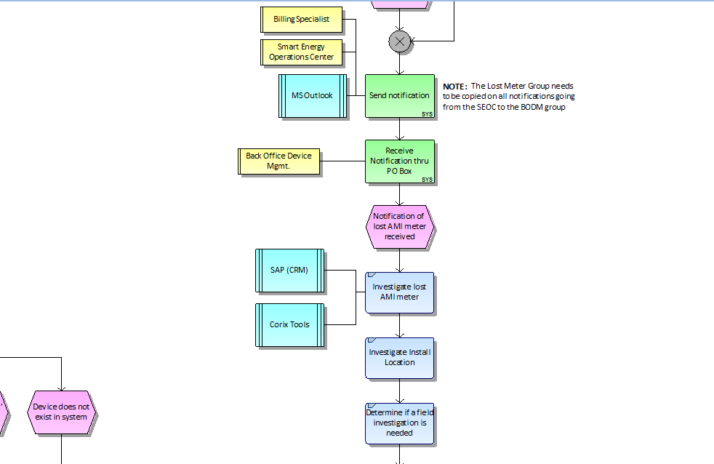

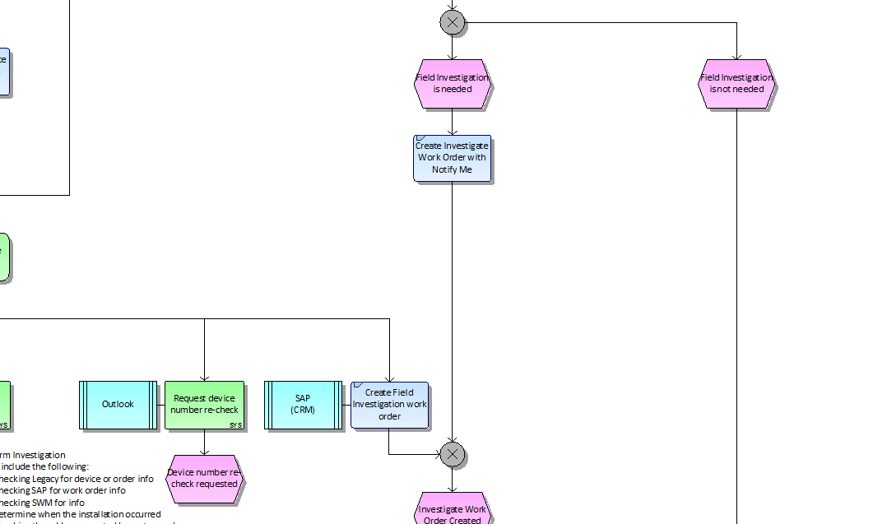

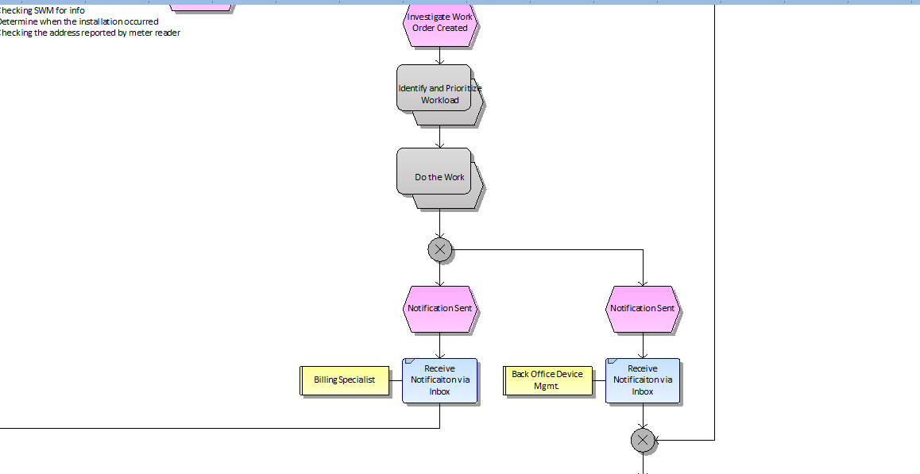

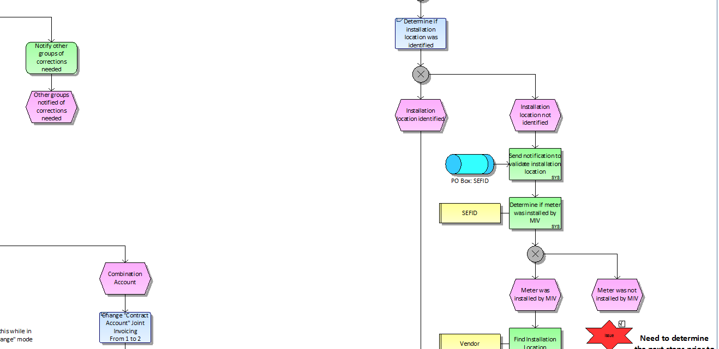

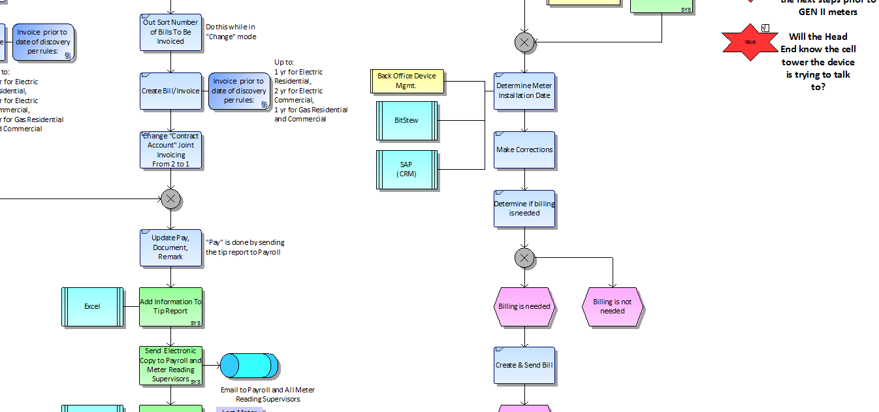

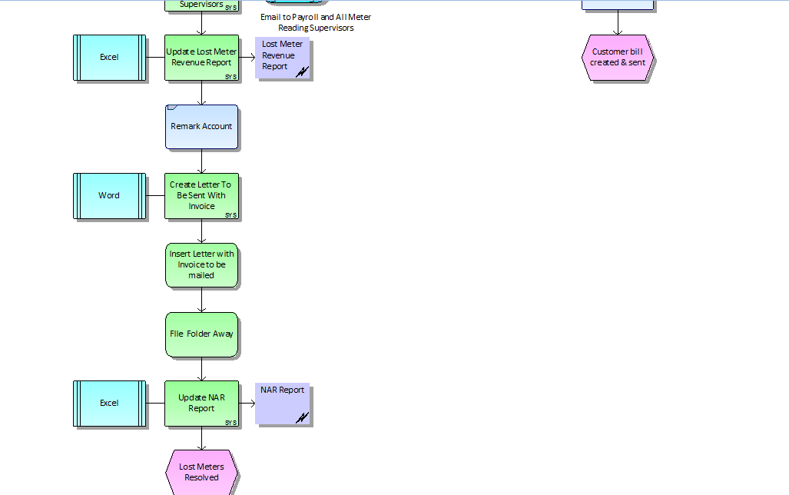

Business Process
Exceptions processing will occur at each of the handshakes between various applications. SEOC will be responsible for the processing of exceptions and manual/automated corrections of data within IEE for the March, 2013 implementation. The following depicts the various handshakes and areas that will require attention and training on an on-going basis.

TMS to IEE Events Exception Processing
Events will be processed through a MultiSpeak interface that passes the meter events, such as power up, power down, self-read, etc., from the TMS Head-End application to the IEE MDM application. Files will be processed through the web-services using an XML format using mutually authenticated SSL. Errors will be logged in a similar manner to the Internal Web Service Host: The .log file will contain info, error and warning messages by default, and debugging or trace as well if debug or trace modes are enabled. The .log file will show a file creation process similar to that shown by the Internal Web Service Host with OpenWay (finding the channel identifier, searching FlatConfigPhysical, and then creating the file itself).
A role should be established at Consumer’s who monitors the log files for errors, warnings, failures, and notifications indicating an issue when the transactions were processed. This role should have the ability to resend the originating transaction or correct and resubmit the original transaction.

TMS to IEE Meter Reading Processing
Meter readings will be processed using TMS CXML file for the March, 2013 implementation. Later versions of the process will utilize the Device Comm interface. The CXML file will be created twice a day for the meter readings in TMS and passed to IEE. As it is passed, the data will be converted from the CXML format to the XML required by IEE for the ARI processing. Errors in generating the file will be part of the TMS processing.
As the file is converted from CXML to XML, standard file processing exceptions may occur. For example, an incomplete file may error out as it tries to convert. A service will run in IEE to process the file as it is received. Errors generated from the conversion of the file will be visible to the end user on the Task Monitor. The end user will need to troubleshoot the file and determine the source of the issue. Possible problems may include a poorly constructed file, a meter missing in IEE as a result of a failed transaction during synchronization between IEE and SAP, or a reading received on an inactive meter indicating diversion or theft.
The role responsible for managing these exceptions must have access to the task monitor, able to access file systems containing the files, and must be able to correct data within IEE to manage meters and service delivery points.

OpenWay to IEE Meter Reading and Events Exception Processing
Events and Readings will arrive from OpenWay through Itron’s DeviceComm interface. Either server-authenticated or mutually authenticated SSL connections can be implemented. Communication will be logged on the Itron servers In .log files. The .log file will contain info, error and warning messages by default, and debugging or trace as well if debug or trace modes are enabled. The .log file will show a file creation process similar to that shown by the Internal Web Service Host with OpenWay (finding the channel identifier, searching FlatConfigPhysical, and then creating the file itself).
The roles defined above in J31 and J32 should have the same permissions to manage any exceptions encountered in this import process.

Validation Queue Exceptions
Validation exceptions are generated as the readings are loaded into the database. For the March, 2013 implementation, the only validation configured is the gap check. Two separate estimation routines will fire in sequence should a gap be detected. Failure to successfully process those estimations will result in a gap in the interval data. No estimations are to be processed against register reads.
Exceptions will display in two locations: the validation queue and the validation log. The only resolution is to manual edit the missing interval with a manual estimate. Plans to work the validation queue and validation have not been communicated as a requirement at this time. However, a role must be established to manually accept the exceptions on a daily basis. Exceptions generated on non-working days can be accepted on the first working day following the non-working day.

SAP to IEE Synchronization Processing
Meter and service delivery point information is passed from SAP to IEE. Synchronization transactions are generated for the following:
- Bulk Meter Create
- Create Register
- Pod Assignment
- Meter Location
- Meter Replication
- Single Meter Create
- Meter Change
- Register Change

Transactions are passed via web-services from SAP to IEE. The exceptions are transmitted back to SAP and logged in the .log files for IEE. A role should be established at Consumer’s who monitors the log files for errors, warnings, failures, and notifications indicating an issue when the transactions were processed. This role should have the ability to resend the originating transaction or correct and resubmit the original transaction.
Metering Technology Center (MTC) will play a larger role in AMI Lost Meter resolution processing due to the short period involved in the discovery of these lost meters and the groups involvement with failed work orders. Both SGOC and MTC will need to develop Service Level Agreements (SLAs) with Customer Billing to ensure that data requests, investigations, etc. are responded to in a timely manner to avoid a delay that may impact Customer Billing.

SAP to IEE ABE Request Processing
ABE requests will be sent from SAP to IEE based on portions defined in the SAP billing engine. Portions may contain up to 200,000 accounts and define the billing cycles for those accounts. In addition, final bill processing will generate requests as well. Consumer’s has elected to utilize batch mode processing to insure that all accounts for a portion have billing determinants calculated or exceptions created prior to returning the batch to SAP for processing. Final bills will come down in batches as small as one (1) account and processed in the same manner. All requests will be completed and responses generated before the responses are returned to SAP.
The file will be delivered to the ABE request folder on each billing day. The portion file will be sent approximately 5 days prior to the deadline date for the data to be returned and 5 days prior to the scheduled read date. There is a possibility that a portion request and a final request overlap dates to due to the amount of time between the request and the deadline date. Final bills will be sent as they are processed in SAP.
Errors for processing the file will be in the task monitor on the IEE application. Individual errors for processing requests will be maintained on the ABE Monitor. The UI will allow the end user to view the exceptions generated for processing requests, drill down into the details of each account, and manage the files as they are processing. Changes to variables submitted by SAP can be updated through the monitor. For example, deadline dates can be extended if up front processing is not completed such as failure to receive readings from the head-end application.
Roles need to be defined that will monitor and manage the ABE Monitor window. Also, a role needs to be defined that will manage the files through the file system should a file need to be resubmitted, correct if it is malformed, or resent should the error occur before reaching IEE.

IEE to SAP ABE Response Processing
Upon the completion of the calculation of billing determinants or the deadline date and time, the IEE application will generate ABE responses for all requests received in a batch. Errors in calculating determinants are posted in the ABE Monitor and posted at the individual responses in the ABE response file. Those errors are passed into the ISAIM interface but stripped out of the file sent to SAP. Processes need to be established for each type of exception received and what action, if any, is to be taken to resolve. For example, an error indicating that no register reading was available is acceptable for estimation. However, an error indicating that the rate requested is not available for the time period requested may indicate an error was not resolved in the synchronization process before billing was attempted and should be corrected before the deadline date.
A report will be executed in the morning to determine how many service delivery points with a deadline date of the same date do not have a valid register reading for billing. This will provide the SEOC with the number of estimations to be required from SAP. This will allow the end user to determine if action needs to be taken to gather reads manually, delay billing, or allow the billing to continue with estimates from SAP. Guidelines need to be established based on the number of readings missing and what action is to be completed.

IEE to Opower Interval Processing
IEE will produce a daily file of all intervals received from the previous 24 hours for electric meters. The data will be pulled from the database logs and stored in temporary tables within a database specifically for staging. Once the data pull is complete, a script will run to pull the data into the requested flat file format. While sizing of these tables is considered adequate, a DBA must monitor to insure that sufficient space is available.
After the extract flat file is complete, the file will be picked up by Biztalk and copied to the Opower environment. If the file fails to generate from IEE, then the script can be rerun. If the file generates successfully, the data from the staging database is truncated. If the file fails to copy, then the copy can be re-executed.
A role needs to be established that will monitor the file processing (possibly automated) and re-execute the portion that fails. The errors generated for failing to create the file will be located in the task monitor of IEE. A notification will be established in Opower to contact this role should the file not be received as expected.

IEE to Bitstew Data Processing
Custom SQL exports will be built within IEE to handle data requests for Bitstew reporting. These exports will be processed through IEE recurring schedules and errors will be posted on the task monitor. A role needs to be established to monitor the task monitor and re-execute the scripts manually should errors be generated.
Biztalk will be responsible for picking up the files generated and copying them to the proper directories. If the file transfer fails, then the file may need to be moved manually. A role needs to be established that will monitor the file processing (possibly automated) and re-execute the portion that fails. The errors generated for failing to create the file will be located in the task monitor of IEE.

Manage Billing Exceptions Requirements List for December
Req # | Requirement Description | Doc Xref | Solution
SGR01047 | In the case of a mixed meter, the MDM shall be able to re-associate the affected (mixed) meters with the appropriate SDP back to the time of the re-association within SAP, or for as long as the MDM has the meter reading data online. This requires the incorporation of role based security and audit log functionality. | W13b_Manage Billing Exceptions | IEE will allow for a user to manually remove the meter from the service delivery point and re-insert into the correct service delivery point and re-apply the readings to the correct location. This will require a login that allows for the manipulation and creation of data files outside of the application.
SGR03356-G | Daily midnight register meter reads shall be made available to the Customer Billing group for individual meters / SDPs as needed for general billing exception processing. | W13b_Manage Billing Exceptions | The customer billing group logins will allow for the viewing of the register reads within IEE.
SGR03357-G | Meter events shall be made available to the Customer Billing for individual meters / SDPs as needed for general billing exception handling. | W13b_Manage Billing Exceptions | The customer billing group logins will allow for the viewing of events within IEE and allow users to print reports.
SGR03417-G | Meter events shall be made available to groups external to the SGOC for individual meters / SDPs as needed for general billing exception handling. | W13b_Manage Billing Exceptions | The SEOC group logins will allow for the viewing of events within IEE and allow users to print reports.
SGR03418-G | Hourly interval meter reads shall be made available to the Customer Billing group for individual meters / SDPs as needed for general billing exception processing. | W13b_Manage Billing Exceptions | The customer billing group logins will allow for the viewing of the interval reads within IEE.
SGR03419-Control | Operational tools shall have the ability to export/report the register read data for each meter. | W13b_Manage Billing Exceptions | Based on more detailed requirements defined in the PP6, custom SQL scripts will be written to satisfy any reporting requirements for the operational tools.
SGR03422-Control | The MDM shall have the ability to export/report all meter read data. | W13b_Manage Billing Exceptions | The Change Data Capture tool will be installed to extract interval data from the IEE application for use with Opower and other third party vendors/reports. Custom SQL will format the data into the required layouts.  Exports of interval and register data in XML format is standard functionality within IEE. The PP6 documents will further define additional requirements for use of meter read data.
SGR03423-Control | The MDM shall have the ability to limit who can modify or remove meters associated with an SDP. | W13b_Manage Billing Exceptions | Standard Security Functionality within IEE allows for the limiting of access for modification and removal of meters.
SGR03424-Control | The MDM shall have the ability to log the following attributes if meter / SDP relationship is modified: who, what, when. | W13b_Manage Billing Exceptions | Standard Audit Functionality within IEE tracks the modification of data, dates, and user ids.
SGR03584 | Mixed meter resolution within SAP shall not interrupt meter reading flow From the Head End into the MDM. | W13b_Manage Billing Exceptions | Changes to SAP do not affect the reading flow from the Head-End into the MDM.
SGR03585 | The attempted duplicate Install of multiple meters on a single SDP should be excepted and logged within the MDM. | W13b_Manage Billing Exceptions | IEE will not allow for the installation of multiple meters on a single service delivery point. The second record will be rejected and an error sent back to SAP. The failure will also be documented in the processing logs of IEE whether it is received from SAP or through manual processing.
SGR03644 | CE requires the ability to hold the calculation of bill determinants for each meter interval channel until the total number of estimated reads for that meter channel reaches a pre-determined threshold or the deadline date is reached. This threshold will be determined during creation of the PCD (Product Configuration Guide). | W13b_Manage Billing Exceptions | IEE allows for the processing of determinants to be held until the deadline date based on the percentage entered in the variable on the External System Attribute Name Table - AMI_Billing_EstimatedReadingPercentLimit.
SGR03645 | CE requires the ability to hold the calculation of bill determinants for each meter interval channel until the total number of failed validation reads for that meter channel reaches a pre-determined threshold or the deadline date is reached. This threshold will be determined during creation of the PCD (Product Configuration Guide). | W13b_Manage Billing Exceptions | IEE allows for the processing of determinants to be held until the deadline date based on the percentage entered in the variable on the External System Attribute Name Table - AMI_Billing_FailedValidationReadingPercentLimit.
SGR03646 | CE requires the ability to hold the calculation of bill determinants for each meter interval channel until the total number of manually accepted reads for that meter channel reaches a pre-determined threshold or the deadline date is reached. This threshold will be determined during creation of the PCD (Product Configuration Guide). | W13b_Manage Billing Exceptions | IEE allows for the processing of determinants to be held until the deadline date based on the percentage entered in the variable on the External System Attribute Name Table - AMI_Billing_ManualAcceptPercentLimit.
SGR03647 | CE requires the ability to hold the calculation of bill determinants for each meter interval channel until the total number of missing reads for that meter channel reaches a pre-determined threshold or the deadline date is reached. This threshold will be determined during creation of the PCD (Product Configuration Guide). | W13b_Manage Billing Exceptions | IEE allows for the processing of determinants to be held until the deadline date based on the percentage entered in the variable on the External System Attribute Name Table - AMI_Billing_MissingReadingPercentLimit.
SGR03648 | CE requires the ability to hold the calculation of bill determinants for each meter interval channel until the total number of not-validated reads for that meter channel reaches a pre-determined threshold or the deadline date is reached. This threshold will be determined during creation of the PCD (Product Configuration Guide). | W13b_Manage Billing Exceptions | IEE allows for the processing of determinants to be held until the deadline date based on the percentage entered in the variable on the External System Attribute Name Table - AMI_Billing_NotValidatedReadingPercentLimit.
SGR03649 | CE requires the ability to hold the calculation of bill determinants for each meter interval channel until the total number of edited reads for that meter channel reaches a pre-determined threshold or the deadline date is reached. This threshold will be determined during creation of the PCD (Product Configuration Guide). | W13b_Manage Billing Exceptions | IEE allows for the processing of determinants to be held until the deadline date based on the percentage entered in the variable on the External System Attribute Name Table - AMI_Billing_EditedReadingPercentLimit.
SGR03650 | CE requires the ability to hold the calculation of bill determinants for each meter interval channel until the total number of un-scaled estimated reads for that meter channel reaches a pre-determined threshold or the deadline date is reached. This threshold will be determined during creation of the PCD (Product Configuration Guide). | W13b_Manage Billing Exceptions | IEE allows for the processing of determinants to be held until the deadline date based on the percentage entered in the variable on the External System Attribute Name Table - AMI_Billing_UnscaledReadingPercentLimit.
SGR03651 | CE requires the ability to hold the calculation of bill determinants for each meter interval channel until the total number of warning reads for that meter channel reaches a pre-determined threshold or the deadline date is reached. This threshold will be determined during creation of the PCD (Product Configuration Guide). | W13b_Manage Billing Exceptions | IEE allows for the processing of determinants to be held until the deadline date based on the percentage entered in the variable on the External System Attribute Name Table - AMI_Billing_WarningReadingPercentLimit.
Single Phase Register | kWh Delivered - Total from self-read register (preferably at midnight) for single phase. This will be the only register passed to SAP to support a meter read request | W13b_Manage Billing Exceptions | SAP will request the KWH_DEL register and IEE will return that determinant with the register read.

Outstanding Issues for IEE
Req # | Requirement Description | Doc Xref | Solution
SGR03419-Control | Operational tools shall have the ability to export/report the register read data for each meter. | W13b_Manage Billing Exceptions | Based on more detailed requirements defined in the PP6, custom SQL scripts will be written to satisfy any reporting requirements for the operational tools.
SGR03422-Control | The MDM shall have the ability to export/report all meter read data. | W13b_Manage Billing Exceptions | The Change Data Capture tool will be installed to extract interval data from the IEE application for use with Opower and other third party vendors/reports. Custom SQL will format the data into the required layouts.  Exports of interval and register data in XML format is standard functionality within IEE. The PP6 documents will further define additional requirements for use of meter read data.

Gaps Identified for IEE
Req # | Requirement Description | Doc Xref | Solution
 | None Identified

Smart Meter Opt Out Inquiry

Summary
During the deployment of Smart Meters in the CE service territory, customers have the right to ‘opt out’ or not have a new Smart Meter installed.
-Opt out flags will be removed by the system during an "End Contract" process.
-Opt out flags will be reset by the system during a "Cancel End Contract" process.
-When an opt-out flag is cleared the system will generate meter exchange order to replace the legacy meter with a smart meter.

When a customer moves to a new location/premise, they must follow the opt-out request process for that specific location regardless of the choices made at the previous locations/premise.
- Prior to May 2013, the customer will not be charged for opting out.
- The process to update the installation fact to show opt out is manual.

Opt-out Program Deliverables by release date:
• July 2012: Technical master data opt out flags, work management auto processing, customer inquiry/request processing
• December 2012: move in/move out processing with auto creation of smart meter exchange order
• May 2013: customer opt out billing

Business Process Flow
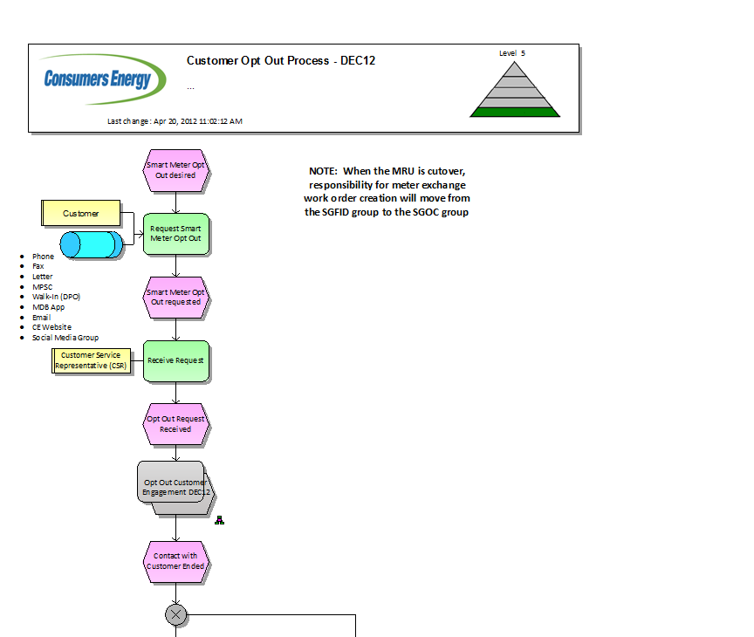
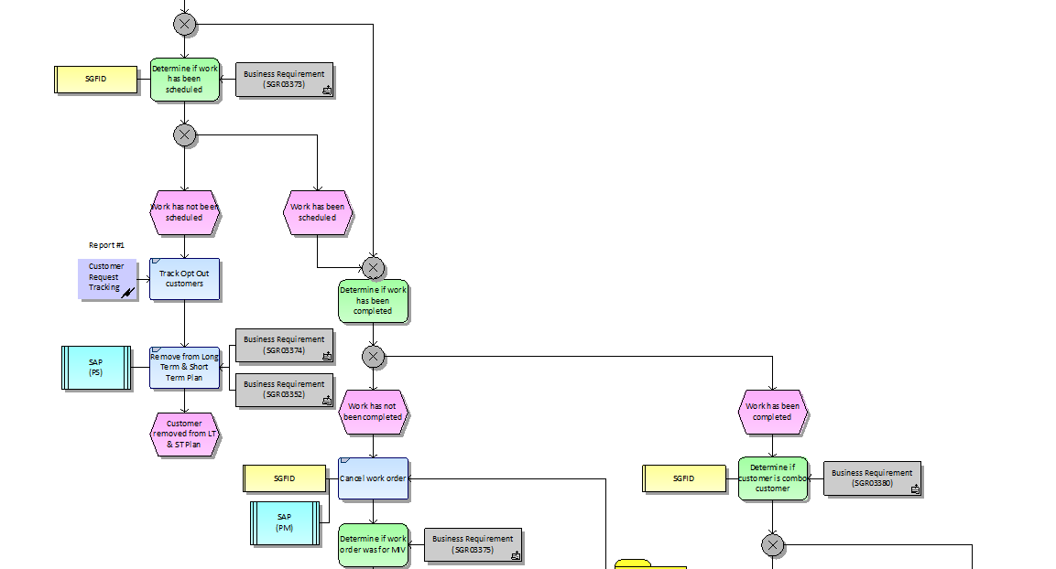

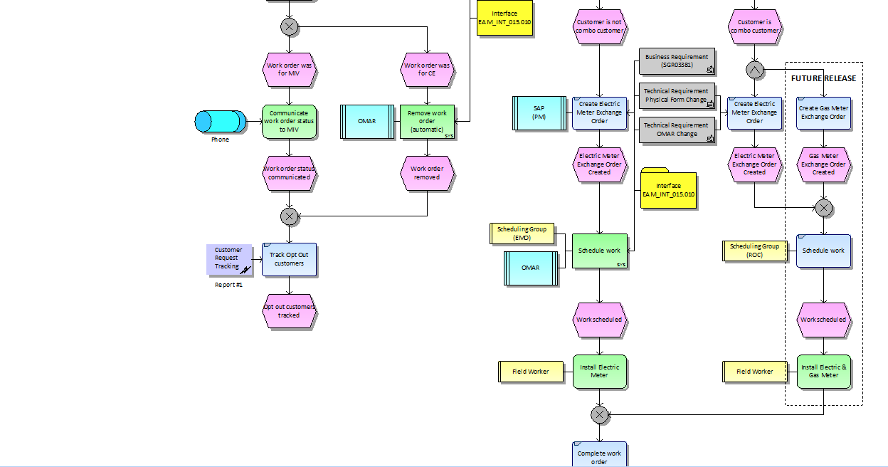

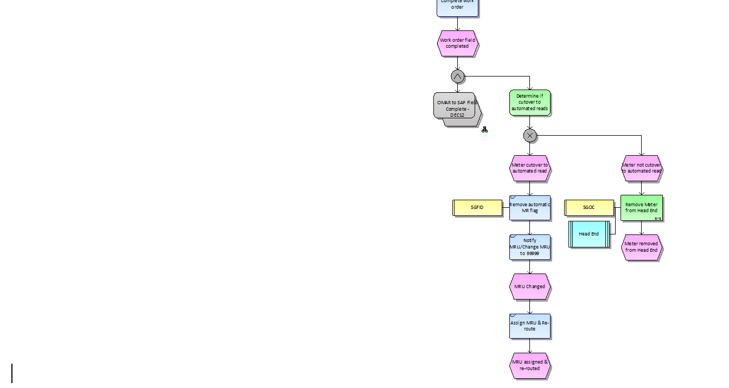

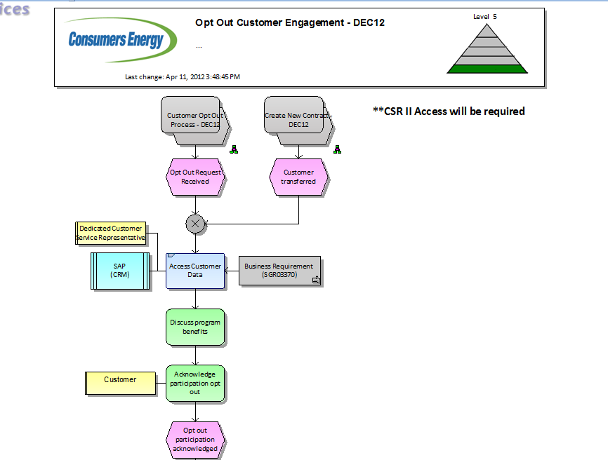

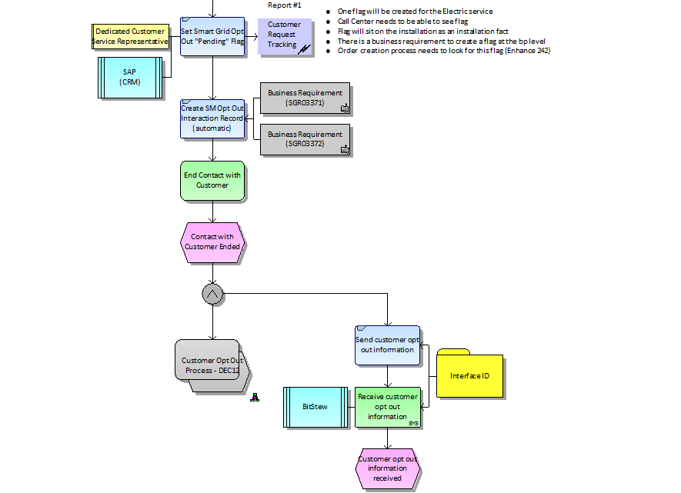

Business Process
The customer will contact the call center to opt out of the Smart Meter program. This may be an existing customer getting a new AMI meeting, an existing customer who has an existing AMI meter, a new customer moving into an existing AMI meter, or a new customer with new construction and an AMI meter. For premises with existing AMI meters, the AMI meter must be removed and a mechanical meter installed. The system must indicate that the meter was not exchanged; the SAP system must be updated indicating that it is not AMI, and the meter should stay on a manual read route. In the event of an existing meter, the mechanical meter will stay installed, and the SAP system must be updated indicating that it is not AMI.
Non-AMI meters will continue to be manually read using register readings, and will not be eligible for interval billing programs. Readings will not be posted to the MDM at this time as the SAP system will be the system of record for register readings. Readings will be posted directly into SAP.
AMI meters will be read through either the TMS or OpenWay head-end applications and passed through to IEE for storage. ABE requests will be issued from SAP when readings are required for billing, and IEE will respond with the readings requested.

Smart Meter Opt Out Requirements Listing for December
Req # | Requirement Description | Doc Xref | Solution
 | None Identified

Outstanding Issues for IEE
Req # | Requirement Description | Doc Xref | Solution
 | None Identified

Gaps Identified for IEE
Req # | Requirement Description | Doc Xref | Solution
 | None Identified

Supply Chain Inventory Management

Summary
Various Supply Chain processes including using MRP to replenish stock at Company headquarters and various report requirements have been identified for the December release of DLM.

Business Process Flow
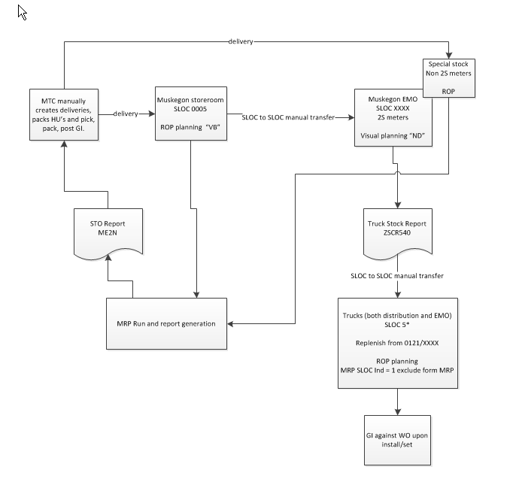

Business Process
CE processes orders through the SAP application. The meters are delivered to the Meter Technology Center for functional testing before being released to the field for installation. This process includes the loading of the data for the meters into the SAP application and a file to TMS to load the data into the head-end. Web services will be used to accomplish the same in OpenWay. IEE is populated from SAP after the meters are approved for installation. However, IEE is not involved in the ordering or receiving process.

Requirements Listing for December
Req # | Requirement Description | Doc Xref | Solution
 | None identified. | SC-050-090 Supply Chain Inv Mgt December 2012 Release

Outstanding Issues for IEE
Req # | Requirement Description | Doc Xref | Solution
 | None Identified

Gaps Identified for IEE
Req # | Requirement Description | Doc Xref | Solution
 | None Identified

RMA – Reverse Logistics

Summary
RMA (Return Material Authorization) & Reverse Logistics process for Smart Grid devices. The RMA and Reverse Logistics process for the returned Smart Grid devices will require the ability to pass various testing and root cause analysis information back and forth from a third party in order to capture the appropriate information needed for MPSC requirements while monitoring on-going quality and/or cause of failures. Also, this needs to include the warranty tracking and reset upon re-receipt of the device.

Business Process Flow
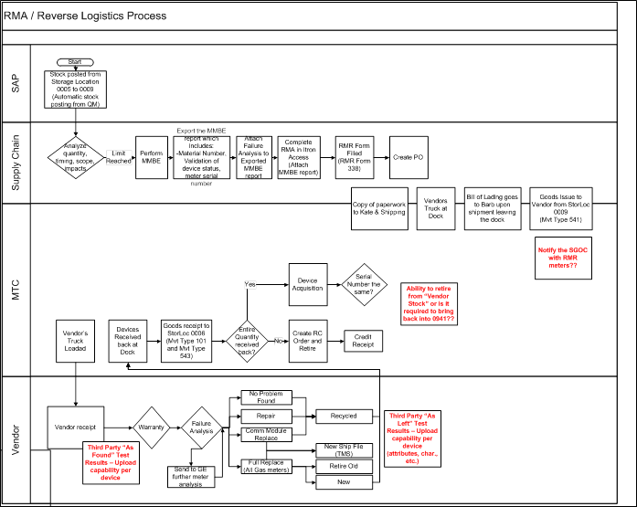.

Business Process
The RMA-Reverse Logistics process handles the return of meters and setting the correct values within the SAP application for inventory, meter status, and financials. Transactions for removing from the head-end are processed as the meter is removed from the field.

RMA-Reverse Logistics Requirements Listing for December
Req # | Requirement Description | Doc Xref | Solution
 | None identified.

Outstanding Issues for IEE
Req # | Requirement Description | Doc Xref | Solution
 | None Identified

Gaps Identified for IEE
Req # | Requirement Description | Doc Xref | Solution
 | None Identified

VEE Requirements
.

Summary
Validation, Estimation, and Editing provide the necessary elements to identify anomalies and make corrections as necessary to provide a steady, accurate stream of data to other applications such as billing, web presentment, and reporting. For the April, 2013 release, the only validation to be implemented will be the gap check rule. This will identify missing intervals and provide estimated intervals. Register readings from the meters are considered gospel, and are not validated nor changed. Any validations against registers are performed within SAP.
For the 2013 Billing Release there are two processes that will be impacted by VEE, Billing and the Customer Web Presentment Portal:

- Billing Process: the process of validating data for Billing will not change for the 2013 Billing release. VEE will continue to be performed by SAP for all customer accounts (mass market, commercial and industrial). SAP billing will continue to be based upon register readings.
- Customer Web Presentment Portal – VEE to support the Meter Data Web Portal (the Portal) will be a new process for the 2013 Billing Release. This process will be performed by the Itron Meter Data Management System (MDMS), and will include one (1) validation to check for missing interval data (Gap Check), and two (2) estimation routines to fill gaps in interval data – California Historical and Linear Interpolation.
VEE for the Portal will generally run as follows:
At scheduled time each day the MDM will begin the VEE process for all data that has been collected by the Head-End for the previous day (midnight to midnight). VEE will begin with processing the interval data Gap Check validation rule. Data that passes validation will be stored within the MDM until ready for transport to the Portal. Data that fails the Gap Check validation rule will move on to the estimation process.

The Estimation process will first try to fill interval data gaps using the California Historical estimation routine. This process looks at maximum of three weeks historical data and attempts to fill interval gaps using an average of the data found. Data successfully processed will be stored within the MDM until ready for transport to the Portal. If California Historical fails, then the MDM will attempt to fill remaining interval gaps using Linear Interpolation. This estimation routine simply fills data using a straight line calculation between two endpoints.

For both estimation routines, scaling to the midnight (anchor) register reads will be performed whenever possible. If scaling is not possible, the intervals estimated without scaling will be passed on to the web portal. Consumers Energy (CE) will use standard “out of the box” MDM functionality for the interval Gap Check validation rule and the, California Historical and Linear Interpolation estimation routines. For additional details on how the validation and estimation routines function, please reference the Itron IEE User Guide.

Business Process Flow

Business Process
Data is loaded from a variety of sources into the MDM database. As the readings are collected, current data (data from yesterday – previous 24 hour window) is held until all 24-hours are received and the anchor read (midnight reading) is received and the data collection window opens. Once all are received, then validation occurs and data is loaded into the database. Historical data (data dated prior to yesterday) is loaded immediately if the data collection window is not open. Once the data collection window closes estimates are created for all missing data. All data is validated in-line, but also allows for manual validation of edits.

VEE Requirements List for April
Req # | Requirement Description | Doc Xref | Solution
N/A | Single Phase Interval Channel 1 - kWh Delivered Interval Channel for Single Phase | W27_RM-010-160_Validation Editing and Estimation | Meter programs and Service Point programs will have channel 1 and 101 as the KWH Interval and Register respectively.
N/A | IEE Validation Queue Access - Limit IEE Validation Queue access to SEOC users only; Read/Write access to view and clear queue items. | W27_RM-010-160_Validation Editing and Estimation | Security access to validation queue will be set up to allow only the SEOC users at this time. The work will consist of someone flushing the queue on a daily basis.
SGR03782 | The MDM shall check for missing interval data for all active service delivery points regardless of customer status on a daily basis. (This will be considered the eligible group of meters for VEE) | W27_RM-010-160_Validation Editing and Estimation | A gap check validation rule will be created in the VALSINGLE1 and VALSINGLE2 validation sets. VALSINGLE1 will be assigned to the ESM_A_1NDRSRT001 program and VALSINGLE2 will be assigned to the ESM_B_1NDRSRT001 program. All existing service points will have
SGR03760 | The MDM data collection window shall be open from 2:30 a.m. to 6:30 a.m. The MDM shall have the flexibility to adjustment its data collection window due to workload. | W27_RM-010-160_Validation Editing and Estimation | Data collection window will be configured to open at 2:30 a.m. and close at 6:30 a.m. This can be changed based on workloads, but due to the dependencies in processing, this should be limited to extreme conditions.
SGR03050 | Perform VEE on all eligible meters for KWH delivered only. | W27_RM-010-160_Validation Editing and Estimation | All intervals will be validated in-line as they are received from the head-end. Edited reads can be validated manually as they are entered.
SGR03783 | The MDM shall validate Current Data (data for the previous day, 00:01:00 - 24:00:59) during the data collection window after all intervals are received and the midnight register read are received. | W27_RM-010-160_Validation Editing and Estimation | As the readings are collected, current data (data from yesterday – previous 24 hour window) is held until all 24-hours are received and the anchor read (midnight reading) is received and the data collection window opens. Once all are received, then validation occurs and data is loaded into the database. Once the data collection window closes estimates are created for all missing data.
SGR03784 | The MDM shall process validation immediately for Historical Data (data that is outside of what is considered "Current Data" at the time of validation). Note: This will not happen during the MDM data collection window (DCW) | W27_RM-010-160_Validation Editing and Estimation | Historical data (data dated prior to yesterday) is loaded immediately if the data collection window is not open. All data is validated in-line, but also allows for manual validation of edits.
SGR03058 | During VEE the MDM will consider zero value intervals resulting from power outages as valid, and will not attempt to estimate the intervals. | W27_RM-010-160_Validation Editing and Estimation | IEE MDM considers 0 readings with power outage status to be a valid reading and will not identify it as a gap. Only gaps will be estimated.
SGR03071 | If actual data becomes available after an interval has been estimated, the MDM shall accept the new data and pass it on to the customer web portal. | W27_RM-010-160_Validation Editing and Estimation | All data received during the previous day will be sent to Opower regardless of the actual read date. The CDC interface will be implemented to strip data from log files and create temporary table. A script will be written to format temporary table data into the Opower format.
SGR02965 | The MDM shall be capable of determining a "Duplicate" for each meter interval based on timestamp and value. This will determine whether or not to delete or allow the existence of duplicate data based on source, status, and business rules. | W27_RM-010-160_Validation Editing and Estimation | Duplicated identified during the load of current data will be ignored. Should a duplicate interval be identified after the current data is loaded a new version of the data will be saved. Duplicates will be identified as matching meter, channel, date, time, and time zone.
SGR03704 | IEE will use California historical as the first attempt to estimate missing intervals. CA historical is defined as an average of the nearest 3 weeks of like-day interval for the exact time period as the missing interval. Intervals will be estimated individually. | W27_RM-010-160_Validation Editing and Estimation | Configuration of estimations will put CA Historical in the first position of the hierarchy.  California historical averages the interval from the same time period across the last three weeks. For example, Wednesday at 2:00 p.m. will average the 14:00 interval from the closet three Wednesdays to get the estimate. If three weeks are not available, then two are used. If two are not available, then one is used.
SGR03712 | Like days for estimation will be as follows:  Weekdays = Mon, Tues, Wed, Thurs, Fri, No holidays  Weekends = Sat, Sun  CE Holidays = List of Holidays  Note; If there is not enough historical holidays exist in the like days period, use a weekend day. | W27_RM-010-160_Validation Editing and Estimation | Holiday schedules will be entered to adhere to the CE holiday schedule. Estimation routines will adhere to the holiday schedules entered and treat holidays like Sundays and Saturdays.
SGR03710 | Usage from a previous customer shall not be used to estimate usage for the current customer at a given SDP. | W27_RM-010-160_Validation Editing and Estimation | CANNOT BE MET – SAP doesn’t send sufficient data to IEE to perform this edit.
SGR03711 | Estimation processes with IEE should not use previously estimated data to calculate estimated reads. | W27_RM-010-160_Validation Editing and Estimation | This is baseline functionality from IEE.
SGR03791 | The California Historical Rule shall scale to register reads unless the beginning and ending registers are missing. | W27_RM-010-160_Validation Editing and Estimation | This is baseline functionality from IEE.
SGR03759 | If the MDM does not have the beginning and ending register reads, the MDM shall keep the California Historical estimates without scaling | W27_RM-010-160_Validation Editing and Estimation | This is baseline functionality from IEE. Readings will be marked as unscaled interval statuses.
SGR03705 | If California historical is unable to estimate, IEE will use linear interpolation (LI) to estimate. LI is defined as drawing a line between the last good interval received and the next good interval received and allowing the missing intervals to use whatever point is defined by the line between the two good intervals. | W27_RM-010-160_Validation Editing and Estimation | Linear Interpolation will be configured in the second level of hierarchy for the estimation routines. The process is baseline functionality.
SGR03707 | Linear interpolation will scale to register reads unless the beginning and ending registers are missing. | W27_RM-010-160_Validation Editing and Estimation | Linear interpolation will be configured as Desired for Scaling to register reads.
SGR03758 | If the MDM does not have the beginning and ending register reads, the MDM shall keep the linear interpolated estimates without scaling | W27_RM-010-160_Validation Editing and Estimation | Linear Interpolation will be configured as Process if the scaling is not possible.
SGR03787 | Estimated interval data shall be routed for revalidation. | W27_RM-010-160_Validation Editing and Estimation | This is baseline functionality from IEE. The only validation will be gap check so filling with estimation will cause it to pass validation.
SGR02966 | The MDM shall identify the type of data represented by the interval channel validated. (i.e., kWh delivered kVARh, etc.) | W27_RM-010-160_Validation Editing and Estimation | IEE channels must contain the specific unit of measure associated with the reading type. Meter programs are defined with the following channels.  1/101 – KWH Delivered  2/102 – KWH Received  3/103 – Varh Total Lag  40 – KWH On Peak Delivered  41 – KWH Off Peak Delivered  44 – KW On Peak Demand  45 – KW Off Peak Demand  46 – KW Demand  58 – VH
SGR03056 | The MDM shall denote the validation status of each interval. (e.g., passed, estimated, etc.) | W27_RM-010-160_Validation Editing and Estimation | As each estimation is complete for an interval, the interval status will be set to Passed, Failed, Estimated, etc.
SGR03761 | In addition to the estimation status the MDM shall identify the type of estimation used. (i.e., CA Historical or Linear Interpolation). | W27_RM-010-160_Validation Editing and Estimation | As each estimation is complete for an interval, the interval status will be set to ESTLINEAR or ESTHISTORICAL.
SGR03072 | The MDM will log in real time changes to validated data by time and date. | W27_RM-010-160_Validation Editing and Estimation | Changes are logged in the audit tables based on date and time and user ID.
SGR02983 | The MDM shall complete VEE for Current Data by 8 a.m. if the requisite data from the Head End is received no later than 5 a.m. | W27_RM-010-160_Validation Editing and Estimation | If data is received from the head end by 5:00 a.m., then validation can be completed by 8:00 a.m. The data collection window will close at 6:30 and estimations completed shortly thereafter.
SGR02988 | In the event the MDM is not able to estimate missing interval data, the MDM shall flag the data as missing. | W27_RM-010-160_Validation Editing and Estimation | If there is a gap in interval data that IEE cannot estimate, the user’s window will display the interval with a 0 reading and a status of missing. This is baseline functionality from IEE.
SGR02993 | The MDM shall provide a mechanism to view failed validation results. The view/report shall include the status for each step in the VEE process for a given interval timestamp information for each entry, and identify the resulting action of the validation failures. | W27_RM-010-160_Validation Editing and Estimation | Validation Queue, Validation Log, and Validation reports provide validation status of each interval result. This is baseline functionality from IEE.
SGR03788 | Authorized users shall have the ability to clear failed validations within the MDM. | W27_RM-010-160_Validation Editing and Estimation | SEOC users will be granted security access to update the validation queue and accept all updates for failed validations.
SGR02994 | The VEE results shall be accessible by an authorized user for analysis. | W27_RM-010-160_Validation Editing and Estimation | Validation Queue, Validation Log, and Validation reports provide validation status of each interval result. This is baseline functionality from IEE. SEOC will have update and view, Billing will have view only.
SGR03029 | The MDM shall have a Validation Failure Detail Report that shows a detailed list of meter/SDP ID that failed validation and reason of failure. | W27_RM-010-160_Validation Editing and Estimation | Validation Queue, Validation Log, and Validation reports provide validation status of each interval result. This is baseline functionality from IEE. SEOC will have update and view, Billing will have view only.
SGR03022 | The MDM shall provide a report that summarizes at the SDP level, by user, daily validation failures that have been cleared or not cleared. | W27_RM-010-160_Validation Editing and Estimation | Validation Queue, Validation Log, and Validation reports provide validation status of each interval result. This is baseline functionality from IEE. SEOC will have update and view, Billing will have view only.

Outstanding Issues for IEE
Req # | Requirement Description | Doc Xref | Solution
SGR03710 | Usage from a previous customer shall not be used to estimate usage for the current customer at a given SDP. | W27_RM-010-160_Validation Editing and Estimation | CANNOT BE MET – SAP doesn’t send sufficient data to IEE to perform this edit.

Gaps Identified for IEE
Req # | Requirement Description | Doc Xref | Solution
 | None Identified

Events
.

Summary
Events, alarms and exceptions are generated by the meter based on specific scenarios and activities within the meter. For example, when the meter is powered up, powered down, self reads or someone tampers with the meter, the meter automatically generates a flag that is passed up through the head-end application and into the MDM application. At this time, event data is not passed onto the billing system.
The trouble codes received from the mechanical will no longer be received. Codes such as ‘Bad Dog’ or ‘Locked Gate’ are no longer applicable to the AMI environment. There is no meter reader to be chased by a bad dog or worry about whether the gate is locked or not. However, there will be events and alarms received when the meter self-detects problems such as memory overflow, RAM errors, etc.

Business Process Flow

Business Process
Events will ‘bubble-up’ from the meter into the TMS head end application. TMS will push the events to IEE MDM application through an interface. IEE MDM will store the events for up to 7 years. End users will be able to view and print reports of events through the User Interface. No new reports are required. The same process will be used for OpenWay. The additional events will be included in the existing

Non-Functional Requirements List for December
Req # | Requirement Description | Doc Xref | Solution
N/A | Add 18 additional events to the 19 events already implemented. | TMSEventHandling-Approved 19-Oct-12.xlsx | Configure the additional events passed up from the head-end. Update the CXML interface to convert the events to the IEE XML format. See list for details.

Outstanding Issues for IEE
Req # | Requirement Description | Doc Xref | Solution
 | None Identified

Gaps Identified for IEE
Req # | Requirement Description | Doc Xref | Solution
 | None Identified

Cutover to Automated Reads Requirements
.

Summary
Cutover to Automated Reads is the process by which customers are moved from manual meter reads (by meter readers) to automated meter reads (by the AMI system). Please see figure below for process details.

Cutover to Automated Reads is the predecessor process to the Route Closure process and the new objects being developed to support this process must also be designed to effectively support the successor process.

Cutover to Automated Reads is a new process unique to SEFID requiring deployment and device information across multiple systems and modules (SAP, Corix Portal, and AMI Head End), which needs to be kept in sync.

The Call Center will need to know if customer is on automated or manual reads for high bill complaint resolution, on demand reads, marketing customer programs, etc.
Electric Meter Operations (EMO) - will need to know if customer is on automated or manual reads for work management processes (download interval data for unreachable meters prior to exchanges, removals).

Business Process Flow
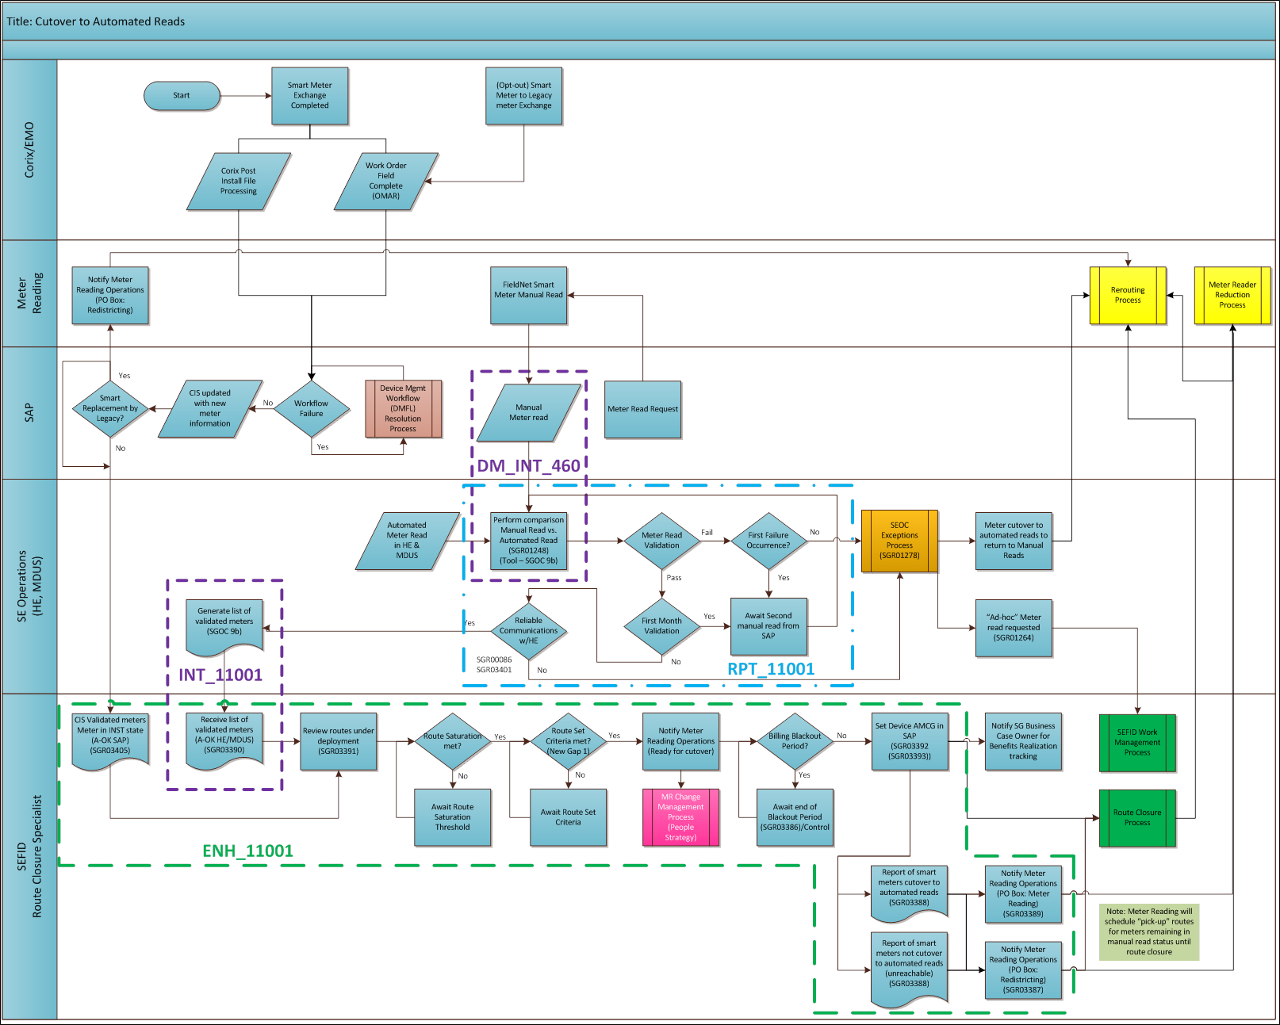

Business Process
Consumer’s Energy will install the meter and compare the readings from the manual read process to the automated read process for 60 days prior to converting the meter to automated billing. When they are satisfied that everything in the route is reading in an acceptable manner, they will accept the route (route closure) and move it to automated reads. This will consist of setting a flag in SAP to send the readings only to IEE MDM for processing unless a legacy meter is installed in the premises.
To facilitate that comparison, the readings from the ABE response file can be parsed and compared to the readings being collected manually.

Cutover to Automated Reads Requirements List for April
Req # | Requirement Description | Doc Xref | Solution
RPT_11001  SGR01248-G  SGR03401-G | SEOC shall have the capability to compare automated reads versus manual reads (usage data) between the MDUS and SAP’s billing system. The manual meter read must have a time and date stamp as well as an indication if it is an estimated or actual read.  There shall be a report that quantifies meter read reliability rates. | W11 _RM-030-040_Cutover to Automated Reads | The ABE response file can be sent through to the Grid Director and parsed to get the meter readings that would be sent to SAP for billing. This is a more accurate method of retrieving the actual billing read that was chosen than trying to pick the reading that was the current version after the fact.

Outstanding Issues for IEE
Req # | Requirement Description | Doc Xref | Solution
 | None Identified

Gaps Identified for IEE
Req # | Requirement Description | Doc Xref | Solution
 | None Identified

Non-Functional Requirements
.

Summary
Non-functional requirements define the technical aspects required to install, maintain, and manage the various applications.

Business Process Flow
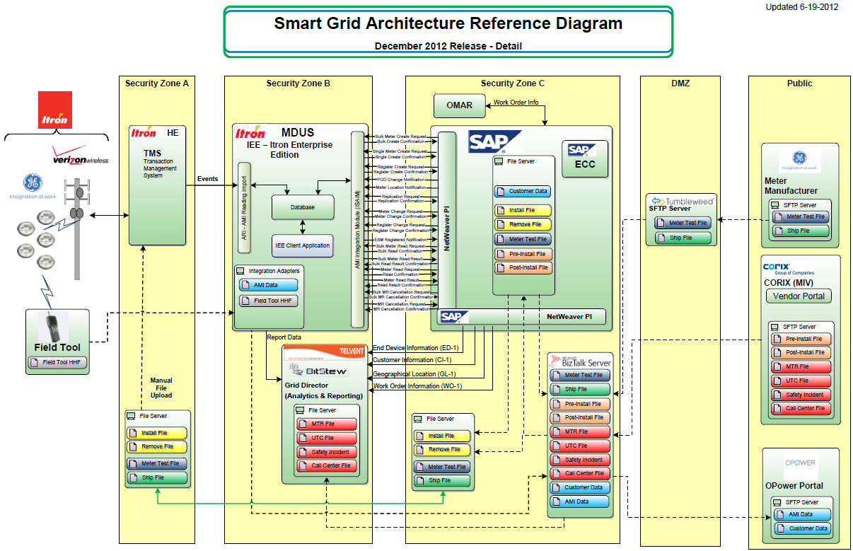

Business Process
Meter data will be received into the MDM through synchronization transactions in the SAP billing application. The Reads and Events will be loaded into the MDM from the head-end application. ABE requests and responses will facilitate the exchange of meter reads for billing between IEE and MDM. Extracts from the MDM will propagate reports and web presentment for Bitstew and Opower respectively.

Non-Functional Requirements List for December
Req # | Requirement Description | Doc Xref | Solution
New 2 | For the December Release, there needs to be a process to simulate the required communication of 60,500 meters in the performance environment. | Final_SG Non-Functional Reqs_W17 | IEE will be configured to load a full deployment of electric meters. Additional servers will be configured as they are established by Consumer’s to manage the load balance of inbound reads and events.
SGR02162 | The AMI System shall retrieve power usage data from Electric Smart Meters (ESM).  The AMI System shall retrieve interval data six to 24 times per day with a reliability of  98% every three hours and 99.5% over two days for poly-phase meters assigned to commercial classes of customers | Final_SG Non-Functional Reqs_W17 | IEE is not limited to the number of files received from the head end. Files will be processed as they are received.
SGR02172 | The AMI System shall retrieve power usage data from Electric Smart Meters (ESM).  The AMI System shall retrieve interval and register data on demand.  The AMI System shall support an on-demand request for  C&I classes of customers with a minimum of 98% reliability within 30 seconds. (add polyphase) | Final_SG Non-Functional Reqs_W17 | IEE will be configured for the following intervals and registers:  Interval/Register  1/101 –KWH Delivered  2/102 – KWH Received  3/103 – KW Demand  58/NA - VH_ELE_A  Registers Only  40 - WH_ELE_DEL_RATE_A (On Peak KWH)  41 - WH_ELE_DEL_RATE_B (Off Peak KWH)  44 - W_ELE_DEL_MAX_RATE_A (On Peak KW)  45 - W_ELE_DEL_MAX_RATE_B (Off Peak KW)  46 - W_ELE_DEL_MAX (Peak KW)
SGR02288 | The AMI Head End shall communicate with the MDM  The AMI Head End shall process and forward on demand meter read requests communications errors with 99.5% reliability in less than 5 seconds. Minimum occurrence assumption is 25 transactions for each transaction type per 1,000 meters/day. | Final_SG Non-Functional Reqs_W17 | An interface will be developed to convert the CXML format reading file from TMS to the IEE XML format reading file. This will allow for the use of baseline functionality for ARI processing.
SGR02289 | The AMI Head End shall communicate with the MDM  The AMI Head End shall process and forward on demand meter data with 99.5% reliability in less than 5 seconds. Minimum occurrence assumption is 25 transactions for each transaction type per 1,000 active meters per day. | Final_SG Non-Functional Reqs_W17 | IEE will be configured to handle large files from TMS and load balance those across servers to provide sufficient performance to meet the metrics presented.
SGR02291 | MR-13 - The AMI Head End shall process & send bulk on-demand ESM read information data to MDM with 99.5% reliability in less than 1 hour. | Final_SG Non-Functional Reqs_W17 | IEE will accept readings 24/7. Those will be processed and validated as they are received. Historical data will be managed immediately. Current data will be held in temp storage areas until the total 24 hours are available for the previous day become available.
SGR01678 | REQ0320 - The Head End will deliver at least 99.9% of event messages from the Meter to the MDM | Final_SG Non-Functional Reqs_W17 | IEE will accept meter events, alarms, and exceptions and process those transactions immediately after receiving from TMS.
SGR02290 | The AMI Head End shall communicate with the MDM  The AMI Head End shall process and forward ESM on-demand read request application errors to MDM with reliability of 99.5% in less than 5 seconds. Minimum occurrence assumption is 1 transaction per application error event. | Final_SG Non-Functional Reqs_W17 | IEE will accept readings 24/7. Those will be processed and validated as they are received. Historical data will be managed immediately. Current data will be held in temp storage areas until the total 24 hours are available for the previous day become available.
SGR01909 | For Billing purposes the MDM shall be able process the meter read data for the largest of 21 cycles plus 10-20k off cycle within one day. | Final_SG Non-Functional Reqs_W17 | The MDM will calculate determinants between the wait-until-date and the deadline date for up to 300K requests per day during the timeframes outlined by Consumer’s. The wait-until-date and deadline dates will be configured as off-sets to the time sent from the SAP application. These times can be adjusted using the UI based on delays within the billing schedule.
New 4 | MDM shall be able to accept up to 15,000 ABE requests per day for the December Release. | Final_SG Non-Functional Reqs_W17 | This is baseline functionality. This will be confirmed when 15,000 ABE requests are produced by SAP in a single run during performance testing. ISAIM will consume however many are sent in the web service where the messages get turned into PBC XML and then load-balanced through IEE tasks/runners system.
SGR01910 | MDM shall be able to return up to 15,000 ABE responses to SAP per day with reliability greater than 99.5%. | Final_SG Non-Functional Reqs_W17 | This is baseline functionality. This will be confirmed when 15,000 ABE requests are produced by SAP in a single run during performance testing.
SGR01911 | MDM shall be able to process & send bulk meter read information data to SAP with latency of less than 1 hour. | Final_SG Non-Functional Reqs_W17 | This is baseline functionality. This will be confirmed when 15,000 ABE requests are produced by SAP in a single run during performance testing.
SGR02012 | MDM shall be able to process, extract, and send bulk meter information to OPower for all kwh interval channels by 9:30AM EST daily. | Final_SG Non-Functional Reqs_W17 | Provided data is received within the defined period prior to the close of the data collection window, IEE will be able to produce the output by 9:30 a.m. This will be confirmed during performance testing.
SGR02013 | MDM shall be able to process, extract, & send available bulk meter read information data to OPower with reliability greater than 99.5%. | Final_SG Non-Functional Reqs_W17 | MDM will process the data received from TMS. This will be confirmed during performance testing.
SGR02014 | MDM shall be able to process, extract, send bulk kwh interval channels to Opower - Utility with a latency of less than 1 hour. | Final_SG Non-Functional Reqs_W17 | MDM will process the data received from TMS through the Change Data Capture tool. This will be confirmed during performance testing.
SGR01905 | MDM shall be able to send bulk meter read information requests to AMI Head-End typically performed in x batches of y number meters once per day (x) * (y) = total Smart Meters deployed with data the size of 25 Bytes. | Final_SG Non-Functional Reqs_W17 | Two-way communication to the head-end is not possible with this release of TMS. This cannot be completed until that communication line is released.
SGR01906 | MDM shall be able to send bulk meter read information requests to AMI Head-End with reliability greater than 99.5%. | Final_SG Non-Functional Reqs_W17 | Two-way communication to the head-end is not possible with this release of TMS. This cannot be completed until that communication line is released.
SGR01907 | MDM shall be able to send bulk meter read information requests to AMI Head-End with latency of less than 1 hour. | Final_SG Non-Functional Reqs_W17 | Two-way communication to the head-end is not possible with this release of TMS. This cannot be completed until that communication line is released.
New 8 | The MDM shall be able to handle and process a full Itron meter shipment (currently up to 13,200 meters) via the Device Create Interface a day. | Final_SG Non-Functional Reqs_W17 | This is baseline functionality. This will be confirmed when 13,200 meter synchronization records are produced by SAP in a single run during performance testing.
New 9 | The MDM shall be able to handle and process a full Itron meter shipment (currently up to 13,200 meters) via the Device Install Interface a day. | Final_SG Non-Functional Reqs_W17 | This is baseline functionality. This will be confirmed when 13,200 meter synchronization records are produced by SAP in a single run during performance testing.

Outstanding Issues for IEE
Req # | Requirement Description | Doc Xref | Solution
SGR01905 | MDM shall be able to send bulk meter read information requests to AMI Head-End typically performed in x batches of y number meters once per day (x) * (y) = total Smart Meters deployed with data the size of 25 Bytes. | Final_SG Non-Functional Reqs_W17 | Two-way communication to the head-end is not possible with this release of TMS. This cannot be completed until that communication line is released in version 8.1.
SGR01906 | MDM shall be able to send bulk meter read information requests to AMI Head-End with reliability greater than 99.5%. | Final_SG Non-Functional Reqs_W17 | Two-way communication to the head-end is not possible with this release of TMS. This cannot be completed until that communication line is released in version 8.1.
SGR01907 | MDM shall be able to send bulk meter read information requests to AMI Head-End with latency of less than 1 hour. | Final_SG Non-Functional Reqs_W17 | Two-way communication to the head-end is not possible with this release of TMS. This cannot be completed until that communication line is released in version 8.1.
SGR03489 | The AMI System shall process and send ACM program update multicast (assuming carrier network supports multicast) request without impacting normal operations up to (x or multiple) times per day with 98% reliability. Latency requirement is less than days per 100,000 meters. | Final_SG Non-Functional Reqs_W17 | Multicast is not supported by Verizon, the chosen network provider of Consumer’s Energy.

Gaps Identified for IEE
Req # | Requirement Description | Doc Xref | Solution
 | None Identified

Reports – Interactive Map

Summary
The concept behind the interactive map report is to display either all or a subset of devices/meters in a geospatial model based on the device/meters lat/long coordinates. This will enable a user to view devices/meters based on a geographical relation to each other. Having this type of relationship between the devices/meters is important when analyzing events and system performance.

The color of each device/meter will indicate the current status of the device. (i.e., communicating, not communicating, power outage, critical/error event received, etc…) Either hovering over a device or selecting it will pop up a tool tip window providing details for the device and SDP.

Various options for this display shall include a search feature where a device ID, SDP, substation, circuit, transform, zip code, city, address, or other attribute can be provided to have the display zoom in on the specified device(s).

Other options for this display shall include a filtering feature where devices can be highlighted / called out based on a custom or predefined filter. Filters will be based on the different list provided in the Analytical Reporting system such as the Non-Reporting Device List, Excessive Event Display List, and SDP List for changed/modified devices, etc.

Selecting a specific device shall open a window providing details of either the SDP or the device. The detail information will contain events, last communication, last read information, Service Delivery Point (SDP), device history, circuit information, etc…

A. If Data Access Points are used, next to each Data Access Point (DAP), provide the number of devices currently communicating through the specific DAP (or most recent). Historical data should also be available when requested. If Cell Towers are used, next to each Cell Tower, provide the number of devices currently communicating through the specific Cell tower (or most recent). Historical data should also be available when requested.
B. If DAPs are in use, color of the DAP display shall represent the current status of a DAP (e.g., on battery, Operational (Active), not communicating, etc.).
C. If DAP in use, ability to add a note/comment/flag to any DAP for operational management of asset.
D. If CELL TOWER/DAP in use, selecting a CELL TOWER/DAP shall open a second display detailing a geographical display of all devices communicating through the particular CELL TOWER/DAP.
i. The display will be either a real-time network topology showing the communication path of each device (including non-communicating devices) or a real-time circuit topology. (Example of devices includes but not limited to meters, relays, bridging devices, etc.)
ii. The color of a device will represent the device’s current functional state. Note: The refresh rate of the current functional state TBD.
iii. Selecting a device will open a display detailing either the Service Delivery Point or the just the device detail. (Selection will be based on user.)
iv. Ability to add a note/comment/flag to any device and/or SDP.
v. An indication will appear on any device scheduled for “work”.

When a device/meter(s) is selected, additional options shall be available. These options shall include:
A. Option to add/edit a note to the device and/or SDP.
B. Option to open the SDP History screen
C. Option to open the Device History screen
D. Option to open an events display for the device
E. Option to add the device to a “watch list”

Business Process Flow

Business Process
The MDM participation in the Interactive map is to simply log events received from the head-end application against the meter creating the event.

Reports – Interactive Map Requirements for December
Req # | Requirement Description | Doc Xref | Solution
SGR01695-G  INT-6101,  INT-6102,  INT-6103 | REQ0184 - Meter analytics shall operate on the following minimum attributes: meter type, module type, manufacturer, event type, time/date of event, time/date of purchase, time/date of installation, BOM, firmware version and detailed configuration information. | W6.3_TS-030-010 SGOC Reports - 03 Interactive Map | Itron will develop a query to produce a .csv file that contains MeterID, MeterNumber, EndpointID, StatusID, MeterProgramID, EffectiveStartDate, EffectiveEndDate, DeviceID, EffectiveStartDate, EffectiveEndDate, ServicePointID
INT_6102 | Interface to MDUS/MDM for data related to either the SDP or meter. | W6.3_TS-030-010 SGOC Reports - 03 Interactive Map | Itron will develop a query to produce a .csv file that contains MeterID, MeterNumber, EndpointID, StatusID, MeterProgramID, EffectiveStartDate, EffectiveEndDate, DeviceID, EffectiveStartDate, EffectiveEndDate, and ServicePointID. The Utility Serial Number shall be stored in the EndpointID and RecorderID for electric meters.
SGR02755 | The Utility Serial Number shall be used to uniquely identify a meter. | W6.3_TS-030-010 SGOC Reports - 03 Interactive Map | Itron will develop a query to produce a .csv file that contains MeterID, MeterNumber, EndpointID, StatusID, MeterProgramID, EffectiveStartDate, EffectiveEndDate, DeviceID, EffectiveStartDate, EffectiveEndDate, and ServicePointID. The Utility Serial Number shall be stored in the EndpointID and RecorderID for electric meters.

Outstanding Issues for IEE
Req # | Requirement Description | Doc Xref | Solution
 | None Identified

Gaps Identified for IEE
Req # | Requirement Description | Doc Xref | Solution
 | PP6 documents detailing data requirements have not been completed.

Reports – Device List

Summary
The concept behind these reports is to highlight either the Service Delivery Point and/or the devices based on specific criteria such as Non-Reporting Devices and Critical Customers. Each list/report shall be customizable to display any attribute selected by the user. Each list/report can be filtered (inclusively or exclusively) by any one or more various criteria.

The reports shall include SEOC-4 Change and/or modified devices report; SEOC–5 Non-Reporting Device List; and SEOC-6 Work Order Management Cross Reference.

The concept for SEOC-4 is to highlight the devices that have had some type of change. Since the change may cause a gap or delay in device data, this will help SEOC to understand the possible cause for the gap or delay.

This display will list all SDPs for a given time period that have had devices with any of the following types of changes. If a time period is not specified, the default will be the previous day, midnight to midnight. The fields displayed in the list shall be completely customizable to display any attribute associated to a SDP and/or device. The list shall be printable and exportable in a CSV format.
A. Change in Device State (Provisioned vs. Unprovisioned)
B. Change in Device (i.e., device exchange)
C. Change in Device Programming
D. Change in Service (i.e., service disconnect)
E. Change in Firmware

Installed meters are expected to report data every day. SEOC-5 shall list all devices for a specified day that have not reported any expected data within a specified time frame. If the time frame is not specified, the default will be the previous 72 hours of the specified day, midnight to midnight. The expected data shall include interval data, register data, and event data. The concept behind this report is to list the devices that are not communicating but are expected to communicate.
This list/report of non-communicating meters will display the devices with a list of its attributes as configured by the specific user.

SEOC-6 will link Work Order Management information with either meter events or condition such as a power outage to display a list of all SDPs and devices affected by scheduled work.
Work through the work order management system will include:
A. Device Exchanges
B. Device Firmware Upgrades
C. Device Programming
D. Service Disconnect/Reconnect
E. Substation Planned Outage
F. Circuit Planned Outage
G. Transformer Planned Outage
H. Investigations

Business Process Flow

Business Process
The MDM participation in the Device List is to simply log events received from the head-end application against the meter creating the event.

Reports – Device List Requirements for December
Req # | Requirement Description | Doc Xref | Solution
SGR02755 | The Utility Serial Number shall be used to uniquely identify a meter. | W6.3_TS-030-010 SGOC Reports - 10 11 12 13 14 Device List | IEE will produce a Custom SQL Export with the data defined within the PP6 document.

Outstanding Issues for IEE
Req # | Requirement Description | Doc Xref | Solution
 | None Identified

Gaps Identified for IEE
Req # | Requirement Description | Doc Xref | Solution
 | None Identified

Reports – Device List Continued

Summary
The concept behind these reports is to highlight either the Service Delivery Point and/or the devices based on specific criteria such as Non-Reporting Devices and Critical Customers. Each list/report shall be customizable to display any attribute selected by the user. Each list/report can be filtered (inclusively or exclusively) by any one or more various criteria.

The reports shall include SEOC-10 Watch List; SEOC–11 Slow Reading Meters; SEOC -12 Usage Trend Analysis, SEOC-13 Lost Meter, and SEOC-14 Removed but Communicating.

The SEOC_10 Watch List report is list of meters that have been placed on a customer list by a specific operator. This list can be public of other operators to view or private. Any operator shall be able to maintain any number of watch lists.

The SEOC-11 Slow Reading Meters report contains a list of meters/SDPs that report meter data between X hours and Y hours; where x defaults to 24 and Y defaults to 72.

The SEOC-13 Lost Meter reports is a list of meters that have provisioned and are currently communicating with TMS but have not been placed into the Installed function group within X hours after provisioning; where x defaults to 72 hours. The idea here is that if a meter is provisioned and communicated to the HE for three or more days, then it should be in the Installed functional group.

SEOC-14 Removed but Communicating report is a list of meters in the Removed functional group that are still communicating with TMS. When a meter is in the removed functional group it is an indication that the meter has been de-energized and removed from the field. If the meter is communicating, this may be an indication of a break down in workflow processes.

The SEOC-12 Usage Trend Analysis report enables the operator to do any number of different trend analyses on the interval data, whether comparing one meter against a group average based on customer classification or compare a meter against its historical usage.

Business Process Flow

Business Process
The MDM participation in the Device List is to simply log events received from the head-end application against the meter creating the event.

Reports – Interactive Map Requirements for December
Req # | Requirement Description | Doc Xref | Solution
INT_6102 | Interface to MDMS/MDM for data related to either the SDP or meter. | W6.1_TS-030-090_SEOC Device List Continued | Itron will develop a query to produce a .csv file that contains MeterID, MeterNumber, EndpointID, StatusID, MeterProgramID, EffectiveStartDate, EffectiveEndDate, DeviceID, EffectiveStartDate, EffectiveEndDate, ServicePointID

Outstanding Issues for IEE
Req # | Requirement Description | Doc Xref | Solution
 | None Identified

Gaps Identified for IEE
Req # | Requirement Description | Doc Xref | Solution
 | None Identified

Reports – Reconciliation

Summary
Success is defined by delivery of working reconciliation reports mentioned below.

The Smart Grid system is a complex system employing many different technologies. Like any complex system, there are a multitude of problems that can occur at any level. Based on the experiences learned from the various pilot programs, a set of operational reports have been specified. These reports will provide the ability to do analytics to sift through the massive quantity of data being collect in the hopes to identify problems. The processes supported by the operational reports are:
SC-050-050 Meter Acquisition
TS-030-020 Deployment
WM-080-150 Meter Install/registration

SGOC -1 is the Meter Create Reconciliation Report to reconcile the Smart Meters in SAP with IEE and the Head End. When meters are procured through the supply chain, these meters are loaded into SAP via the 305 file. Upon loading meters into SAP, SAP will issue a bulk meter create request to IEE. In addition, these meters are loaded into the Head End via a Device Import File (DIF). All three systems need to align. The common data elements among the systems for Meter Create are Utility Serial Number and Equipment ID.

After the meters have been created in all three systems, this reconciliation report needs to verify that each system does indeed have the expected meters. In order to accomplish this there will be three interfaces to the analytical system. The interface from TMS is via file exports. TMS will export all meter IDs on a regular schedule. This export file shall be consumed by the Smart Grid Analytical System. The interface from SAP is via a direct connection (ED01). The interface from IEE is via the IEE API.

The meter create reconciliation report shall identify
1. All Smart Meters in TMS that are not in SAP
2. All Smart Meters in SAP not in TMS
3. All Smart Meters in SAP not in IEE
4. All Smart Meters in IEE not in IEE
5. All Smart Meters in TMS not in IEE
6. All Smart Meters in IEE not in TMS

SGOC-2 is the Meter Install Reconciliation Report to reconcile all meters installed per SAP aligns with all meters installed per the Head End and IEE. For this report, the analytical systems shall use the same three interfaces as for the Meter Create reconciliation report. TMS will export a list of installed meters. ED01 shall provide all meters with SDP in SAP. And the IEE API will provide information from our MDM.

The meter install reconciliation report shall identify.
1. All Smart meters in the Installed functional group in TMS but not installed per SAP.
2. All Smart meters installed per SAP but not in the TMS functional group Installed.
3. All Smart meters installed per SAP but not installed per IEE.
4. All Smart meters installed per IEE but not installed per SAP.
5. All Smart meters in the Installed functional group in TMS but not installed per IEE.
6. All Smart meters installed per IEE but not in the TMS functional group Installed.

Business Process Flow

Business Process
Meters within the IEE application are created based on synchronization transactions received from SAP. Maintenance transactions are received to update statuses, removal, and installs. TMS receives meter information based on files process through SAP and the PO applications. A web service is used to do the same for OpenWay. This three-way operation has the option of manual intervention as well as the possibility of failed transactions. To maintain data integrity across applications a reconciliation report will be used to identify discrepancies.

Reports – Interactive Map Requirements for December
Req # | Requirement Description | Doc Xref | Solution
SGR02755 | The Utility Serial Number shall be used to uniquely identify a meter. | W6.3_TS-030-010 SGOC Reports - 01 02 Reconciliation | Data passed from SAP will populate the endpoint Id and the recorder ID with the utility serial ID.
SGR03122  SGR03122-G | Reconciliation Reporting  Given the complexity of the different systems to support Smart Grid, there is a distinct need to verify that shared system data matches up from end to end. An example includes shared meter information in SAP needs to matchup with the MDUS/MDM, and the Head End. When the matchup fails, the specific meter needs to be identified for quick and immediate action.  This report should draw the operator’s attention to the differences between shared data elements. The report is not intended to allow for automated actions to remedy any conflict. Corrective actions will be performed in the individual systems or by the defined synchronization procedures. This is a read only tool for diagnosis of issues.  Reconciliation reports shall include the checks between the following systems:  A. Device data between systems  i. SAP and MDUS/MDM  ii. MDUS/MDM and Head End  iii. SAP and Head End  iv. Meters with Work orders in DMFL verses meters in a "provisioned" state. | W6.3_TS-030-010 SGOC Reports - 01 02 Reconciliation | Itron will develop a query to produce a .csv file that contains MeterID, MeterNumber, EndpointID, StatusID, MeterProgramID, EffectiveStartDate, EffectiveEndDate, DeviceID, EffectiveStartDate, EffectiveEndDate, ServicePointID

Outstanding Issues for IEE
Req # | Requirement Description | Doc Xref | Solution
 | None Identified

Gaps Identified for IEE
Req # | Requirement Description | Doc Xref | Solution
 | None Identified

Reports – Read Rate

Summary
This tool has been identified as SGOC – 7.

This display will show the counts for all devices both current and not current with the read schedule. The information display shall include:

A. The number of interval and register reads in the previous X days; where X is configurable. This will include a percentage based on the number of reads expected.
B. The number of devices not reporting interval and/or register data in the last X days, where X is configurable.
C. The number of devices within Y days of their scheduled billing where Y is configurable or final billing and their read success.
D. Selecting any particular category will open a new display listing the devices. List will be similar to tool #2.

Further breakouts of the devices will include:
A. All devices
B. Devices one day prior to Read Day
C. Devices on Read Day
D. Devices on Bill Day (day after Read Day)
E. Devices two days prior to Read Day
F. Non Billing devices

The list of devices will be able to include/exclude specific devices based on various attributes such as:
A. Specific devices
B. Non-communicating devices
C. Devices listed for manual read routes
D. Devices based on read route

Clicking on a specific count display will pop up a window detailing the devices behind the count. This detailed list will operate as Tool #2, Non-Reporting Device List.

This display shall be printable and exportable in a CSV format.

All counts shall be linked to the Interactive Map so that each device/SDP included in the count will be called out on the model.

Business Process Flow

Business Process
Read schedules are not maintained within the IEE application, for TMS. They are maintained within the TMS application. Read schedules for IEE are contained at a group-level for OpenWay. However, individual meter read schedules are not maintained.

Reports – Read Rate Requirements for December
Req # | Requirement Description | Doc Xref | Solution
 | None Identified

Outstanding Issues for IEE
Req # | Requirement Description | Doc Xref | Solution
 | None Identified

Gaps Identified for IEE
Req # | Requirement Description | Doc Xref | Solution
 | None Identified

Reports – Event Display

Summary
This report has been identified as SGOC – 8.
This display will show the events for a given time period. If the time period is not specified, the default will be the previous day, midnight to midnight. The concept behind this report is to provide the operator with a quick and easy method for reviewing all reported events for a given time frame.

A. All events (interval events and device events) in the last X hours, where X is configurable.
i. Event shall be grouped by event type.
ii. The number of each particular event will be displayed.
iii. The devices with such event will be displayed under that event.
iv. Dynamic filters can be generated to include/exclude devices.
v. List can be sorted by any criteria.
B. List shall be printable and exportable to a CSV format for further analysis

Business Process Flow

Business Process
Events are identified in the meters and collected by TMS and OpenWay. They are passed by TMS into the Multispeak interface passed into IEE MDM. IEE MDM loads the data and maintains the events for viewing and research purposes. OpenWay transmits the same to IEE through DeviceComm, which requires no translation.

Reports – Events Display Requirements for December
Req # | Requirement Description | Doc Xref | Solution
SGR00633 | Meter Data Management System shall log event message exceptions. | W6.1_TS-030-070_SEOC Event Display | IEE will create an extract containing the DeviceID, DeviceEventTime (includes date), DeviceEventCodeID, Description and pass that information to Bitstew

Outstanding Issues for IEE
Req # | Requirement Description | Doc Xref | Solution
 | None Identified

Gaps Identified for IEE
Req # | Requirement Description | Doc Xref | Solution
 | None Identified

Reports – Data Integrity

Summary
The Data Integrity Check is a comparison between the Field Net (SAP) read with the midnight register read from the Head End. When a read is uploaded into SAP through the manual meter reading process, that read shall be compared to the midnight register read from the same day within the Head End and the MDM. The midnight register read should be within a specified tolerance of the SAP read. Any deltas outside the tolerance will be flagged for manual comparison. Tolerance will be set based on customer account type and average daily usage.

Example: Midnight Register read morning of manual read < SAP Manual Meter Read < Midnight Register Read next day of manual read.

Business Process Flow

Business Process
Meter readings will be collected in two different manners during route acceptance. Field Mate will read the meters manually and readings will be compared to the meter readings uploaded into SAP from the MDM.

Reports – Data Integrity Requirements for April
Req # | Requirement Description | Doc Xref | Solution
SGR03153  SGR03153-G | Data Integrity Check Tool shall have the ability to display and provide a comparison in the interval, register and event data between the meter, the Head End, the MDMS/MDM, and SAP. This report is similar to the data walk performed the Pilot program, comparing the data at each step in the path. This should be capable of being reported on demand. | W6.1_TS-030-080_SEOC Data Integrity Check | IEE will provide an ABE response file for all register meter readings that are requested from Grid Director for billing for a particular day. CE has indicated that the CDC daily extract is sufficient for the interval register reads and the daily events extract will suffice for the events to be reported.

Outstanding Issues for IEE
Req # | Requirement Description | Doc Xref | Solution
 | None Identified

Gaps Identified for IEE
Req # | Requirement Description | Doc Xref | Solution
 | None Identified

Opower Web Presentment

Summary
Leveraging the Energy Efficiency (EE) measures web portal demonstration pilot, the company has contracted with third party service provider Opower’s solution for the presentment of customer consumption data through web services. The project will be expanded from the EE pilot, adding a subset of the initial customers scheduled to receive smart meters during the Smart Energy Project Phase II deployment in 2012. Customers will be initially enrolled on the EE pilot during integration activities to include interval data presentment.

In addition to the web portal, Opower’s solution for customer communications is being considered for the delivery of the Smart Energy message to impacted customers. Through the EE mail drops, discussions around Smart Energy can be included with the customers’ monthly consumption data. Following the customer’s installation of a smart meter, the EE experience will be enhanced by leveraging the customer interval data made available by smart meter networks.

During the 2013 deployment year, effectiveness of the Opower solution is to be evaluated for determination of a full deployment strategy. Leveraging the EE Phase II pilot, initial costs for Smart Energy communication and data presentment are limited to system integration costs for providing data for those customers receiving smart meters in 2012 and 2013. Subsequent years will require additional development for a full deployment solution.

Business Process Flow

Business Process
Meter readings will be collected through various means and stored in the MDM database. On a daily basis, the Change Data Capture will scrape the data from the redo logs of the database and create temporary tables of the data. An extract will pull the data, create an output file, and then truncate the data tables. The output file will be picked up by Biztalk and delivered to Opower. Opower will combine the output file received from the MDM and combine it with a file from SAP based on service delivery point. They will create a file to be loaded into the web presentment database so that customers can view their data on-line.

Reports – Opower Web Presentment Requirements for April
Req # | Requirement Description | Doc Xref | Solution
SGR00772  SGR00772-G | Consumers shall be able to upload to the Opower platform selected energy data via a file from MDM. | W16.1_CM-080-160_ Opower Web Portal Operations | Itron will install the Change Data Capture tool to extract large volumes of data from the IEE MDM database. It will create temp tables. Itron will write extracts to pull the data and format it into the layouts provided by Opower.

Outstanding Issues for IEE
Req # | Requirement Description | Doc Xref | Solution
 | None Identified

Gaps Identified for IEE
Req # | Requirement Description | Doc Xref | Solution
 | None Identified

Requirements Not Applicable to IEE

Summary
These requirements were identified, but do not apply to the IEE implementation. They pertain to other applications or have been rejected by CE after they were identified.
Application | Requirement Number | Requirement Description | Document Xref
TMS | SGR03475-G | In addition to accuracy testing, meters must undergo communications functional testing. SGOC must be able to identify these meters in the Head End.  MANUAL WORKAROUND:  SGOC will perform a manual workaround to 1) communicate with MTC for the list of meters being sample lot tested, 2) manually create a DASA file containing all meters in the sample test lot, 3) manually import DASA file into TMS. This process will result in the meters being placed into a sample testing functional group in TMS. | W1_SC-050-050 Device Acquisition (2)
TMS | N/A | The Manufacturer Test File and Head End Ship File both need to have validation of the source to ensure Consumers Energy is receiving authenticate files before downloading them and loading them into our systems.  A final resolution to this issue has not yet been determined, however, the PP4 approval is proceeding with the understanding that the details of the Security and Controls requirements are still evolving and updates are expected to be added to this document at a later date. | W1_SC-050-050 Device Acquisition (2)
TMS | INT_SN01 | Itron ICS (TMS) to use Utility Serial Number (Device Name) as Key | W1_SC-050-050 Device Acquisition (2)
Procedural | SGR03091 | The electric smart meter utility serial number must be 8-digits in length and be between 10000001 and 99999999. | W1_SC-050-050 Device Acquisition (2)
TMS | SGR03475-G | In addition to accuracy testing, meters must undergo communications functional testing. SGOC must be able to identify these meters in the Head End. | W1_SC-050-050 Device Acquisition (2)
SAP | SGR03763-G | SAP shall have the capability to allow user to manually enter register reads or estimate register reads for billing purposes. | W13a_RM-010-140 Smart Meter Billing V1.5 2012.08.21
SAP | SGR03765-G | SAP will have the ability to filter out the meters that have been cut over to the MDM for remote meter reading from the Field Net download file. The Field Net download file must only contain the meters that are not being read remotely. | W13a_RM-010-140 Smart Meter Billing V1.5 2012.08.21
SAP | ENH_13a06 | An SAP BADI to allow entry of index reads by SAP user for bulk and single meter read request in transaction EL28 | W13a_RM-010-140 Smart Meter Billing V1.5 2012.08.21
SAP | ENH_13a07 | An SAP BADI or SAP change will be required in the Fieldnet download job not to include AMI meters that are remote read enabled. | W13a_RM-010-140 Smart Meter Billing V1.5 2012.08.21
SAP | ENH_13a08 | SAP will require a new redwood job to be able to send the on-cycle bulk meter read request to the MDM. | W13a_RM-010-140 Smart Meter Billing V1.5 2012.08.21
SAP | ENH_13a09 | An SAP BADI will be required to suppress the AMI service calls for move-out/in read request from SAP to the MDM. SAP will continue the current process we have for move-out/in. This is temporary until the SAP workflow can be modified to include the remote read for move-out/in from the MDM to SAP. | W13a_RM-010-140 Smart Meter Billing V1.5 2012.08.21
ESM | SGR03633 | Single phase ESMs shall sense and record power consumed over intervals.  Single phase ESMs shall sense and record the accumulated value of real power (kWh) consumed over each interval.  Single phase ESMs shall be configurable to sense and separately record power delivered and received (bi-directional /net metering) | W13a_RM-010-140 Smart Meter Billing V1.5 2012.08.21
SAP | SGR01328 | Once SAP receives the MNRR data that it requested from the MDM, SAP will post and store that data for billing purposes | W13a_RM-010-140 Smart Meter Billing V1.5 2012.08.21
SAP | SGR01332 | SAP will estimate a register for billing if MDM cannot provide an actual register read during the predefined read for billing window. | W13a_RM-010-140 Smart Meter Billing V1.5 2012.08.21
SAP | ENH_13a03 | An SAP BADI will be required to change the Midnight Register Self-Read Date for an On-Cycle Schedule Bill Read received from the MDM meter read response. An SAP BADI will also be used to change the Midnight Register Self-Read Date for any Off-Cycle Bill Read response from the MDM.  An SAP BADI will also be required to change date for any On-Cycle and Off-Cycle Bill Read received from the MDM for Non-Midnight Register Self-Read such as an On-Demand Register Read. | W13a_RM-010-140 Smart Meter Billing V1.5 2012.08.21
SAP | SGR03428 | SAP bulk meter read request process shall have the ability to create read requests for both the FieldNet and AMI meter read systems. | W13a_RM-010-140 Smart Meter Billing V1.5 2012.08.21
SAP | SGR03429 | SAP dispatch meter read request process shall have the ability to send meter read requests to both the FieldNet and AMI meter read systems based upon meter cutover flag. | W13a_RM-010-140 Smart Meter Billing V1.5 2012.08.21
SAP | SGR03433-Control | SAP shall have the ability to limit who can submit a request to the MDM for meter read data. | W13a_RM-010-140 Smart Meter Billing V1.5 2012.08.21
SAP | SGR02863-G | SGOC needs to know whether a meter is certified in SAP. | W3_WM-080-150 Meter Registration
SAP | SGR02864-G | SGOC needs to know of any change in meter status within SAP | W3_WM-080-150 Meter Registration
SAP/TMS | SGR03308-G | The Head End and SAP shall have the ability to export/report the meter status data for an installed meter so that this information can be reconciled between each system. | W3_WM-080-150 Meter Registration
SAP/TMS | SGR03582-G | Smart Electric Meter IDs within SAP and the HE need to be reconciled and any exceptions synchronized.  If SGOC-2 report indicates the HE is not in synch with SAP, manual intervention will be required. It may involve simply re-importing a DASA file from SAP. | W3_WM-080-150 Meter Registration
SAP/TMS | SGR03583-G | Smart Electric Meters with a status of "INST" in SAP need to be reconciled with meters in the "Installed" functional group in the HE.  Any exceptions from the reconciliation process need to be synchronized.  If SGOC-2 report indicates the HE is not in synch with SAP, manual intervention will be required. It may involve simply re-importing a DASA file from SAP. | W3_WM-080-150 Meter Registration
SAP/TMS | SGR03308-Control | The Head End and SAP shall have the ability to export/report the meter status data for an installed meter so that this information can be reconciled between each system. | W3_WM-080-150 Meter Registration
SAP | DM_INT_450 | DM_INT_450 is the AMI registration services PP6  Register Create, Register Change, and Replication services need to be modified to include additional reference to which pulse multiplier to use (likely Material number- register group combination) | W3_WM-080-150 Meter Registration
SAP | SGR03158-G | SAP Enhancement ZSCE100 shall be updated to accommodate a goods receipt of serialized devices from the vendor. | SC-050-090 Supply Chain Inv Mgt December 2012 Release
SAP | SGR03159-G | Source list records containing the supplying plant and MPN is required to enable auto STO generation using MRP and ME59N. | SC-050-090 Supply Chain Inv Mgt December 2012 Release
SAP | SGR03162-G | Activate MRP in SAP to replenish meters and other serialized devices at CE MDCs and CSCs from the MTC through a batch job. Deliveries will be created manually, because of HU's. This requirement is dependent on the Source List requirement BR-SGR03159. | SC-050-090 Supply Chain Inv Mgt December 2012 Release
SAP | SGR03167-G | SAP Material Master F4 Search Help MPN custom search shall be updated with ECM number, ECM short description, Manufacturer Part Profile, and Revision number. | SC-050-090 Supply Chain Inv Mgt December 2012 Release
SAP | SGR03170-G | SAP shall be able to report on FIFO for Inventory (Shelf Life/ Aging of Inventory) along with turns, value and carrying cost. (Last goods movement?) | SC-050-090 Supply Chain Inv Mgt December 2012 Release
SAP | SGR03171-G | Ability to pull Warranty Information; including but not limited to: PO, GR Date; Serial Number; Reason Code; Movement Type; Vendor; MPN; Date Installed (if applicable); Premise where device was installed. The current terms for warranty are 42 months from GR date or 36 months from install. | SC-050-090 Supply Chain Inv Mgt December 2012 Release
SAP | SGR03738-G | Truck Stock Replenishment Report needs to be set up to run as a Redwood batch job, with each plants report printing on their storeroom printer. | SC-050-090 Supply Chain Inv Mgt December 2012 Release
SAP | SGR03739-G | Ability to update multiple reorder points (ROP's). | SC-050-090 Supply Chain Inv Mgt December 2012 Release
SAP | SGR03740-G | ZSCE107 Sloc to Sloc transfer to be used to transfer meter stock from new EMO Sloc to individual truck Sloc according to the Truck Stock Replenishment Report. This t-code does not work for serial numbers. | SC-050-090 Supply Chain Inv Mgt December 2012 Release
SAP | SGR03741-G | Add SLoc to Material Long Text Report selection and display SLOC level fields from MRP4. | SC-050-090 Supply Chain Inv Mgt December 2012 Release
SAP | SGR03743-G | Truck Stock Replenishment Report (ZSCR540) should look at SLoc ROP's when SLOC MRP Indicator is set to 1-exclude from MRP. Might already work. Needs to be tested. | SC-050-090 Supply Chain Inv Mgt December 2012 Release
SAP | SGR03744-G | SAP batch job needed to create meter replenishment STO's using ME59N with Confirmation Control Key set to 0003. | SC-050-090 Supply Chain Inv Mgt December 2012 Release
SAP | SGR03745-G | ME2N needs to be run in a daily batch job with reports printing on the MTC printers. | SC-050-090 Supply Chain Inv Mgt December 2012 Release
SAP | RPT_SGR03170-G | Create a FIFO report for tracking inventory shelf life, turns and value. If the date is > 270 days, flag the serial number in the report. This needs to be ABAP report so the data is real time. Must be able to display by Plant/ SLOC so truck stock can be seen. | SC-050-090 Supply Chain Inv Mgt December 2012 Release
SAP | RPT_SGR03171-G | Create a report of warranty related information for tracking devices to be or have been sent back to the vendor for replacement. This needs to be ABAP report so the data is real time. Also includes INST devices, all statuses. | SC-050-090 Supply Chain Inv Mgt December 2012 Release
SAP | SC_REP_1790 | Update report ZSCR1790, Material Long Text report, to add the SLOC field to the selection and display the MRP4 SLOC level fields. | SC-050-090 Supply Chain Inv Mgt December 2012 Release
SAP | SC_REP_540 | Modify the truck stock replenishment report ZSCR540 to look at Sloc ROP's when SLOC MRP Indicator is set to 1-exclude from MRP. (This might already work, but needs to be tested.) | SC-050-090 Supply Chain Inv Mgt December 2012 Release
SAP | ENH_SGR03159-G | Enhancement to automate the creation of Source List records for MRP/STO process. (Could use existing functionality now and push the enhancement into the next release. Only about 10 plants will have the new meters thru 2013, so the existing Source List program and transactions can be used. | SC-050-090 Supply Chain Inv Mgt December 2012 Release
SAP | ENH_SGR03162-G | New Batch Jobs:  Turn MRP on for meters by setting up the master data and setting up batch job(s) to run MRP and ME59N nightly. The existing Redwood jobs could possibly be used. (Deliveries will be created manually, because they require a handling unit to exist with the exact number of meters from the STO.) | SC-050-090 Supply Chain Inv Mgt December 2012 Release
SAP | ENH_SGR03738-G | New enhancement:  Enhancement to run ZSCR540 and split report by plant. Then use the printer Z table to print the plant reports on the plant printers specified in the Z table. Create new Redwood job to run daily. | SC-050-090 Supply Chain Inv Mgt December 2012 Release
SAP | ENH_SGR03739-G | New enhancement:  Enhancement to create new transaction to display plant, sloc, material, BOH, ROP and ability to update ROP's for multiple SLOC's. Distinguish between ROP at plant level and ROP at SLOC level. | SC-050-090 Supply Chain Inv Mgt December 2012 Release
SAP | ENH_SGR03744-G | New batch job, New enhancement or config:  Enhancement to have ME59N create STO's for meters with CCK set to 0003. This should run in a daily redwood batch job. | SC-050-090 Supply Chain Inv Mgt December 2012 Release
SAP | ENH_SGR03745-G | New enhancement, New batch job:  Enhancement to execute ME2N for the MTC and print STO's that need to be filled on the MTC printer. | SC-050-090 Supply Chain Inv Mgt December 2012 Release
SAP | SC_ENH_070 | (Not 100% sure SC_ENH_070 is the correct number)  Enhancement to Material Master for custom MRP search help. Add fields ECM number, ECM short description, Manufacturer Part Profile, and Revision number. | SC-050-090 Supply Chain Inv Mgt December 2012 Release
SAP | SC_ENH_100 | Enhancement to transaction ZSCE100 for goods receipt of serialized devices from a vendor. | SC-050-090 Supply Chain Inv Mgt December 2012 Release
SAP | SC_ENH_107 | Enhancement to modify the handheld transaction for SLOC to SLOC transfer postings, ZSCE107. It should be able to transfer serialized material. | SC-050-090 Supply Chain Inv Mgt December 2012 Release
SAP | SGR03742 | Master data cleansing and set up for Sloc's for truck stock, material extensions to the plant/SLOC. | SC-050-090 Supply Chain Inv Mgt December 2012 Release
SAP | ENH_SGR03159-G | Enhancement to automate the creation of Source List records for MRP/STO process. (Could use existing functionality now and push the enhancement into the next release. Only about 10 plants will have the new meters thru 2013, so the existing Source List program and transactions can be used. | W20_CM-080-150 Smart Meter Opt Out
SAP | ENH_SGR03162-G | New Batch Jobs: | W20_CM-080-150 Smart Meter Opt Out
SAP |  | Turn MRP on for meters by setting up the master data and setting up batch job(s) to run MRP and ME59N nightly. The existing Redwood jobs could possibly be used. (Deliveries will be created manually, because they require a handling unit to exist with the exact number of meters from the STO.) | W20_CM-080-150 Smart Meter Opt Out
SAP | SGR03100-G | SAP shall contain an opt-out flag and a Pending flag with effective date field required for each installation. Date field should auto-complete with default date (e.g. 2099). Note: bold requirement represents unrealized business requirement from July release (see HP Service Manager ticket SD00316063). 1) Create a new remote enabled function module in CRM to cancel and recreate product changes, using earlier start dates.  o One may want to support cancelling and recreating multiple product changes on a contract.  o Product attributes attached to each product change must be included in the product change recreation.  o The difference in days between each product change probably should be preserved. Or,  2) Create a new remote enabled function module in CRM to check whether a contract change has completed.  o In this specific case, we would want to be able to check that the move-in date is the same between ECC and CRM. Or,  •3) Update the Move-in Date Update workflow, WS93000145.  o When a move-in date is changed because of device installation, check whether the move-in date change has successfully replicated to CRM.  - We may want a time-out on this, so that someone can look into it and make manual corrections if necessary.  • A contact group would be needed.  o If the move-in date change was successful in CRM, then cancel and recreate product changes in CRM.  - CRM contract changes should be reported.  • Will need to know who needs to notified and how. | W20_CM-080-150 Smart Meter Opt Out
SAP | SGR03351-G | When the device location shows "deployed" in SAP and the customer Opt Out flags are cleared in SAP, the legacy meter is exchanged for a smart meter. | W20_CM-080-150 Smart Meter Opt Out
SAP | SGR03352-G | When the device location shows "not deployed" in SAP and the customer Opt Out flags are cleared in SAP, then update the SGFID Long Term Plan and do not automatically create a work order to set a smart meter. | W20_CM-080-150 Smart Meter Opt Out
SAP | SGR03372-G | SAP shall send customer opt out information (opt out flag and premise address) to BitStew once a Smart Meter Opt Out Interaction Record is created in SAP. | W20_CM-080-150 Smart Meter Opt Out
SAP | N/A | End contract (move out) document. Opt out flags to be set on technical master data identify customers and related premises requesting opt out and agreeing to related charges (to be delivered May 2013) | W20_CM-080-150 Smart Meter Opt Out
SAP | N/A | Installation meter deployment status. Pending opt out flag to identify customers who are requesting an opt out prior to tariff availability for billing or smart meter deployment | W20_CM-080-150 Smart Meter Opt Out
SAP | N/A | Legacy meter to smart meter exchange order. Dates in which the pending and subsequent opt out are applicable | W20_CM-080-150 Smart Meter Opt Out
SAP | SGR03349 | SGFID shall have the capability to manually cancel meter exchange services orders (MIV/EMO) in SAP. | W20_CM-080-150 Smart Meter Opt Out
SAP | SGR03373 | SGFID shall be able to determine if a work order has been scheduled. | W20_CM-080-150 Smart Meter Opt Out
SAP | SGR03374 | SGFID ability to remove meters from Long Term and Short Term plan in SAP. | W20_CM-080-150 Smart Meter Opt Out
SAP | SGR03375 | SGFID must be able to determine if work orders are for MIV. | W20_CM-080-150 Smart Meter Opt Out
SAP | SGR03381 | SGFID must be able to create meter exchange orders in SAP. | W20_CM-080-150 Smart Meter Opt Out
SAP | SGR03382 | Customer Management and SGFID must be able to determine if meters have been cutover to automated reads | W20_CM-080-150 Smart Meter Opt Out
SAP | SGR03412 | When the device location shows “under deployment" in SAP and the customer Opt Out flags are cleared in SAP, a notification shall be delivered by SAP to the SGFID PO Box. | W20_CM-080-150 Smart Meter Opt Out
SAP | SGR03575 | Adequate security and/or controls are provided to ensure opt out flags are set by appropriate personnel. | W20_CM-080-150 Smart Meter Opt Out
SAP | DM_RPT_470 | DM_RPT_470 Customer Opt out to Bitstew: SAP shall send customer opt out information (opt out flag and premise address) to BitStew once a Smart Meter Opt Out Interaction Record is created in SAP. | W20_CM-080-150 Smart Meter Opt Out
SAP | DM_INT_470 | DM_INT_470 Customer Opt out to Bitstew: SAP shall send customer opt out information (opt out flag and premise address) to BitStew once a Smart Meter Opt Out Interaction Record is created in SAP. | W20_CM-080-150 Smart Meter Opt Out
SAP | DLM.PP6.WM-010-070.Enh_242-86.MIV | DLM.PP6.WM-010-070.Enh_242-86.MIV Work Order Processing: When the device location shows "not deployed" in SAP and the customer Opt Out flags are cleared in SAP, then update the SGFID Long Term Plan and do not automatically create a work order to set a smart meter. (242) for SGR03331 (from July) & SGR03352  SAP shall not create deployment work orders for opt out customers. | W20_CM-080-150 Smart Meter Opt Out
SAP | ENH_####A | Create a new remote enabled function module in CRM to cancel and recreate product changes, using earlier start dates.  o One may want to support cancelling and recreating multiple product changes on a contract.  o Product attributes attached to each product change must be included in the product change recreation.  o The difference in days between each product change probably should be preserved. | W20_CM-080-150 Smart Meter Opt Out
SAP | ENH_####B | When the device location shows “under deployment" in SAP and the customer Opt Out flags are cleared in SAP, a notification shall be delivered by SAP to the SGFID PO Box. | W20_CM-080-150 Smart Meter Opt Out
SAP | SO_ENH_010 | SO_ENH_010 Service Order Management: When the device location shows "deployed" in SAP and the customer Opt Out flags are cleared in SAP, the legacy meter is exchanged for a smart meter. | W20_CM-080-150 Smart Meter Opt Out
SAP | WS93000145 | Update the Move-in Date Update workflow:  o When a move-in date is changed because of device installation, check whether the move-in date change has successfully replicated to CRM.  ? We may want a time-out on this, so that someone can look into it and make manual corrections if necessary.  • A contact group would be needed.  o If the move-in date change was successful in CRM, then cancel and recreate product changes in CRM.  ? CRM contract changes should be reported.  • Will need to know who needs to notified and how. | W20_CM-080-150 Smart Meter Opt Out
SAP | SGR03100-G | SAP shall contain an opt-out flag and a Pending flag with effective date field required for each installation. Date field should auto-complete with default date (e.g. 2099). Note: bold requirement represents unrealized business requirement from July release (see HPQC ticket SD00316063). | W20_CM-080-150 Smart Meter Opt Out
SAP | SGR03349-Security | SGFID shall have the capability to manually cancel meter exchange services orders (MIV/EMO) in SAP. | W20_CM-080-150 Smart Meter Opt Out
SAP | SGR03350 | At a customer move-out, the Pending and Opt Out flags are cleared from SAP. | W20_CM-080-150 Smart Meter Opt Out
SAP | SGR03351-G | When the device location shows "deployed" in SAP and the customer Opt Out flags are cleared in SAP, the legacy meter is exchanged for a smart meter. | W20_CM-080-150 Smart Meter Opt Out
SAP | SGR03352-G | When the device location shows "not deployed" in SAP and the customer Opt Out flags are cleared in SAP, then update the SGFID Long Term Plan and do not automatically create a work order to set a smart meter. | W20_CM-080-150 Smart Meter Opt Out
SAP | SGR03370 | Move out access in SAP for Opt Out Customers shall follow currently established access restrictions. | W20_CM-080-150 Smart Meter Opt Out
SAP | SGR03371 | Once a "Pending" flag is set in SAP by those who have access, a Smart Meter Opt Out Interaction Record shall be automatically generated within SAP and posted to Customer Account. | W20_CM-080-150 Smart Meter Opt Out
SAP | SGR03372-G | SAP shall send customer opt out information (opt out flag and premise address) to BitStew once a Smart Meter Opt Out Interaction Record is created in SAP. | W20_CM-080-150 Smart Meter Opt Out
SAP | SGR03373-Security | SGFID shall be able to determine if a work order has been scheduled. | W20_CM-080-150 Smart Meter Opt Out
SAP | SGR03374-Security | SGFID ability to remove meters from Long Term and Short Term plan in SAP. | W20_CM-080-150 Smart Meter Opt Out
SAP | SGR03375-Security | SGFID must be able to determine if work orders are for MIV. | W20_CM-080-150 Smart Meter Opt Out
SAP | SGR03380-G | SGFID must be able to determine if a customer is a combo customer for a service order. | W20_CM-080-150 Smart Meter Opt Out
SAP | SGR03381-Security | SGFID must be able to create meter exchange orders in SAP. | W20_CM-080-150 Smart Meter Opt Out
SAP | SGR03382-Security | Customer Management and SGFID must be able to determine if meters have been cutover to automated reads | W20_CM-080-150 Smart Meter Opt Out
SAP | SGR03412-G | When the device location shows “under deployment" in SAP and the customer Opt Out flags are cleared in SAP, a notification shall be delivered by SAP to the SGFID PO Box. | W20_CM-080-150 Smart Meter Opt Out
SAP | SGR03575-Security | Adequate security and/or controls are provided to ensure opt out flags are set by appropriate personnel. | W20_CM-080-150 Smart Meter Opt Out
SAP | SGR03158-G | SAP Enhancement ZSCE100 shall be updated to accommodate a goods receipt of serialized devices from the vendor. | PP4_SC-050-090 Supply Chain Inv Mgt December 2012 Release
SAP | SGR03159-G | Source list records containing the supplying plant and MPN is required to enable auto STO generation using MRP and ME59N. | PP4_SC-050-090 Supply Chain Inv Mgt December 2012 Release
SAP | SGR03162-G | Activate MRP in SAP to replenish meters and other serialized devices at CE MDCs and CSCs from the MTC through a batch job. Deliveries will be created manually, because of HU's. This requirement is dependent on the Source List requirement BR-SGR03159. | PP4_SC-050-090 Supply Chain Inv Mgt December 2012 Release
SAP | SGR03167-G | SAP Material Master F4 Search Help MPN custom search shall be updated with ECM number, ECM short description, Manufacturer Part Profile, and Revision number. | PP4_SC-050-090 Supply Chain Inv Mgt December 2012 Release
SAP | SGR03170-G | SAP shall be able to report on FIFO for Inventory (Shelf Life/ Aging of Inventory) along with turns, value and carrying cost. (Last goods movement?) | PP4_SC-050-090 Supply Chain Inv Mgt December 2012 Release
SAP | SGR03738-G | Truck Stock Replenishment Report needs to be set up to run as a Redwood batch job, with each plants report printing on their storeroom printer. | PP4_SC-050-090 Supply Chain Inv Mgt December 2012 Release
SAP | SGR03739-G | Ability to update multiple reorder points (ROP's). | PP4_SC-050-090 Supply Chain Inv Mgt December 2012 Release
SAP | SGR03740-G | ZSCE107 Sloc to Sloc transfer to be used to transfer meter stock from new EMO Sloc to individual truck Sloc according to the Truck Stock Replenishment Report. This t-code does not work for serial numbers. | PP4_SC-050-090 Supply Chain Inv Mgt December 2012 Release
SAP | SGR03741-G | Add SLoc to Material Long Text Report selection and display SLOC level fields from MRP4. | PP4_SC-050-090 Supply Chain Inv Mgt December 2012 Release
SAP | SGR03743-G | Truck Stock Replenishment Report (ZSCR540) should look at SLoc ROP's when SLOC MRP Indicator is set to 1-exclude from MRP. Might already work. Needs to be tested. | PP4_SC-050-090 Supply Chain Inv Mgt December 2012 Release
SAP | SGR03744-G | SAP batch job needed to create meter replenishment STO's using ME59N with Confirmation Control Key set to 0003. | PP4_SC-050-090 Supply Chain Inv Mgt December 2012 Release
SAP | SGR03745-G | ME2N needs to be run in a daily batch job with reports printing on the MTC printers. | PP4_SC-050-090 Supply Chain Inv Mgt December 2012 Release
SAP | RPT_SGR03170-G | Create a FIFO report for tracking inventory shelf life, turns and value. If the date is > 270 days, flag the serial number in the report. This needs to be ABAP report so the data is real time. Must be able to display by Plant/ SLOC so truck stock can be seen. | PP4_SC-050-090 Supply Chain Inv Mgt December 2012 Release
SAP | SC_REP_1790 | Update report ZSCR1790, Material Long Text report, to add the SLOC field to the selection and display the MRP4 SLOC level fields. | PP4_SC-050-090 Supply Chain Inv Mgt December 2012 Release
SAP | SC_REP_540 | Modify the truck stock replenishment report ZSCR540 to look at Sloc ROP's when SLOC MRP Indicator is set to 1-exclude from MRP. (This might already work, but needs to be tested.) | PP4_SC-050-090 Supply Chain Inv Mgt December 2012 Release
SAP | ENH_SGR03159-G | Enhancement to automate the creation of Source List records for MRP/STO process. (Could use existing functionality now and push the enhancement into the next release. Only about 10 plants will have the new meters thru 2013, so the existing Source List program and transactions can be used. | PP4_SC-050-090 Supply Chain Inv Mgt December 2012 Release
SAP | ENH_SGR03162-G | New Batch Jobs: | PP4_SC-050-090 Supply Chain Inv Mgt December 2012 Release
SAP |  | Turn MRP on for meters by setting up the master data and setting up batch job(s) to run MRP and ME59N nightly. The existing Redwood jobs could possibly be used. (Deliveries will be created manually, because they require a handling unit to exist with the exact number of meters from the STO.) | PP4_SC-050-090 Supply Chain Inv Mgt December 2012 Release
SAP | ENH_SGR03738-G | New enhancement: | PP4_SC-050-090 Supply Chain Inv Mgt December 2012 Release
SAP | ENH_SGR03744-G | New batch job, New enhancement or config: | PP4_SC-050-090 Supply Chain Inv Mgt December 2012 Release
SAP | ENH_SGR03745-G | New enhancement, New batch job: Enhancement to execute ME2N for the MTC and print STO's that need to be filled on the MTC printer. | PP4_SC-050-090 Supply Chain Inv Mgt December 2012 Release
SAP | SC_ENH_070 | (Not 100% sure SC_ENH_070 is the correct number) | PP4_SC-050-090 Supply Chain Inv Mgt December 2012 Release
SAP | SGR03158-G | SAP Enhancement ZSCE100 shall be updated to accommodate a goods receipt of serialized devices from the vendor. | PP4_SC-050-090 Supply Chain Inv Mgt December 2012 Release
SAP | SGR03159-G | Source list records containing the supplying plant and MPN is required to enable auto STO generation using MRP and ME59N. | PP4_SC-050-090 Supply Chain Inv Mgt December 2012 Release
SAP | SGR03162-G | Activate MRP in SAP to replenish meters and other serialized devices at CE MDCs and CSCs from the MTC through a batch job. Deliveries will be created manually, because of HU's. This requirement is dependent on the Source List requirement SGR03159. | PP4_SC-050-090 Supply Chain Inv Mgt December 2012 Release
SAP | SGR03167-G | SAP Material Master F4 Search Help MPN custom search shall be updated with ECM number, ECM short description, Manufacturer Part Profile, and Revision number. | PP4_SC-050-090 Supply Chain Inv Mgt December 2012 Release
SAP | SGR03170-G | SAP shall be able to report on FIFO for Inventory (Shelf Life/ Aging of Inventory) along with turns, value and carrying cost. (Last goods movement?) | PP4_SC-050-090 Supply Chain Inv Mgt December 2012 Release
SAP | SGR03738-G | Truck Stock Replenishment Report needs to be set up to run as a Redwood batch job, with each plants report printing on their storeroom printer. | PP4_SC-050-090 Supply Chain Inv Mgt December 2012 Release
SAP | SGR03739-G | Ability to update multiple reorder points (ROP's). | PP4_SC-050-090 Supply Chain Inv Mgt December 2012 Release
SAP | SGR03740-G | ZSCE107 Sloc to Sloc transfer to be used to transfer meter stock from new EMO Sloc to individual truck Sloc according to the Truck Stock Replenishment Report. This t-code does not work for serial numbers. | PP4_SC-050-090 Supply Chain Inv Mgt December 2012 Release
SAP | SGR03741-G | Add SLoc to Material Long Text Report selection and display SLOC level fields from MRP4. | PP4_SC-050-090 Supply Chain Inv Mgt December 2012 Release
SAP | SGR03742 | Master data cleansing and set up for Sloc's for truck stock, material extensions to the plant/SLOC. | PP4_SC-050-090 Supply Chain Inv Mgt December 2012 Release
SAP | SGR03743-G | Truck Stock Replenishment Report (ZSCR540) should look at SLoc ROP's when SLOC MRP Indicator is set to 1-exclude from MRP. Might already work. Needs to be tested. | PP4_SC-050-090 Supply Chain Inv Mgt December 2012 Release
SAP | SGR03744-G | SAP batch job needed to create meter replenishment STO's using ME59N with Confirmation Control Key set to 0003. | PP4_SC-050-090 Supply Chain Inv Mgt December 2012 Release
SAP | SGR03745-G | ME2N needs to be run in a daily batch job with reports printing on the MTC printers. | PP4_SC-050-090 Supply Chain Inv Mgt December 2012 Release
SAP | ENH_13b001 | An enhanced BADI will be implemented to allow for validation, estimation and manual editing of meter register reads (VEE) within SAP. | W13b_Manage Billing Exceptions
SAP | SGR03420-Control | SAP shall have the ability to limit users from updating/modifying historical meter read data in SAP for smart meters. | W13b_Manage Billing Exceptions
SAP | SGR03421-Control | If historical read data for AMI “remotely” read meters is modified, a log shall be captured in SAP noting who, what , when the change was made. | W13b_Manage Billing Exceptions
SAP | SGR03586 | Re-requesting register read data from the MDM to SAP shall not overwrite consumption edits. | W13b_Manage Billing Exceptions
TMS/SAP | SGR03426-G | A report shall be available indicating meters that have been communicating to the Head End for more than a configurable period of time (defaulting to 72 hours) and have not been designated as “installed” by SAP. | W13b_Manage Billing Exceptions
Bitstew | SGR01048 | In the case of a mixed meter, the operational tools (BitStew) shall be able to re-associate the affected (mixed) meters with the appropriate SDP. | W13b_Manage Billing Exceptions
SAP | BR-SGR00201 and  ENH-SGR00201 | System should allow the capture and storage of the following observation codes (captured when and where, during waht process, and where are they stored, a new Z table?):  > Adjustment Screw Moved (ADJ)  > Arms Worn (AW)  > Base Damaged (BAS)  > Battery Low/Defective (BAT)  > Bayonets corroded/Copper (BAY)  > Bearings loose (BRG)  > Broken Screws (BS)  > Bearings Worn (BWN)  > Out of Calibration (CAL)  > Current Coil Defective (CCD)  > Cannot Adjust (CNA)  > Circuit Board Defective (CRB)  > Corrosion - Internal (CRI)  > Disc - Damaged (DCD)  > Disc - No Float (DCF)  > Disc - Riders (DCR)  > Display Defective (DD)  > Dropped - Meter (DM)  > Detent Defective (DNT)  > Dirty - Internal (DTI)  > Encoder Defective (EDF)  > Fire Damage (FIR)  > Firmware Error (FWE)  > Glass in Meter (GLS)  > Grounded (GRD)  > High Differential (HDF)  > Impeller Damage (IMP)  > Index - Broken Drive (IXB)  > Index Damaged (IXD)  > Index Defective (IXF)  > Index - Incorrect Size (IXS)  > Lab Services Test (LAB)  > Leads Defective (LD) | SG4_SC-050-090_RMA- Reverse Logistics
SAP | BR-SGR00201 contd. | > Lightning Damage (LGH)  > Leaking Meter (LKG)  > Light Load Variation (LLV)  > Leak - Metered (LM)  > Leak - Not Metered (LNM)  > Leak in Regulator (LR)  > Magnets Weak (MAG)  > Mesh Binding (MBD)  > Meter Damaged (MD)  > Mesh Dirty (MDT)  > Misprogrammed(other than Kh) (MIS)  > Misprogrammed Constant (MKH)  > Mesh Open (MSH)  > Contact Metering Technology Center (MTC)  > Non Register (NR)  > Noisy (NSY)  > Oil in Meter (OIL)  > Overloaded (OLD)  > Optic Defective (OPT)  > Physical Case Damage (PCD)  > Potential Coil Open (PCO)  > Potential Gate Open (PGO)  > Regulator Building Pressure (RBP)  > Regulator Damaged (RD)  > Register Discolored (RDS)  > Register Damaged (REG)  > Register Gears Defective (RGD)  > Register Hands out of Position (RHP)  > Register Ratio Incorrect (RR)  > Rust / Corrosion (RST)  > Rusted/Corrosion (RUS)  > Sender/Pulse Initiator Defective (SND)  > Stuck (ST)  > TC Unit Defective (TC)  > Thermal Unit Damaged (THL)  > Tampering (TMR)  > Vandalism (VND)  > Water in Meter (WTR)  > Transformer Damaged (XFM) | SG4_SC-050-090_RMA- Reverse Logistics
SAP | BR-SGR00616 | Devices located at a non-CE site (e.g. MIV cross-dock) that needs to be returned to the vendor under warranty will be managed with CE's SAP system and will follow the "normal" process. The normal process includes moving meters to the Warranty storage location at the Cross Dock and then returning them back to the MTC to go through the "Sort" process where the observation codes will be captured. | SG4_SC-050-090_RMA- Reverse Logistics
SAP | BR-SGR03163 | Configuration for observation code additions to allow for new fields identified by MTC, or on Form 229 (Yellow Tag), or specified by the vendor. When defective smart meters are returned to the MTC because they could not be installed or failed in the field, the installer/employee will identify the reasons the meter requires testing. Smart Grid wants the ability to report on those condition and observation codes, perform root cause analysis and what does CE send the vendor on the return. | SG4_SC-050-090_RMA- Reverse Logistics
SAP | BR-SGR03164 and  REP_SGR03164 | A new root cause anaylsis report with selection fields of material and/or serial number and/or equipment number with the standard SAP selection screen functionality including copy/paste from clipboard. The return fields would include observation codes and notes. Additional fields to be included during design. | SG4_SC-050-090_RMA- Reverse Logistics
SAP | BR-SGR03171 | Sub-Requirement - Ability to pull Warranty information; including but NOT limited to : PO; GR Date; Serial Number; Reason Code; Movement Type; Vendor; MPN; ESM/Device attributes (individual or multiple); Date Installed (if applicable); Premise where device was installed. Also, the ability to track the timeliness of the warranty return and attributes with the capability to search devices by individual or a group of attributes. The current terms for warranty are 42 months from GR date or 36 months from install.  Gap Analysis:  Development REP_130 Inventory Master Data without Warranty references. Inclusion required of Warranty and attributes.  (SGR03174 combined into this req) | SG4_SC-050-090_RMA- Reverse Logistics
SAP | BR-SGR03174 | SAP shall contain additional attributes to fill the gap between the March release and July. Capability to look for everything with these attribute and capability to search devices by individual or a group of attributes.(COMBINE w/ SGR03171) | SG4_SC-050-090_RMA- Reverse Logistics
SAP | BG_STR03176 and  INT_SGR03176 | Outbound delivery from SAP to the vendor.  SAP shall send outbound Reverse Logistics Files (RMA process) providing information (failure codes) to the vendor on RMA meters. Interface (Outbound) RMA file from Consumers to the vendor identifying RMA reasons. | SG4_SC-050-090_RMA- Reverse Logistics
SAP | BR-SGR03177 | SAP shall contain new Observation Codes (In the MTC Testing process).Configuration - Transport when CE & vendor determine adequate codes. | SG4_SC-050-090_RMA- Reverse Logistics
SAP | BGR-SGR03178 and  INT_SGR03178 | Inbound interface from the vendor to SAP.  SAP shall have the ability to create an inspection lot to accommodate third party "As Left" test results with appropriate Root Cause Analysis (RCA) from the Vendor and post all data in order to do analytics during RMA processing. Interface (Inbound) which is a root cause analysis from the vendor/Master Data Creation required | SG4_SC-050-090_RMA- Reverse Logistics
SAP | BR-SGR03268 | Warranty (KPI-048)  Comparison of the # of Meter Failures for Unrestricted AMI Stock Covered Under Warranty vs. the Total Unrestricted AMI Stock. This would be reported in total as well as by meter type.  Calculation: (# of Meter Failures for Unrestricted AMI Stock Covered Under Warranty [External Procurement into MTC / Cross Dock]) / (Total Unrestricted AMI Stock [External Procurement into MTC / Cross Dock])  Reported Monthly  Supply Chain - Reverse Logistics  Gap Analysis:  Development REP_140 Meter Failure Rates for July without Warranty reference. Enhancement/Update for inclusion of Warranty in REP_140 | SG4_SC-050-090_RMA- Reverse Logistics
SAP | BR-SGR03587 | Ability to report by devices (meter serial numbers) regardless of inspection type including but not limited to observation codes, test data and warranty information required for data analytics, especially tracking failure data. Supporting contract requirements as defined. | SG4_SC-050-090_RMA- Reverse Logistics
SAP | REP_SGR03587 | A new report. Selection fields are serial number, material number. Data returned is condition codes, observation codes, test data and warranty information required for data analytics, especially tracking failure data. More details? | SG4_SC-050-090_RMA- Reverse Logistics
SAP | BR-SGR03588 and  ENH_SGR03588 | Ability to reset the warranty date on devices that are returned from the vendor under warranty as either corrected, repaired or replaced. Currently, the contract indicates the warranty can have the longer of the length of remaining warranty or 12 months from delivery of the returned device. A contract change is pending to simplify this rule. Exact details for this enhancement are dependent on the outcome of this pending change. | SG4_SC-050-090_RMA- Reverse Logistics
SAP | BR-SGR03589 and  ENH_SGR03589 | The warranty process must accommodate extended warranties outside of the standard warranty lengths defined when applicable. | SG4_SC-050-090_RMA- Reverse Logistics
SAP | BR-SGR03747 and  INT_SGR03747 | Inbound interface from a third party vendor to SAP.  SAP shall have the ability to receive recycled "As Found" test results with appropriate condition codes from a third party vendor. Inbound Interface to post "As Found" & "As Left" Test Results in SAP. | SG4_SC-050-090_RMA- Reverse Logistics
SAP | BR-SGR03748 and  ENH_SGR03748 | SAP shall have the ability to create a recycled inspection lot, sort and perform a Usage Decision to accommodate third party "As Found" test results with appropriate condition codes. | SG4_SC-050-090_RMA- Reverse Logistics
SAP | BR-SGR03790 | Need to verify volume of serial numbers on Return PO's do not cause a system limitation and delay in processing. | SG4_SC-050-090_RMA- Reverse Logistics
TMS | SGR02171 | The Head End shall retrieve power usage data from Electric Smart Meters (ESM).  The Head End shall retrieve interval and register data on demand.  The Head End shall support an on-demand requests for  Residential classes of customers from the AMI Head End for up to 25 transactions per 1,000 meters daily within 30 seconds of request (dependent on 3G meters.) | Final_SG Non-Functional Reqs_W17
TMS | SGR01851 | REQ0057 - The Head End shall complete an on-demand read (data returned to requesting system or operator) within 30 seconds 80% of the time and within 60 seconds 99% of the time (dependent on 3G meters.) | Final_SG Non-Functional Reqs_W17
TMS | SGR00126 | If there is more than one physical Head End that can reach a specific Meter, the system shall behave as if there is only one (i.e. there must be a logical grouping) | Final_SG Non-Functional Reqs_W17
TMS | SGR03360 | The Head End must be capable of calculating and reporting the on-demand read request performance metrics. | Final_SG Non-Functional Reqs_W17
TMS | SGR03362 | The Head End must be capable of calculating and reporting ESM register read success rate for a configurable period of time. | Final_SG Non-Functional Reqs_W17
TMS | SGR03363 | The Head End must be capable of calculating and reporting ESM interval read success rate for a configurable period of time. | Final_SG Non-Functional Reqs_W17
TMS | New 1 | For the December Release, the Head End shall be able to receive and process the events and interval reads for up to 60,500 meters a day (note - another performance metric will be needed for March). | Final_SG Non-Functional Reqs_W17
TMS | SGR03482 | The Head End shall retrieve power usage data from Electric Smart Meters (ESM).  The Head End shall retrieve interval data one time per day from the previous day within a 2 hour time period with a reliability of  90% the first day, 98% each day and 99.5% over two days for meters assigned to residential classes of customers (dependent on 3G meters.) | Final_SG Non-Functional Reqs_W17
TMS | SGR03487-SPLIT | The AMI systems requires the ability to process firmware requests for metrology without adversely impacting its normal operation with 98% reliability 2-5 times per year. (The 2-5 times a year is an accumulation of firmware metrology, ACM, and ESI) | Final_SG Non-Functional Reqs_W17
TMS | SGR03487-SPLIT | The AMI systems require the ability to process firmware requests for ACM without adversely impacting its normal operation with 98% reliability 2-5 times per year. (The 2-5 times a year is an accumulation of firmware metrology, ACM, and ESI) | Final_SG Non-Functional Reqs_W17
TMS | SGR03487-SPLIT | The AMI systems require the ability to process firmware requests for ESI without adversely impacting its normal operation with 98% reliability 2-5 times per year. (The 2-5 times a year is an accumulation of firmware metrology, ACM, and ESI) | Final_SG Non-Functional Reqs_W17
TMS | SGR03488-SPLIT | The AMI System requires the ability to process programming requests for metrology without adversely impacting its normal operation with a 98% reliability up to 5 times per day per 1,000 meters. Assuming latency is 5 minutes to 2 hours for individual meter requests and less than 3 days per 100,000 meters. | Final_SG Non-Functional Reqs_W17
TMS | SGR03488-SPLIT | The AMI System requires the ability to process programming requests for ACM without adversely impacting its normal operation with a 98% reliability up to 5 times per day per 1,000 meters. Assuming latency is 5 minutes to 2 hours for individual meter requests and less than 3 days per 100,000 meters. | Final_SG Non-Functional Reqs_W17
TMS | SGR03488-SPLIT | The AMI System requires the ability to process programming requests for ESI without adversely impacting its normal operation with a 98% reliability up to 5 times per day per 1,000 meters. Assuming latency is 5 minutes to 2 hours for individual meter requests and less than 3 days per 100,000 meters. | Final_SG Non-Functional Reqs_W17
TMS | SGR03489 | The AMI System shall process and send ACM program update multicast (assuming carrier network supports multicast) request without impacting normal operations up to (x or multiple) times per day with 98% reliability. Latency requirement is less than days per 100,000 meters. | Final_SG Non-Functional Reqs_W17
TMS | SGR03361 | The Head End must be capable of calculating and reporting On-demand electric service turn on/off commands performed within five (5) minutes for a configurable period of time. | Final_SG Non-Functional Reqs_W17
TMS | New 3 | For the December Release, the Head End shall be able to process and forward the required interval and event data for up to 60,500 meters a day. | Final_SG Non-Functional Reqs_W17
TMS | SGR02300 | The AMI Head End shall process & forward outage notifications with reliability of 99.5% in less than 5 seconds. Minimum occurrence assumption is 100 percent for all meters that lose power per day. | Final_SG Non-Functional Reqs_W17
TMS | SGR02301 | The AMI Head End shall process & forward power restoration notifications with reliability of 99.5% in less than 5 seconds. Minimum occurrence assumption is 100 percent for all meters that lose power per day | Final_SG Non-Functional Reqs_W17
TMS | SGR02304-G | The AMI Head End shall send “configuration”, “fault/error/ alarm”, “power quality” and “security” events with reliability of 99.5% in less than 30 seconds. Minimum occurrence assumption is up to 4 of each event type per month per 1,000 meters. | Final_SG Non-Functional Reqs_W17
TMS | SGR02314 | The AMI Head End shall communicate with the Network Management System (assuming not resident in Head End)  The AMI Head End shall process & forward Meter on-demand read request application errors with reliability of 99.5% in less than 5 seconds. | Final_SG Non-Functional Reqs_W17
BTS | SGR03476 | The SG Solution systems shall have annual system availability of 99.99%. The availability calculation excludes planned outages. | Final_SG Non-Functional Reqs_W17
BTS | SGR03477 | From the point in time it has been determined that failover of an IT component is required, the failover time shall be less than X minutes. This does not include a failure caused by a functional defect, operational error or data corruption. | Final_SG Non-Functional Reqs_W17
BTS | SGR03479 | Disaster Recovery – Recovery Time Objective (RTO - the maximum allowable length of time that the system can be down after a disaster occurs): 24 hours for the MDM, the Head End and Operational & Deployment Reports assuming the business considers SG components the highest priority to recover. | Final_SG Non-Functional Reqs_W17
BTS | SGR03481 | Disaster Recovery – Recovery Point Objective (RPO - the acceptable amount of data loss measured in time): 1 Hour for the MDM, the Head End and Operational & Deployment Reports. | Final_SG Non-Functional Reqs_W17
BTS | SGR02062 | Capacity: Spare Contingency Storage: 25% | Final_SG Non-Functional Reqs_W17
TMS | New 5 | The Head End shall be able to handle loading a full Itron meter shipment (currently up to 13,200 meters) in one Device Import File (previously the ship file). | Final_SG Non-Functional Reqs_W17
TMS | New 6 | The Head End shall be able to load and process up to 10,000 meters a day via the Meter Install file. | Final_SG Non-Functional Reqs_W17
TMS | New 7 | The Head End shall be able to load and process up to 10,000 meters a day via the Meter Remove file. | Final_SG Non-Functional Reqs_W17
Bitstew | New 10 | Grid Director shall review the Zone C File Server for BIRT Exports at a minimum of every 5 minutes. | Final_SG Non-Functional Reqs_W17
Bitstew | New 11 | All Grid Director reports that have been pre-defined for the December Release should be able to process and display within 5 minutes. If there are multiple reports on a page, no individual report should take longer than 5 minutes. This excludes custom searches and reports that may be initiated by the user. | Final_SG Non-Functional Reqs_W17
SAP | SGR00086-G | 1) Requirement: The SEFID Route Closure SpecialistSmart meters shall not be removed from the manual reading system the following conditions have been met:  - meter has to be in INST status in SAP  - meter has to pass data validation comparing the manual read to the auto read (SEOC Report #9)  - meter has reliable communications per SEOC (automated notification)  2) Business Reason: To prevent the change of a Smart meter SAP AMCG flag to a Capability Group that activates the SAP service UtilitiesDeviceERPSmartMeterChangeRequest.  3) Role: SEFID Route Closure Specialist (Security Requirement)  4) Trigger: Custom analytics report/enhancement. Technical triggers to be identified in PP6.  5) Solution: Enhancement Development, Security and Procedural | W11 _RM-030-040_Cutover to Automated Reads
SAP | SGR01248-G | 1) Requirement: SEOC shall have the capability to compare automated reads versus manual reads (usage data) between the MDUS and SAP’s billing system. The manual meter read must have a time and date stamp as well as an indication if it is an estimated or actual read.  2) Business Reason: To compare the accuracy of manual vs. automated reads and determine a pass/fail qualification for the device location where the device is installed.  3) Role: SEOC Analyst (Security)  4) Trigger: Custom analytics report/enhancement. Technical triggers to be identified in PP6.  5) Solution: Report Development | W11 _RM-030-040_Cutover to Automated Reads
SAP | SGR01264-G  DM_INT_460 | 1) Requirement: When an un-reachable smart meter issue has been identified and is being investigated and analyzed, manual meter reading requests will only be requested on an ad hoc basis with the decision to request a manual meter reading to be made by the technical analyst who is analyzing the issue.  2) Business Reason: To create a meter read order EMTR/RED (registers) and EPMO/MTB (interval data) for the un-reachable smart meter. (Need to be able to do #1 using this order type)  3) Role: SEOC Technical Analyst  4) Trigger: manual ad-hoc request. No auto trigger  5) Solution: Standard SAP Functionality if EMTR/RED order or D1 Meter Reading Notification is to be created. | W11 _RM-030-040_Cutover to Automated Reads
SAP | SGR03384-G  ENH_11001 | 1) Requirement: SEFID Route Closure Specialist shall have the ability to determine what the AMCG (Automated Meter Capability Group) setting is within SAP for all smart meters  2) Business Reason: To determine current Smart Meters AMCG setting in mass.  3) Role: SEFID Route Closure Specialist  4) Trigger: Custom analytics report/enhancement. Technical triggers to be identified in PP6.  5) Solution: Multi-function Enhancement Development. | W11 _RM-030-040_Cutover to Automated Reads
SAP | SGR03385-G  ENH_11001 | 1) Requirement: SEFID Route Closure Specialist shall have the ability to change a smart meter AMCG setting if not in a Blackout period.  2) Business Reason: To change a Smart Meter AMCG setting to disable Smart Meter capabilities.  3) Role: SEFID Route Closure Specialist  4) Trigger: Custom analytics report/enhancement. Technical triggers to be identified in PP6  5) Solution: Multi-function Enhancement. | W11 _RM-030-040_Cutover to Automated Reads
SAP | SGR03386-Control-G  ENH_11002 | 1) Requirement: A Smart Meter AMCG flag in SAP cannot be changed in a Blackout period as defined in SAP.  2) Business Reason: To prevent the change of a Smart meter SAP AMCG flag to a Capability Group that activates the SAP service UtilitiesDeviceERPSmartMeterChangeRequest and results in a change from manual reads to automated reads or vice/versa.  3) Role: All users with authorization to code EG42 Device Modification.  4) Trigger: Smart Meter is in a Blackout Period.  5) Solution: Enhancement or Procedural.  To prevent the change of a Smart meter SAP AMCG flag to a Capability Group that activates the SAP service UtilitiesDeviceERPSmartMeterChangeRequest and results in a change from manual reads to automated reads or vice/versa.  All users with authorization to code EG42 Device Modification. | W11 _RM-030-040_Cutover to Automated Reads
SAP | SGR03387-G  ENH_11001 | 1) Requirement: There shall be the capability for SAP to extract and report the serial number and premise address of Smart Meters cutover to automated reads to be sent Meter Reading Operations (PO Box: Redistricting).  2) Business Reason: To compile and send a report of Smart Meters not cutover to automated reads.  3) Role: SEFID Route Closure Specialist  4) Trigger: Custom analytics report/enhancement. Technical triggers to be identified in PP6.  5) Solution: Multi-function Enhancement. | W11 _RM-030-040_Cutover to Automated Reads  Delayed until a later release.
SAP | SGR03388-G  ENH_11001 | 1) Requirement: There shall be the capability for SAP to extract and report the number of Smart Meters cutover (or not cutover) to automated reads.  2) Business Reason: To determine the number of Smart Meters cutover to automated reads.  3) Role: SEFID Route Closure Specialist.  4) Trigger: The report shall show by MRU the count of meters cutover and the count of meters not cutover. The report can then be drilled down to premise address for the cutover and not cutover meters.  5) Solution: Multi-function Enhancement | W11 _RM-030-040_Cutover to Automated Reads
SAP | SGR03389-G  ENH_11001 | 1) Requirement: There shall be the capability for SAP to extract and report the serial number and premise address of Smart Meters not cutover to automated reads to be sent Meter Reading Operations (PO Box: Meter Reading).  2) Business Reason: To compile and send a report of Smart Meters not cutover to automated reads.  3) Role: SEFID Route Closure Specialist  4) Trigger: Custom analytics report/enhancement. Technical triggers to be identified in PP6.  5) Solution: Multi-function Enhancement. | W11 _RM-030-040_Cutover to Automated Reads
SAP | SGR03390-G  INT_11001  ENH_11001 | 1) Requirement: SEFID Route Closure Specialist shall have the capability to see a list of validated meters in SAP from HE/MDUS.  2) Business Reason: To compile a list of validated smart meters in SAP.  3) Role: SEFID Route Closure Specialist  4) Trigger: Validated meters are those meters that have passed manual versus automated read comparisons for two months and are communicating reliably [as defined by the SGOC] (DPLY-14).  5) Solution: Multi-Function Enhancement | W11 _RM-030-040_Cutover to Automated Reads
SAP | SGR03391-G  ENH_11001 | 1) Requirement: SEFID Route Closure Specialist shall have the capability to review routes under deployment. The report shall by MRU and display the count of meters that are validated in SAP, validated in MDUS, and those ready for cutover. This report shall be able to drill down by meter for a MRU.  2) Business Reason: To determine route saturation and route set criteria.  3) Role: SEFID Route Closure Specialist  4) Trigger: Route Saturation will be a percentage of meters in an MRU ready for cutover. Route Set is  a group of 21 MRUs, one per portion which have met or exceeded the Route Saturation criteria.  5) Solution: Multi-function Enhancement | W11 _RM-030-040_Cutover to Automated Reads
SAP | SGR03392-G  ENH_11001 | 1) Requirement: SEFID Route Closure Specialist shall have the ability to change a smart meter AMCG setting if not in a Blackout period.  2) Business Reason: To change a Smart Meter AMCG setting to enable Smart Meter capabilities.  3) Role: SEFID Route Closure Specialist  4) Trigger: Custom analytics report/enhancement. Technical triggers to be identified in PP6.  5) Solution: Multi-function Enhancement. | W11 _RM-030-040_Cutover to Automated Reads
SAP | SGR03393-G  ENH_11001 | 1) Requirement: SEFID Route Closure Specialist shall be able to view multiple MRUs in a table and have the capability to set or remove the AMCG Flag for each device within the MRU.  2) Business Reason: To change a Smart Meter AMCG setting to enable or disable Smart Meter capabilities in mass.  3) Role: SEFID Route Closure Specialist  4) Trigger: Custom analytics enhancement. Technical triggers to be identified in PP6.  5) Solution: Multi-function Enhancement | W11 _RM-030-040_Cutover to Automated Reads
SAP | SGR03401-G | 1) Requirement: There shall be a report that quantifies meter read reliability rates. This report shall provide the list of meters that pass (or fail) the following criteria:  2) Business Reason: To fulfill one of the required criteria for switching meters installed in the field to automated reads.  3) Role: SEOC Analyst  4) Trigger: Before a meter can be switched from manual reading to automated meter reading, the meter must:  a)Have a 90% register read rate or better  b)Cannot miss three or more consecutive days 10% of the time.  5) Solution: Report Development | W11 _RM-030-040_Cutover to Automated Reads
SAP | SGR03405-G  ENH_11001 | 1) Requirement: SAP shall extract and report if a meter has been set to a device location (validate the work order has been completed and the new device is in the INST State). It shall be able to be run daily (ad-hoc) and can be accessed by SEFID Route Closure Specialist. It shall be able to set with different time constraints. It shall show Work Order Number, Device Location, Old Meter Number, New Meter Number, and Material Number. It should show all meters and have the ability to be filtered.  2) Business Reason: To determine is a meter has been successfully installed.  3) Role: SEFID Route Closure Specialist  4) Trigger: Work Order is field complete (FCMP), DM workflows have completed successfully and the meter is in status INST (Installed).  5) Solution: Multifunction Enhancement | W11 _RM-030-040_Cutover to Automated Reads
SAP | SGR03431-G  ENH_11001  ENH_11002 | 1) Requirement: SAP shall have the ability to limit who can change a meter's AMCG setting.  2) Business Reason: To change the meter AMCG setting.  3) Role: Designated users using Code EG42 Device Modification.  4) Trigger: When a device modification is executed.  5) Solution: Security.  To change the meter AMCG setting. Designated users using Code EG42 Device Modification. | W11 _RM-030-040_Cutover to Automated Reads
SAP | SGR03833-G | 1) Requirement: Capability to freely associate MRUs to a Route Set in order to be able to reduce Meter Reader Headcount.  2) Business Reason: Route Set will be composed of 21 MRUs with one in each portion that have met the route saturation criteria.  3) Role: SEFID Route Closure Specialist  4) Trigger: 21 MRUs that have met the route saturation criteria with one in each portion.  5) Solution: Multi-function Enhancement | W11 _RM-030-040_Cutover to Automated Reads
TMS | SGR00140-G  INT-6103 | The AMI Head End shall know the most recently used communication path to a Meter | W6.3_TS-030-010 SGOC Reports - 03 Interactive Map
Bitstew | SGR00141-G  RPT-6103 | Meter shall be modeled in a geographical display (interactive map). | W6.3_TS-030-010 SGOC Reports - 03 Interactive Map
Bitstew | SGR00317-G  RPT-6103 | Need to be able to perform trend analysis on types of devices based on information such as:  - User-defined time period  - Device Type  - Installation Type  - Vendor  - Firmware Version | W6.3_TS-030-010 SGOC Reports - 03 Interactive Map
Bitstew | SGR02748-G  RPT-6103 | SGOC needs the ability to determine where ESM(Electric Smart Meters) are located geographically i.e. by address or Lat/Long | W6.3_TS-030-010 SGOC Reports - 03 Interactive Map
Bitstew | SGR02895-G  INT-6103 | The Analytical Report system shall have the ability to identify when and where a meter last communicated and its history for its current SDP | W6.3_TS-030-010 SGOC Reports - 03 Interactive Map
Bitstew | SGR03009-G  INT-6101,  INT-6102,  INT-6103 | The Analytical Report system shall provide an SGOC analyst screen to the majority of activity for a particular meter/SDP ID on a single screen, but not limited to:  - Service Delivery Point ID  - Premise  - Service Account Address  - Meter Serial Number (s)  - Customer Name  - Bill Cycle  - Billing Cycle Start Date  - Billing Cycle End Date  - Read Start Date  - Read End Date  - Last Billed Date  - Days in Billing Period  - Unit of measure (UOM)  - Interval Data  - Register Data  - Validation Error & Reason  - Validation Status  - Date Validated  - Pending activity such as pick up read, event  - Account Type (e.g. billing, load research)  Data needed may come from multiple sources. | W6.3_TS-030-010 SGOC Reports - 03 Interactive Map
Bitstew | SGR03117-G | All list/reports can be filtered (inclusively or exclusively) by anyone or more various criteria. The criteria shall include but not limited to the follow:  A. Geographical Location  B. Sub Station/Circuit/Transformer  C. Service Type  D. cell tower/sector/Relay (if in use)  E. Device Type/Material Code  F. Billing Cycle/Portion  G. Scheduled Work during the specified time period  H. Type of work scheduled (i.e. Meter exchange, device reprogram, service removal, transformer replacement, etc.)  I. Outage/Restoration Event during the specified time period  J. Specific devices  K. Change of Device  L. SAP status/certification  M. Meter State/Status | W6.3_TS-030-010 SGOC Reports - 03 Interactive Map
Bitstew | SGR03133-G  INT-6101,  INT-6102,  INT-6103 | Interactive Map View Tool shall use data from the System of Record and include meter ID with SDP and status. This would include all meters with an SDP in the current view. | W6.3_TS-030-010 SGOC Reports - 03 Interactive Map
Bitstew | SGR03134-G  RPT-6103 | Interactive Map View Tool shall be able to be subscribed by SGOC / SGFID and triggered by installation of meter | W6.3_TS-030-010 SGOC Reports - 03 Interactive Map
Bitstew | SGR03237-G  RPT-6103 | Interactive Map View  Interactive Map View shall have the ability to present all devices and SDPs in an interactive map based on Meter Reading Unit (MRU) and GPS coordinates. The color of the device will indicate the current status of deployment. (I.e. planned, opt-out, exchange communicating, exchanged not communicating). This shall be capable of being reported on a daily frequency by pre-install/post install and HE installation file and will have a real-time component from MDUS based attributes. | W6.3_TS-030-010 SGOC Reports - 03 Interactive Map
Bitstew | SGR03238-G  INT-6101,  INT-6102,  INT-6103 | Interactive Map View shall use data from SAP-PS, SAP-WM, and HE. And include meter ID with SDP and status. This would include all meters with an SDP in the current view. | W6.3_TS-030-010 SGOC Reports - 03 Interactive Map
Bitstew | SGR03239-G  INT-6101,  INT-6102,  INT-6103 | Interactive Map View shall be able to be subscribed by SGOC / SGFID and triggered by Long/Short term plan files and installation of meter | W6.3_TS-030-010 SGOC Reports - 03 Interactive Map
Bitstew | RPT_6103 | SGOC -3 Interactive Map View: This display will present all devices and SDPs in an interactive map based on either the communications network or the circuit. The color of the device will indicate the current status of the device. (i.e. communicating, not communicating, power outage, critical/error event received, etc…) | W6.3_TS-030-010 SGOC Reports - 03 Interactive Map
Bitstew | INT_6101 | Interface to SAP for master data related to either the SDP or meter. | W6.3_TS-030-010 SGOC Reports - 03 Interactive Map
Bitstew | SGR03005 | The Analytical Report system shall allow users to add comments at both the service account level and billing span level as needed at any time. | W6.3_TS-030-010 SGOC Reports - 03 Interactive Map
Bitstew | SGR03007 | The Analytical Report system shall allow users to view comments/notes at all levels associated with any billing span for an account. The default is the current span. | W6.3_TS-030-010 SGOC Reports - 03 Interactive Map
Bitstew | SGR03116 | Global Settings and Features for SG Operational Reporting.  1. All lists/reports shall be both printable and exportable in a CSV format and XML format. | W6.3_TS-030-010 SGOC Reports - 03 Interactive Map
Bitstew | SGR03132 | Interactive Map View Tool shall have the ability to present all devices and SDPs in an interactive map based on either the communications network or the circuit. The color of the device will indicate the current status of the device. (i.e. communicating, not communicating, power outage, critical/error event received, etc…). . This shall be capable of being reported on a daily frequency by installation file and will have a real-time component from MDUS/MDM based attributes. | W6.3_TS-030-010 SGOC Reports - 03 Interactive Map
Bitstew | SGR03461 | Global Settings and Features for Operational report set. 2. Customizations for the different list/reports of devices and/or SDP shall be retainable for each user. | W6.3_TS-030-010 SGOC Reports - 03 Interactive Map
Bitstew | SGR03462 | Global Settings and Features for Operational report set. 3. List/report configurations and filters shall be available at both client level and server level. | W6.3_TS-030-010 SGOC Reports - 03 Interactive Map
Bitstew | SGR03463 | Global Settings and Features for Operational report set. 4. All lists/reports shall be linked to the Interactive Map so that each device/SDP in a list will be called out on the model. | W6.3_TS-030-010 SGOC Reports - 03 Interactive Map
Bitstew | SGR03464 | Global Settings and Features for Operational report set. 5. Each report displaying a list/report shall provide the ability to generate, view, and save multiple lists based on different configurations. | W6.3_TS-030-010 SGOC Reports - 03 Interactive Map
Bitstew | SGR03465 | Global Settings and Features for Operational report set. 6. All fields in a list/report are configurable based on the Service Delivery Point and Device attributes. | W6.3_TS-030-010 SGOC Reports - 03 Interactive Map
Bitstew | SGR03466 | Global Settings and Features for Operational report set. 7. Selecting the transformer/circuit/substation within a list will open the Interactive Map, focused on the devices associated with the transformer/circuit/substation. | W6.3_TS-030-010 SGOC Reports - 03 Interactive Map
Bitstew | SGR03467 | Global Settings and Features for Operational report set. 8. If cell tower/sectors/Relays are in use, selecting the cell tower/sector/Relay within a list for a specific SDP or device will either open the Interactive Map, focused on the devices connected to the cell tower/sector/Relay or display a list of all devices communicating through the specific cell tower/sector/Relay. | W6.3_TS-030-010 SGOC Reports - 03 Interactive Map
Bitstew | SGR03468 | Global Settings and Features for Operational report set. 9. Selecting a specific SDP or device within a list will open that individual SDP or device History display for the specified time period. | W6.3_TS-030-010 SGOC Reports - 03 Interactive Map
Bitstew | SGR03469 | Global Settings and Features for Operational report set. 10. Each list/report shall be sortable based on any of the displayed attributes in the specific list/report. | W6.3_TS-030-010 SGOC Reports - 03 Interactive Map
Bitstew | SGR03470 | Global Settings and Features for Operational report set 11. A device exclusion list can be applied to any list/report to exclude the device from a particular list/report. | W6.3_TS-030-010 SGOC Reports - 03 Interactive Map
TMS | SGR00648-G  RPT_8002, RPT_8003 | The AMI Head End shall have the ability to identify the meters that consistently fail to meet targeted schedule read times (REQ0083) | W8.2-WM-050-150 Data Capture
TMS | SGR00650-G  RPT_8002, RPT_8003, RPT_8004 | Head End shall record the results of the read rates analysis. | W8.2-WM-050-150 Data Capture
ESM | SGR02165-G | The AMI System shall retrieve power usage data from Electric Smart Meters (ESM): Missed reads shall be retried at the next scheduled read or on demand.  MANUAL WORKAROUND: The SEOC will manually execute on demand read schedules to obtain missing data as needed. Automatic recollection is planned for TMS 7.2.1 | W8.2-WM-050-150 Data Capture
ESM | SGR02167-G | The AMI System shall retrieve power usage data from Electric Smart Meters (ESM): The midnight register read for each ESM shall be retrieved with the midnight read.  MANUAL WORKAROUND For December kVARh and average voltage will not be available from I-210c meters for billing purposes. We expect enhancements during 2013 to return the remaining I-210C billing determinant registers via an 'accumulator' read. | W8.2-WM-050-150 Data Capture
TMS | SGR02194-G | The Head End shall retrieve events from the ESMs upon demand.  MANUAL WORKAROUND For December all events to be recorded will be sent to the Head End when they occur. We expect future development to provide for retrieval of events on demand during 2013. | W8.2-WM-050-150 Data Capture
TMS | SGR02265-G, RPT_8002, RPT_8003 | The AMI Head End shall generate reports ( by date and time range; and on a schedule as well as on demand), including but not limited to: Reads Performance Success/Failure Rate | W8.2-WM-050-150 Data Capture
TMS | SGR02267-G, RPT_8002, RPT_8003, RPT_8004 | The AMI Head End shall generate reports ( by date and time range; and on a schedule as well as on demand), including but not limited to: Meter read performance (duration) | W8.2-WM-050-150 Data Capture
TMS | SGR02268-G RPT_8001, RPT_8002, RPT_8003, RPT_8004, RPT_8005, RPT_8006, RPT_8007 | The AMI Head End shall generate reports ( by date and time range; and on a schedule as well as on demand), including but not limited to: Meter last read since | W8.2-WM-050-150 Data Capture
TMS | SGR02269-G | The AMI Head End shall generate reports (by date and time range; and on a schedule as well as on demand), including but not limited to: Schedule performance  MANUAL WORKAROUND The SGOC will manually determine when the schedule performance record. We expect future development to automate this process during 2013. | W8.2-WM-050-150 Data Capture
TMS | SGR02281-G | The AMI Head End shall have a scheduling function for the following (but not limited to): Events  MANUAL WORKAROUND: For December all events to be recorded will be sent to the Head End when they occur. We expect future development to provide a scheduling function for events during 2013. | W8.2-WM-050-150 Data Capture
TMS | SGR03077-G | The Head End shall track group configuration changes.  MANUAL WORKAROUND: SGOC will manually track group configuration changes. We expect enhancement to TMS auditing during 2013 to automate this process. | W8.2-WM-050-150 Data Capture
TMS | SGR03078-G | The Head End shall track schedule configuration changes. MANUAL WORKAROUND: SGOC will manually track policy configuration changes. We expect enhancement to TMS auditing during 2013 to automate this process. | W8.2-WM-050-150 Data Capture
TMS | SGR03358-G | The AMI Head End shall publish the midnight register readings and all interval data for the prior day to the MDM by 2am. MANUAL WORKAROUND: The primary TMS data collection window will be configured for midnight to 1:59 AM in the morning. The register and interval data will be published to the MDM by 3:00 AM in the morning each day. The secondary data recovery collection will begin at 3AM each morning and be published to the MDM by 5:00 AM each morning. | W8.2-WM-050-150 Data Capture
TMS
ESM | SGR03574-G | All register billing determinants within the I-210C meter shall be retrieved from the meter with the midnight read.  MANUAL WORKAROUND: For December kVARh and average voltage will not be available from I-210c meters for billing purposes. We expect enhancements during 2013 to return the remaining I-210C billing determinant registers via an 'accumulator' read. | W8.2-WM-050-150 Data Capture
TMS | RPT-8001 | TMS BIRT Report for lost meters | W8.2-WM-050-150 Data Capture
TMS | RPT-8002 | TMS BIRT Report for non-communicating meters | W8.2-WM-050-150 Data Capture
TMS | RPT-8003 | TMS BIRT Report for slow meters | W8.2-WM-050-150 Data Capture
TMS | RPT-8004 | TMS BIRT Report for installed meters | W8.2-WM-050-150 Data Capture
TMS | RPT-8005 | TMS BIRT Report for removed meters | W8.2-WM-050-150 Data Capture
TMS | RPT-8006 | TMS BIRT Report for removed, but communicating meters | W8.2-WM-050-150 Data Capture
TMS | RPT-8007 | TMS BIRT Report for all provisioned meters | W8.2-WM-050-150 Data Capture
TMS | INT_8016 | TMS to IEE interface to deliver meter event data. | W8.2-WM-050-150 Data Capture
TMS | INT_8021 | TMS to IEE interface to deliver meter read data (register and interval) | W8.2-WM-050-150 Data Capture
TMS | INT_SN01 | TMS to IEE cXML interface must be changed to support using Device Utility Serial Number(Device Name) and be implemented and tested with IEE | W8.2-WM-050-150 Data Capture
SAP | ENH_SN01 | Modify SAP to map Meter Serial Number to UIID to pass to IEE | W8.2-WM-050-150 Data Capture
TMS | SGR00297 | The Head End shall collect all available missing meter data following restoration of communications with the device according to its read schedule. | W8.2-WM-050-150 Data Capture
TMS | SGR00648  SGR00648-G | The AMI Head End shall have the ability to identify the meters that consistently fail to meet targeted schedule read times (REQ0083) | W8.2-WM-050-150 Data Capture
TMS | SGR00650  SGR00650-G | Head End shall record the results of the read rates analysis. | W8.2-WM-050-150 Data Capture
ESM | SGR00664 | The AMI Meter shall have the ability to recognize when it cannot send a scheduled read (REQ0206) | W8.2-WM-050-150 Data Capture
TMS | SGR00673 | Head End shall have the ability to recognize when a meter does not respond to an on-demand request. (REQ0221) | W8.2-WM-050-150 Data Capture
TMS | SGR00675 | The AMI Head End shall be able to re-transmit on-demand requests multiple times (configurable) to the meter after a configurable time with no response. (REQ0223) | W8.2-WM-050-150 Data Capture
TMS | SGR01717 | B8993 - The AMI Head End shall send on-demand meter read requests to the meter. | W8.2-WM-050-150 Data Capture
ESM | SGR02165  SGR02165-G | The AMI System shall retrieve power usage data from Electric Smart Meters (ESM). Missed reads shall be retried at the next scheduled read or on demand. | W8.2-WM-050-150 Data Capture
ESM | SGR02167  SGR02167-G | The AMI System shall retrieve power usage data from Electric Smart Meters (ESM). The midnight register read for each ESM shall be retrieved with the midnight read. | W8.2-WM-050-150 Data Capture
TMS | SGR02194  SGR02194-G | The Head End shall retrieve events from the ESMs upon demand. | W8.2-WM-050-150 Data Capture
TMS | SGR02264 | The AMI Head End shall generate reports ( by date and time range; and on a schedule as well as on demand), including but not limited to: Interval gap | W8.2-WM-050-150 Data Capture
TMS | SGR02265  SGR002265-G | The AMI Head End shall generate reports ( by date and time range; and on a schedule as well as on demand), including but not limited to: Reads Performance Success/Failure Rate | W8.2-WM-050-150 Data Capture
TMS | SGR02267  SGR02267-G | The AMI Head End shall generate reports ( by date and time range; and on a schedule as well as on demand), including but not limited to: Meter read performance (duration) | W8.2-WM-050-150 Data Capture
TMS | SGR02268  SGR02268-G | The AMI Head End shall generate reports ( by date and time range; and on a schedule as well as on demand), including but not limited to: Meter last read since | W8.2-WM-050-150 Data Capture
TMS | SGR02269  SGR02269-G | The AMI Head End shall generate reports ( by date and time range; and on a schedule as well as on demand), including but not limited to: Schedule performance | W8.2-WM-050-150 Data Capture
TMS | SGR02281  SGR02281-G | The AMI Head End shall have a scheduling function for the following (but not limited to): Events | W8.2-WM-050-150 Data Capture
TMS | SGR02961 | The Head End shall have the ability to identify per individual meter whether any meter register data and/or interval data is missing, and the system shall retrieve all available missing data automatically. | W8.2-WM-050-150 Data Capture
TMS | SGR03077  SGR03077-G | The Head End shall track group configuration changes. | W8.2-WM-050-150 Data Capture
TMS | SGR03078  SGR03078-G | The Head End shall track schedule configuration changes. | W8.2-WM-050-150 Data Capture
TMS | SGR03358  SGR03358-G | The AMI Head End shall publish the midnight register readings and all interval data for the prior day to the MDM by 2am. | W8.2-WM-050-150 Data Capture
TMS | SGR03574  SGR03574-G | All register billing determinants within the I-210C meter shall be retrieved from the meter with the midnight read. | W8.2-WM-050-150 Data Capture
Bitstew | BR-SGR03317-Control | The toolset shall have the ability to create an aging report based on meter state. | W6.3_TS-030-010 SGOC Reports - 10 11 12 13 14 Device List
Bitstew | RPT_6104 | SGOC -4 Changed or Modified Device List:  The concept for this specific device list is to highlight the devices that have had some type of change. Since the change may cause a gap or delay in device data, this will help SGOC to understand the possible cause for the gap or delay.  This display will list all SDPs for a given time period that have had devices with any of the following changes. If a time period is not specified, the default will be the previous day, midnight to midnight. | W6.3_TS-030-010 SGOC Reports - 10 11 12 13 14 Device List
Bitstew | RPT_6105 | SGOC -5 Non-Reporting Device List:  This display shall list all devices for a specified day that have not reported any expected data within a specified time frame. If the time frame is not specified, the default will be the previous 72 hours of the specified day, midnight to midnight. The expected data shall include interval data, register data, and event data. | W6.3_TS-030-010 SGOC Reports - 10 11 12 13 14 Device List
Bitstew | RPT_6106 | SGOC -6 Work Order Cross Reference:  This display links to the Work Order Management System to display a list of all SDPs and devices affected by scheduled work. This report is a cross reference of either non-reporting devices, changed/modified devices or the events display with the work management system to help identify a root cause for current meter behavior. | W6.3_TS-030-010 SGOC Reports - 10 11 12 13 14 Device List
Bitstew | SGR00143  SGR00143-G | Operations shall have the ability to identify and report slow reading or non-communicating meters. Slow reading meters are meters that only communicate once in a while as opposed to their regular scheduled time. | W6.3_TS-030-010 SGOC Reports - 10 11 12 13 14 Device List
Bitstew | SGR00708  SGR00708-G | The AMI Management System shall correlate tamper events with work orders and work authorizations (REQ0276) | W6.3_TS-030-010 SGOC Reports - 10 11 12 13 14 Device List
TMS | SGR02273  SGR02273-G | The AMI Head End shall generate reports ( by date and time range; and on a schedule as well as on demand), including but not limited to: Firmware/ program | W6.3_TS-030-010 SGOC Reports - 10 11 12 13 14 Device List
TMS | SGR02274  SGR02274-G | The AMI Head End shall generate exportable reports ( by date and time range; and on a schedule as well as on demand), including but not limited to: Functional Group Assignment (i.e., installed, removed, etc.) | W6.3_TS-030-010 SGOC Reports - 10 11 12 13 14 Device List
TMS | SGR02275  SGR02275-G | The AMI Head End shall generate exportable reports ( by date and time range; and on a schedule as well as on demand), including but not limited to: Meter status (i.e., provisioned, unprovisioned, etc.) | W6.3_TS-030-010 SGOC Reports - 10 11 12 13 14 Device List
Bitstew | SGR02285  SGR02285-G | The Analytical Report system shall allow Owner to identify and isolate meters in user-defined groups for managing and monitoring purposes. | W6.3_TS-030-010 SGOC Reports - 10 11 12 13 14 Device List
Bitstew | SGR02971  SGR02971-G | The Analytical Report system shall have a mechanism for producing canned and ad hoc reports, some of which are based on user-selected criteria. | W6.3_TS-030-010 SGOC Reports - 10 11 12 13 14 Device List
Bitstew | SGR03080  SGR03080-G | The SGOC Analytical Systems needs to be able to analyze/report meters based on their group assignments to determine if a meter is either assigned to the wrong group or missing entirely from a group. | W6.3_TS-030-010 SGOC Reports - 10 11 12 13 14 Device List
Bitstew | SGR03118  SGR03118-G | Non-Reporting Device List  This display will list all devices for a specified time period that did not report any expected data. If a time frame is not specified, the default will be the 72 hours. The fields displayed in the list shall be completely customizable to display any attribute associated to a SDP and/or device.  A. The list/report will display the devices with a list of its attributes as configured by the specific user. Attribute of the device may include but not limited to items such as MAC address, Service Delivery Point (SDP), primary cell tower/sector, date/time of last reported interval and register, last known communication route.  Dynamic filters can be generated to include/exclude devices.  List can be sorted by any number of criteria.  B. List/report can be exported to Excel, tab delimited, etc. for additional analysis.  C. Devices that are within X days of their scheduled billing or final billing date will be flagged.  D. Any device scheduled for “work”, shall have an indicator. | W6.3_TS-030-010 SGOC Reports - 10 11 12 13 14 Device List
Bitstew | SGR03119  SGR03119-G | Work Order Management Cross Reference  This display links to the Work Order Management System to display a list of all SDPs and devices affected by scheduled work. Work through the work order management system will include:  A. Device Exchanges  B. Device Firmware Upgrades  C. Device Programming  D. Service Disconnect/Reconnect  E. Substation Planned Outage  F. Circuit Planned Outage  G. Transformer Planned Outage  H. Investigations | W6.3_TS-030-010 SGOC Reports - 10 11 12 13 14 Device List
Bitstew | SGR03120  SGR03120-G | Changed/Modified devices  The concept for this specific device list is to highlight the devices that have had some type of change. Since the change may cause a gap or delay in device data, this will help SGOC to understand the possible cause for the gap or delay.  This display will list all SDPs for a given time period that have had devices with any of the following changes. If a time period is not specified, the default will be the previous day, midnight to midnight. The fields displayed in the list shall be completely customizable to display any attribute associated to a SDP and/or device. The list shall be printable and exportable in a CSV format.  A. Change in Device State (provisioned, unprovisioned)  B. Change in Device(i.e. device exchange)  C. Change in Device Programming  D. Change in Service (i.e. service disconnect)  E. Change in Firmware | W6.3_TS-030-010 SGOC Reports - 10 11 12 13 14 Device List
Bitstew | SGR03135  SGR03135-G | Changed and Modified Devices Tool shall have the ability to highlight the devices that have had some type of change. Since the change may cause a gap or delay in device data, this will help SGOC to understand the possible cause for the gap or delay. This display will list all SDPs for a given time period that have had devices with any of the following changes. If a time period is not specified, the default will be the previous day, midnight to midnight. This shall be capable of being reported on-demand. | W6.3_TS-030-010 SGOC Reports - 10 11 12 13 14 Device List
Bitstew | SGR03136  SGR03136-G | Changed and Modified Devices Tool shall use data from the System of Record and include Meter ID, SDP, Status, and the attribute that was changed/modified for the time frame specified for reporting meters that have been changed/modified (example: Change in Device state, Device (i.e. device exchange), Programming (configuration), service (i.e. service disconnect), firmware) | W6.3_TS-030-010 SGOC Reports - 10 11 12 13 14 Device List
Bitstew | SGR03137 | Changed and Modified Devices Tool shall be able to be subscribed by SGOC | W6.3_TS-030-010 SGOC Reports - 10 11 12 13 14 Device List
Bitstew | SGR03138  SGR03138-G | Non-Reporting Devices Tool shall have the ability to list all devices for a specified time period that did not report all of the expected data. If a time frame is not specified, the default will be the previous day, midnight to midnight. . This shall be capable of being reported on a daily frequency. | W6.3_TS-030-010 SGOC Reports - 10 11 12 13 14 Device List
Bitstew | SGR03139  SGR03139-G | Non-Reporting Devices Tool shall use data from System of Record and include Meter ID, SDP, Status, Time of Last Communication, Sub Station/Circuit/Transformer, Service Type, Meter Type/Material Code, Billing Cycle/Portion, and MRU. This report will include all installed meters within the time frame specified. | W6.3_TS-030-010 SGOC Reports - 10 11 12 13 14 Device List
Bitstew | SGR03140 | Non-Reporting Devices Tool shall be able to be subscribed by SGOC | W6.3_TS-030-010 SGOC Reports - 10 11 12 13 14 Device List
Bitstew | SGR03141 | Non-Reporting Devices Tool shall archive reports produced for 1 year | W6.3_TS-030-010 SGOC Reports - 10 11 12 13 14 Device List
Bitstew | SGR03142  SGR03142-G | Work Order Management Cross Reference Tool shall have the ability to show the links to the Work Order Management System to display a list of all SDPs and devices affected by scheduled work. This report is a cross reference of either non-reporting devices, changed/modified devices or the events display with the work management system to help identify a root cause for current meter behavior. This should be capable of being reported on demand. | W6.3_TS-030-010 SGOC Reports - 10 11 12 13 14 Device List
Bitstew | SGR03143  SGR03143-G | Work Order Management Cross Reference Tool shall use data from the System of Record and include Meter ID, SDP, Status, Time of Last Communication, Location, Sub Station / Circuit / Transformer, Service Type, Meter Type / Material Code, and Billing Cycle / Portion. This is using data within time frame specified (generally within last week) and correlate meter with current work orders. | W6.3_TS-030-010 SGOC Reports - 10 11 12 13 14 Device List
Bitstew | SGR03144 | Work Order Management Cross Reference Tool shall be able to be subscribed by SGOC | W6.3_TS-030-010 SGOC Reports - 10 11 12 13 14 Device List
Bitstew | SGR03317-Control  SGR03317-Control-G | The analytical reports shall have the ability to create an aging report based on meter state (provisioned, unprovisioned). | W6.3_TS-030-010 SGOC Reports - 10 11 12 13 14 Device List
Bitstew | SGR03500  SGR03500-G | Watch List Report  The analytical Report system shall be designed to maintain several watch lists based on any number of customizable settings. | W6.3_TS-030-010 SGOC Reports - 10 11 12 13 14 Device List
Bitstew | SGR03501  SGR03501-G | Watch List Report  The filters for the watch lists shall be either dynamic or static. | W6.3_TS-030-010 SGOC Reports - 10 11 12 13 14 Device List
Bitstew | SGR03502  SGR03502-G | Watch List Report  Each watch list shall be capable of displaying any attribute for a SDP and/or device. | W6.3_TS-030-010 SGOC Reports - 10 11 12 13 14 Device List
Bitstew | SGR03503  SGR03503-G | Watch List Report  Each watch list shall be configurable to be either global for all users or local only to the specific user. | W6.3_TS-030-010 SGOC Reports - 10 11 12 13 14 Device List
Bitstew | SGR03504  SGR03504-G | Watch List Tool  Users shall be able to add and remove meters from each watch list. | W6.3_TS-030-010 SGOC Reports - 10 11 12 13 14 Device List
Bitstew | SGR03557  SGR03557-G | Aging Reports  Aging reports shall be available based on Device state/status. | W6.3_TS-030-010 SGOC Reports - 10 11 12 13 14 Device List
Bitstew | SGR03558  SGR03558-G | Aging Reports  Aging reports shall be available based on Last Communication. | W6.3_TS-030-010 SGOC Reports - 10 11 12 13 14 Device List
Bitstew | SGR03559  SGR03559-G | Aging Reports  Aging reports shall be archived for up to one year | W6.3_TS-030-010 SGOC Reports - 10 11 12 13 14 Device List
Bitstew | SGR03560  SGR03560-G | Aging Reports  Aging reports shall be available based on communicated interval. | W6.3_TS-030-010 SGOC Reports - 10 11 12 13 14 Device List
Bitstew | SGR03561  SGR03561-G | Aging Reports  Aging reports shall be available based on communicated register | W6.3_TS-030-010 SGOC Reports - 10 11 12 13 14 Device List
Bitstew | SGR03769  SGR03769-G | The Analytical Reporting system shall import data from the HE via file exports. These exports from the HE shall include Device Information export. | W6.3_TS-030-010 SGOC Reports - 10 11 12 13 14 Device List
Bitstew | SGR03770  SGR03770-G | The Analytical Reporting system shall import data from the HE via file exports. These exports from the HE shall include Lost Meter export. | W6.3_TS-030-010 SGOC Reports - 10 11 12 13 14 Device List
Bitstew | SGR03771  SGR03771-G | The Analytical Reporting system shall import data from the HE via file exports. These exports from the HE shall include Non Communicating Meters export. | W6.3_TS-030-010 SGOC Reports - 10 11 12 13 14 Device List
Bitstew | SGR03772  SGR03772-G | The Analytical Reporting system shall import data from the HE via file exports. These exports from the HE shall include Slow Meters export. | W6.3_TS-030-010 SGOC Reports - 10 11 12 13 14 Device List
Bitstew | SGR03773  SGR03773-G | The Analytical Reporting system shall import data from the HE via file exports. These exports from the HE shall include Installed Meters export. | W6.3_TS-030-010 SGOC Reports - 10 11 12 13 14 Device List
Bitstew | SGR03774  SGR03774-G | The Analytical Reporting system shall import data from the HE via file exports. These exports from the HE shall include Removed Meters Export. | W6.3_TS-030-010 SGOC Reports - 10 11 12 13 14 Device List
Bitstew | SGR03775  SGR03775-G | The Analytical Reporting system shall import data from the HE via file exports. These exports from the HE shall include Removed but Communicating export. | W6.3_TS-030-010 SGOC Reports - 10 11 12 13 14 Device List
Bitstew | SGR03776  SGR03776-G | The Analytical Reporting system shall import data from the HE via file exports. These exports from the HE shall include All Provisioned Meters export. | W6.3_TS-030-010 SGOC Reports - 10 11 12 13 14 Device List
Bitstew | RPT_6110 | SEOC-10 Watch List A customer configured list of meters. The list can either be public for all operators to share or private. | W6.1_TS-030-090_SEOC Device List Continued
Bitstew | RPT_6111 | SEOC-11 Slow Reading Meters A list of meter that have not report meter data between X and Y hours, where x defaults to 24, Y defaults to 72, and X < Y. | W6.1_TS-030-090_SEOC Device List Continued
Bitstew | RPT_6112 | SEOC-12 Usage Trend Analysis A Trend Analysis report for a single meter compared against a group of meters or historical usage. | W6.1_TS-030-090_SEOC Device List Continued
Bitstew | RPT_6113 | SEOC-13 Lost Meters - A list of meters that have provisioned and are communicated with the HE but have not been placed into the Installed functional group within X hours, where X defaults to 72. | W6.1_TS-030-090_SEOC Device List Continued
Bitstew | RPT_6114 | SEOC-14 Removed but Communicating A list of meters that are currently communicating with the HE and are in the Removed functional group. | W6.1_TS-030-090_SEOC Device List Continued
Bitstew | SGR00168  SGR00168-G | Analytical Reports shall provide diagnostic capabilities in order to allow someone to issue work orders based on specific criteria. | W6.1_TS-030-090_SEOC Device List Continued
Bitstew | SGR01052  SGR01052-G | A report needs to be available to easily review meter consumption data, e.g. by using graphs, perhaps indicating the anomalies in usage pattern. Possibly integrated with indications for meter events (see 1160, requirement 1302) | W6.1_TS-030-090_SEOC Device List Continued
Bitstew | SGR01053  SGR01053-G | A report needs to be available to easily review meter events e.g. by using graphs, time-lines, perhaps indicating the anomalies in usage pattern. Possibly integrated with indications for consumption data (see 1150, requirement 1301) | W6.1_TS-030-090_SEOC Device List Continued
Bitstew | SGR03125  SGR03125-G | Meter Create Reconciliation Report shall have the ability to match up the Meters ID in SAP, Head End, and the MDUS/MDM and report when one system is not synchronized with the other. This shall be capable of being reported on demand after SAP File and Head End Ship File have been loaded, reporting exceptions only. | W6.3_TS-030-010 SGOC Reports - 01 02 Reconciliation
Bitstew | SGR03126 | Meter Create Reconciliation Report shall be able to be subscribed by SGOC / SGFID / MTC and triggered by the meter create: meter procurement processes | W6.3_TS-030-010 SGOC Reports - 01 02 Reconciliation
Bitstew | SGR03127 | Meter Create Reconciliation Report shall archive reports produced for 1 year | W6.3_TS-030-010 SGOC Reports - 01 02 Reconciliation
Bitstew | SGR03128  SGR03128-G | Meter Install/Registration Reconciliation Report shall have the ability to match up the Meters with SDP and Status in SAP, Head End, and the MDUS/MDM. Report when one system is not synchronized with the other. This shall be capable of being reported on a daily frequency after SAP has processed MIV Installation File from the previous day and before meter installations begin for the current day, reporting exceptions only. | W6.3_TS-030-010 SGOC Reports - 01 02 Reconciliation
Bitstew | SGR03129  SGR03129-G | Meter Install/Registration Reconciliation Report shall use data from SAP, MDUS/MDM, and Head End and include Meter ID for meter base report exceptions only. | W6.3_TS-030-010 SGOC Reports - 01 02 Reconciliation
Bitstew | SGR03130 | Meter Install/Registration Reconciliation Report shall be able to be subscribed by SGOC / SGFID / MTC and triggered by Work Order close process | W6.3_TS-030-010 SGOC Reports - 01 02 Reconciliation
Bitstew | SGR03131 | Meter Install/Registration Reconciliation Report shall archive reports produced for 1 year | W6.3_TS-030-010 SGOC Reports - 01 02 Reconciliation
Bitstew | SGR03493  SGR03493-G | There shall be the capability to select an individual device and be able to see its reconciliation state across all AMI Systems (SAP, MDUS, Head End) | W6.3_TS-030-010 SGOC Reports - 01 02 Reconciliation
Bitstew | RPT_6107 | SEOC - 7 A display to show the register and interval read rates for each day broken out by either by no breakout, billing cycle, and/or MRU. | W6.1_TS-030-060_SEOC Read Rate
Bitstew | SGR02270  SGR02270-G | The AMI System shall generate reports ( by date and time range; and on a schedule as well as on demand), including but not limited to: Network performance | W6.1_TS-030-060_SEOC Read Rate
Bitstew | SGR03079  SGR03079-G | The SGOC Analytical System shall record/report the results of the read rates analysis | W6.1_TS-030-060_SEOC Read Rate
Bitstew | RPT_6108 | SGOC -8 Event Display: This display will present all events in a consolidated view. The report will provide each event for a given time frame as well as the number of event. Expanding a specific event will display details regard which device reported the event and when. | W6.1_TS-030-070_SEOC Event Display_
Bitstew | SGR01133  SGR01133-G | Need a report to provide capability to analyze events for determine if there is an issue that needs to be addressed. The analysis will be done using historical information for that asset such as work order history, event history, usage, etc. | W6.1_TS-030-070_SEOC Event Display
Opower | SGR00773 | The Website shall provide cost and usage comparison views (REQ0411) | W16.1_CM-080-160_ Opower Web Portal Operations
Opower | SGR00774 | The Website shall provide the ability to compare data from different time periods. (REQ0412) | W16.1_CM-080-160_ Opower Web Portal Operations
Opower | SGR00775 | The Website shall provide the ability to view energy usage for Customer specified time intervals (REQ0413) | W16.1_CM-080-160_ Opower Web Portal Operations
Opower | SGR00777 | The Website shall provide the Customer the ability to compare their usage against similar customers. (REQ0415) | W16.1_CM-080-160_ Opower Web Portal Operations
Opower | SGR01676 | REQ0410 - The Website shall provide energy data on all intervals for a period of at least 13 months for Consumers Energy customers when available | W16.1_CM-080-160_ Opower Web Portal Operations
Opower | SGR03440  SGR03442-Config | Consumers shall be able to upload to the Opower platform selected customer/billing data via a file from SAP. | W16.1_CM-080-160_ Opower Web Portal Operations
Opower | SGR03442 | Opower shall be able to render estimated energy costs based on provided rate structures and consumption data. | W16.1_CM-080-160_ Opower Web Portal Operations
Opower | SGR03443  SGR03443-G | There shall be the capability to refresh the Web Presentment data when provided by SAP/MDM | W16.1_CM-080-160_ Opower Web Portal Operations
Opower | SGR03807  SGR03807-G | There shall be flags designating customer accounts where a smart meter is installed for web portal program (EE or SE) identification and when moved to automated meter reading, viewable within CRM7. | W16.1_CM-080-160_ Opower Web Portal Operations
Opower | SGR03810  SGR03810-G | Access to the Opower Web portal shall to be made available to customers through a single sign on initiated through consumerenergy.com. | W16.1_CM-080-160_ Opower Web Portal Operations
Opower | SGR03811  SGR03811-G | Consumers Energy employees listed in “Departments and Roles Affected” shall be able to access Opower from within the CRM7 work center. Their access shall be passed to Opower active directory authentication from CRM7 and not require additional sign on. | W16.1_CM-080-160_ Opower Web Portal Operations
Bitstew | RPT_6109 | SGOC -9 Data Integrity Check: This report will compare the SAP read captured via the Neptune System with both anchor reads with in TMS from the day of the Neptune read. The idea is to verify that the TMS anchor reads are in line with the SAP Neptune read before switching an account over to AMI reading. | W6.1_TS-030-080_SEOC Data Integrity Check
Bitstew | SGR03124  SGR03124-G | Data Integrity Check: A comparison between the Neptune (SAP) reads with the midnight register read. When a read is uploaded into Neptune through the manual meter reading process, that read shall be compared to the midnight register read from the same day within the MDMS/MDM. The MDMS/MDM read should be within a specified tolerance of the Neptune read. Any deltas outside the tolerance will be flagged for manual comparison. Tolerance will be set based on customer account type. | W6.1_TS-030-080_SEOC Data Integrity Check
Bitstew | SGR03154  SGR03154-G | Data Integrity Check Tool shall use data from the System of Record and include interval, register, and event data. All data on a meter shall be provided). | W6.1_TS-030-080_SEOC Data Integrity Check
Bitstew | SGR03155  SGR03155-G | Data Integrity Check Tool shall be able to be subscribed by SGOC / SGFID | W6.1_TS-030-080_SEOC Data Integrity Check
Bitstew | SGR03156  SGR03156-G | Data Integrity Check Tool shall archive reports produced for 1 year | W6.1_TS-030-080_SEOC Data Integrity Check

Requirements Not Included In This Document

Interface
These details are contained within the Technical Architecture Design document.

Data Migration
These details are contained within the Technical Architecture Design document.

Network Design
These details are contained within the Technical Architecture Design and Network Design document.

Installation Planning
All installation planning, work order management and endpoint specification requirements will be documented separately (not in this document).
The contract (a.k.a. Statement of Work) between Itron and CE is the key reference point for installation deployment requirements. The workshops are intended to gather the additional details required move to the design phase of the project for this portion of the effort.

Solution Technical Architecture & System Security
These details are contained within the Technical Architecture Design document.

Gaps/Concerns Listing
This section lists the known gaps and concerns.
Process / Design | To Be Gap | Gap Priority  (H/M/L) | Cost  (H/M/L) | Type  (Strategic/Process/ System / Culture / Organization) | Potential Solutions
Demand reset processing has not been defined.

Open Issues & Questions
# | Section | Open Item | Priority | Status | Comments
1 |  | Need requirements for Bitstew reporting
2 | Smart Meter Billing | Need details for the wait-until-date and deadline-date times. | M | Open
3

Solution Requirements Sign-Off
By signing this, Consumer's Energy agrees with the solution requirements outlined.
Team Member | Name | Authorized Signature | Date
CE Team Members
Project Sponsor
Project Manager | Chad Conrad
Business Process Owner | Mark McCollum
Business Process Owner | Jack Hobbick
Smart Grid Requirements Manager | Ivan Principe
Itron Team Members
Project Manager | BJ Hardesty
Business Consultant | BJ Hardesty
Technical Consultant | Hari Bhanu

Appendices

Glossary
Acronym/Term/Phrase | Definition
ABE | AMI Billing Export – Requests are received from the SAP Billing Engine for billing cycle determinants and responses are created in an AMI Billing Export file.
Advanced Shipping Notification (ASN) | Represents a vendors confirmation of a delivery date for a certain quantity of ordered materials; shipping notifications may also be referred to by a number of other names, including "advance (note)", "advance of dispatch", "ship notice", and "advanced shipping notice".
Alarm | A communication originated at the meter that is sent to the head-end and forwarded to the MDM indicating a serious situation at the meter. These are reported immediately.
AMI | Advanced Metering Infrastructure
AMI Head End | Advanced Metering Infrastructure (AMI) Head End System which controls meter & communication infrastructure, manages meter & event data, and forwards information to MDM
Anchor Read | The midnight register reading for electric. Typically the 10:00 a.m. register reading for gas. This is configurable.
ARI | AMI Reading Import – High volume reading import in the AMI MDM application.
BADI | Business Add-In
Bitstew | Bit Stew Systems Inc. is makers of the Grid Director Platform suite which features AMI Deployment and Management, next generation Demand Response and Home Energy Management.
Blocked Stock | Stock of a material that is not available for use
BPL | Broadband over Power Line. A technology used to transmit data over existing power lines using a system of signal injectors, repeaters, and extractors that avoid interference at the distribution transformer. Within the OpenWay system BPL can be used via the Ethernet port in a Cell Relay for WAN backhaul.
BTS | Business Technology Services
C&I | Commercial and Industrial accounts read through MV90 or like reading method.
CE | Consumer’s Energy
Cell Relay | Specific to the OpenWay System, the Cell Relay communicates between the Collection Engine and the RFLAN via the WAN.
Client | Consumer’s Energy
CM | Change Management – documentation for variances to the scope of work.
CE | Consumer’s Energy
Commissioning | Initial set-up of AMI electric meter and gas module in IEE v7.0 following synchronization which enables the service point channel to receive meter reading data from TMS
Confirmation | Information provided by a vendor to a customer with regard to ordered goods (possible types of confirmation include the following: order acknowledgements, loading or transport confirmations and shipping notifications).
Contingency Read | A head end function that provides an immediate read (Asynchronous, designed to bring back data)
CSR | Customer Service Representative – Any individual having face-to-face communication with a customer regarding electric or gas service.
Customer | Any party receiving utility services from CMS.
Demand | The maximum amount of required electricity at any given period of time. Measured by a period register read. A periodic register is like a trip meter, i.e., it measure for a specific amount of time and then is reset.
DM | SAP Device Management
EMMA Case | Error Message/exception identified within SAP.
Endpoint | An electric meter or gas or water device attached to a meter.
ES | Enterprise Services
Event | A communication that originates at the meter and is forwarded to the head-end and MDM indicating a particular situation has occurred at the meter. These are reported as they occur for CE, but do not indicate a serious situation. This is typically situations such as self reads.
Exception | A communication that originates at the meter and is forwarded to the head-end and MDM indicating a particular situation has occurred at the meter. These are problems reported as they occur for CE, but do not indicate a serious situation. This is typically events such as power up and power down.
FD | Full Deployment
Financial Accounting Document | This is an electronic document showing the financial information like G/L accounts, price and discounts.
Firmware | Programming instructions stored in ROM of the meter.
First Article Meters | First articles of the production line and final audit before allowing shipment (not the same as prototype/test meters).
Goods Receipt (GR) | A Process of receiving and updating stock and value of material in the plant.
GPRS | General Packet Radio Service cellular data backhaul protocol provided by 3rd party over a private APN (Access Point Name) network. Within the TMS system GPRS can be used via an internal modem in a Cell Relay for WAN backhaul.
Grid Director | Grid Director 2.0 introduces an industry first for real-time management and visualization of the grid including live, real-time, and interactive mapping technology; real-time dashboards, and real-time calendar of events all within an intuitive web-based application. Grid Director provides a dynamic view into the grid by aggregating, analyzing and correlating information across the many disparate technologies that are embedded in operations and the enterprise.
HAN | Home Area Network. Within the TMS and OpenWay networks, the HAN facilitates the collection from, the communication with, and the control of energy-using appliances throughout the home. Also used for other monitoring devices, such as Itron 2.4GZ Gas Modules.
Handling Unit (HU) | A handling unit (HU) has a single, scan enabled identification number that can be used to call up the data.
Head End | TMS and OpenWay Collection Engines: A pass-through for meter data collection, events and two-way communication between the OpenWay CENTRON meter and the MDMS or other upstream systems. Limited two-way controls are present for the GE I210+C meter.
HHF | Hand Held Format, typically output from a hand held meter reading application or device
IEE | Itron Enterprise Edition Version 7.0 Service Pack 4
IMR | Reporting
Inbound Delivery | A further form of confirmation frequently used in Purchasing which is created on the basis of an incoming shipping notification.
Index | See Register
Inspection Lot | Request to a plant to carry out a quality inspection for a specific quantity of material.
Inspection Type | Determines how an inspection is to be carried out.
Interactive Read | A head end function that provides an immediate read (Synchronous, designed to bring back small amounts of data).
Interrogation | A head end function that provides a scheduled, asynchronous, or periodic read to the MDMS.
Interval Read | Consumption amount for a specific time period. (5 minutes to 24hours).Amount is registered by the meter and passed through the head end to the MDM.
Interval Status | The status of the interval reading such as spike, estimated, etc.
LAN | Local Area Network. A communications system that lies within a limited geographic area has a specific user group and is usually restricted to relatively small areas. Within TMS and OpenWay, the LAN connects meters to the Cell Relay. Note that in a cellular environment, meters communicate to the cellular network directly.
Material Master | The total of all material master records. A company manages the data on all its materials in the material master.
Materials Document | This is an electronic document showing inventory updates for a plant, storage location and type of stock.
Materials Receipt | A Process of receiving and updating stock and value of material in the plant.
MD | Mass Deployment (not including C&I accounts)
MDMS | Meter Data Management System. A back-office system that houses and optimizes the use of the collected metering data.
MDM | Meter Data Management - A back office system that houses and optimizes the use of the collected metering data for billing purposes. Capable of doing VEE on collected meter data for the purpose of billing. Support processes defined by SAP and partners providing MDM, of which IEE MDM is one.
MED / MIRA | The current system used at the MTC for recording test results (will become obsolete in 2012)
Meter Status | Status of the meter at any given point in time. For example, active, inactive, decommissioned.
Metrology Firmware | Meter manufacturer firmware designed for power measurement for electric meters
MM | SAP Materials Management
MPSC | Michigan Public Service Commission
Movement Type | A classification key to describe a material movement within SAP (i.e. Goods Receipt, Goods Issue, Stock Transfer).
MTC | Metering Technology Center - personnel who test meters after exchange as well as manage firmware.
OMAR | OMAR system for mobile work management
PBC | Program Based Configuration – Defined programs for meters and service delivery points in IEE MDM.
Pallet/Basket | A container used within the warehouse for material storage (not SAP assigned or maintained)
Peak | See Demand
PEV | Plug-In Electric Vehicle
PLC | Power Line Communications. A communication system that transmits data between devices over power lines normally in the range of a few bits per second to hundreds of bits per second.
POD | Point of delivery - the point where power is delivered to a structure but is not unique in multi dwelling or multi meter buildings.
Prototype/Test Meters | Test meters purchased for DEV/QA end-to-end testing. These materials will be purchased using a text PO (non-stock/non-material master PO). Test meters will never become production meters.
Provisioning | The process of preparing and equipping a network so that it can provide (new) services to its users.
PSC | Public Service Commission
QA | This is performed by technicians to validate the testing of meters performed on the floor. Technical re test the meters which were tested and approved in past weeks. The results will be verified with results recorded during shop floor testing.
QC | This is performed by shop general. This is performed to validate the equipment. Master meter will be tested on each test board and compared with results on the previous QC inspection lots for that test board. Approval of shop floor test board is done based on MTC set limits.
QM | SAP Quality Management
QM Control Key | Control keys for QM in procurement are maintained in material master and are defined at plant level. They contain a range of control options. You must carry out the following additional activities, depending on how you defined the control key:  -Define technical delivery terms for material and plant  -Define quality assurance agreements for material, vendor and plant  -Release material, vendor and plant  -Define certificate types and certificate processing activities
QM Procurement Key | Indicator on QM view of Material Master. If you set this indicator, you should activate "QM in procurement" for all plants in the client.
Quality Inspection Stock | Stock awaiting Quality Inspection UD code.
Register | An individual measurement taken on a meter. A totalizing register is like an odometer – cumulative. A periodic register is like a trip meter, i.e., it measure for a specific amount of time and then is reset.
Required Retention Period | 84 months or 7 years
RFLAN | Radio Frequency Local Area Network. Specific to OpenWay, the RFLAN is the mesh network in which electric meters communicate with each other and the Cell Relay.
SAP | Customers’ billing engine - The SAP AMI Integration for Utilities software streamlines and automates access to all data related to customer-centric business processes and makes it available for instant use by your back-end systems supporting customer management, billing, and more.
SAP PI | SAP NetWeaver Process Integration (SAP PI) is SAP's enterprise application integration (EAI) software, a component of the NetWeaver product group used to facilitate the exchange of information among a company's internal software and systems and those of external parties. Before the current version, SAP PI was called SAP Exchange Infrastructure (SAP XI). Like other NetWeaver components, SAP PI is compatible with software products of other companies. SAP calls PI an integration broker because it mediates between entities with varying requirements in terms of connectivity, format, and protocols.
SDE | Stale Data Export – An unsolicited response from the ABE as a result of new data being created for an interval that was previously used in the creation of an ABE response.
SDP | Service delivery point - Systematic location uniquely identifying the device in the system. - SAP uses Device Location ID. Often referred to as the socket.
SEOC | Smart Energy Operations Center
Smart Meter | The GE I210+c single phase, GE KV2C poly-phase.is a solid state, single- or poly-phase mass market electricity meter capable of remote communications, interrogation, and functionality.
Step Down | A scenario where the current meter reading is less than the previous month’s meter reading.
Stock Type | A means of subdividing storage location stock or special stock. The stock type gives an indication of a material's usability. The storage location stock and special stocks on hand on an enterprise's own premises are divided into the following types: Unrestricted-use stock, Stock in quality inspection, Blocked stock.
Super User | ID used to complete tasks that aren’t normally assigned to the specific individual.
TA | Technology Assessment (SAP Audit Management)
Telvent | Telvent is an information technology company for a sustainable and secure world that specializes in high value-added real-time products, services and integrated solutions to customers in targeted industrial sectors (Energy, Transportation, Environment and Agriculture) as well as Global Services, primarily in Europe, North America, Latin America, the Asia-Pacific region, the Middle-East and Africa. These products and services solutions include systems integration, consulting services, design and engineering services, maintenance services, real-time business-to-business information services and software that enable our customers to more efficiently manage their operations, business processes and customer services.
TMS | Transaction Management System (TMS) is a real-time smart metering solution that provides connectivity to your SmartMeterTM to proactively access energy usage information and manage energy consumption. The TMS allows the utility and their commercial and industrial customers to access a constant stream of valuable SmartMeter information, facilitating immediate reaction and enabling real-time solutions; and allows the utility to eliminate on-site meter reading.
TOU | Time of Use
Unrestricted Stock | Stock of a material that is available for use.
UIID | Unique Item Identifier
UOM | Unit of Measurement
VEE | Validation, Estimation, and Editing - is the process of refining raw Head-End interval reads to provide the most complete and accurate set of intervals to SAP for customer billing purposes.  Validation - a check performed against AMI meter usage data to assess its accuracy. Validations are represented as algorithms or rules and will be performed against AMI data on a daily basis and for monthly billing.  Estimation - data that has been calculated using a standard set of rules. Data is estimated only when it fails validation. Estimated data must pass Validation rules to be considered bill quality.  Editing - is the process of manually modifying AMI data and is generally only performed when data is unable to be estimated by the VEE engine. Edited data must pass back through the Validation rules to be considered bill quality or it is manually tagged as validated.
WAN | Wide Area Network (backhaul). In the OpenWay and TMS systems, the WAN provides communication between OpenWay and TMS’s Cell Relays and its Collection Engine. Note that in a cellular network, the WAN is the cellular network itself, and the meters communicate to it directly.
WiMax | Worldwide Interoperability for Microwave Access. Within the OpenWay system WiMax can be used via the Ethernet port in a Cell Relay for WAN backhaul.
XML | Extensible Markup Language – Set of rules for encoding documents.
ZigBee | IEE 802.15.4B standardized wireless communication protocol utilized in the HAN. OpenWay and TMS Smart Meters are ZigBee enabled allowing the Utility to use the Meter Data Management System (MDMS) and upstream applications to control in-home devices.

Reference Documents
Ref # | Name | Description
1 | IEE Configuration Guide | Defines the tasks that must occur after installation but before using IEE regarding configuring customer and temporal hierarchy data within IEE.
2 | IEE Customer Configuration XML API Guide | Describes the primary elements and attributes within the Customer Configuration XML import file and how they relate to the customer configuration tables in the IEE database.
3 | IEE Data Dictionary | Describes the database schema and tables for the Itron Enterprise Edition (IEE) system. This document is organized by functional category. Each chapter presents a functional category of the IEE system. Within each chapter, the data tables display alphabetically, by table name. The data tables identify table elements by column name, column data type, and description. Reference information, following each table, lists other tables that the subject table references, as well as tables referenced by the subject table.
4 | IEE Device Communications XML API Guide | Describes the IEE API for issuing commands to devices (meters and endpoints) and for receiving responses from these devices. This API includes the following capabilities:  • Receive, route, and respond to two-way AMI device requests.  • Support synchronous and asynchronous web service requests, where appropriate.  • Communicate between utility business solutions and one or more data collection engines.
5 | IEE Device Events XML API Guide | Describes the IEE import and export process to collect tamper, outage, restore and event data as well as normalizing incoming data for storage in IEE along with meter readings and subsequently exporting event data for use in external systems.
6 | IEE Mass Market Account API Guide | Describes the API for providing customer data to be displayed by IEE Mass Market Customer Care (MM CC).  IEE MM CC collects usage, cost, rate, event, and bill cycle data from IEE and third-party databases such as billing systems. The data is retrieved on an as-needed basis for presentment in the MM CC portlets. Data may be retrieved from external systems by calling out to an external service that implements the IMassMarketAccount interface. The IEE MM CC user interface invokes a web service and then displays the customer, account, rate, and bill information that the service returns. This service provides a synchronous interface for fetching accounts and associated data from the IEE and CIS databases.
7 | IEE Program-Based Configuration API Guide | Describes the API for creating and maintaining configurations in IEE that are based on programs. Configurations represent the objects in IEE that allow the system to support business processes required by both the IEE platform and other applications built on top of that platform. Depending on the desired business process, the API provides both synchronous and asynchronous methods, as well as batch-based actions and operations for single entities.
8 | IEE Readings XML API Guide | Describes the primary elements within the Readings XML Schema. The Reading XML file contains two types of information: Processing Instructions and Reading Data. The Reading web service supports web services security through WS-Security credentials (part of WSE) and Secure Sockets Layer (SSL) when acting as a web service provider.
9 | IEE Reference Guide | Describes the multiple flat-file import and export adapters to move data among IEE and external various systems.
10 | IEE Task Web Services XML API Guide | Describes the API to the Task Management system that allows a request/response XML task to either be run in-line on the web service or be schedule for the next available task runner.
11 | IEE Web Services User Guide | Provides a general guide to the “public” web services that communicate between IEE and external systems. Specific documentation for each web service can be found in the individual API guides.
12 | IEE SAP Integration Module EP5 Installation and Configuration Guide | Provides installation and configuration instructions for the IEE to SAP interface.

Event Codes to be Processed
